Name: ____________________________
Chapter 10 Notes
Accounting for Notes Receivable, Unearned Revenue, and Accrued Revenue
10.1: NOTES RECEIVABLE
- Because of the nature of notes receivable and some types of revenue, special accounting procedures may be required at the end of a fiscal period.
  - For example, a note receivable issued in one fiscal period with a maturity date in the following fiscal period requires special accounting procedures.
  - Special accounting procedures are also required for two types of revenue:
- Revenue received in one fiscal period but not earned until the next fiscal period.
- Revenue earned in one fiscal period but not received until the next fiscal period.
- N_____________________ R_________________ - promissory notes that a business accepts from customers
  - These are usually due within a year and are therefore classified as current assets.
  - Notes receivable can be issued to customers who need an extension of time to pay on account. When this occurs, the amount to be received is changed from an account receivable to a note receivable.
    - Example: April 3. Accepts a 30-day, 12% note from Duane Jansen for an extension of time on his account, $300. Note Receivable No. 11.
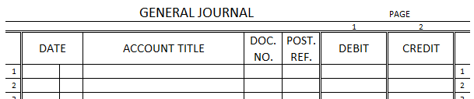
- Issuing a Note for a Sale
  - Most sales on account assume that the customer will pay within 30 days or less. To promote sales, a company may allow its customers to sign a note extending payment over a longer period of time.
  - If no cash is received, the sale is recorded in a general journal. If a cash down payment is received, the transaction could be recorded in a cash receipts journal.
    - Example: April 4. Accepts a 90-day, 12% note from Mark Carver for the sale of an appliance, $450. Note Receivable No. 12.

- Receiving Cash for a Note Receivable
  - Interest is earned for the period of time a note is outstanding. Because the interest rate is state as an annual rate, the actual interest earned must be computed as a fraction of a year (using 360 days).
    - Example: May 3. Received cash for the maturity value of Note Receivable No. 11: principal, $300, plus interest, $3; total, $303. Receipt No. 452.
Interest Calculation:
Principal x Interest Rate x Fraction of Year = Interest
$300.00 x 12% x 30 = $3.00
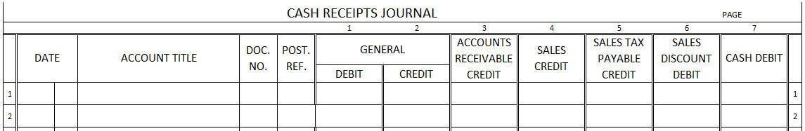
360

- Recording a Dishonored Note Receivable
  - D______________________ N___________ - a note that is not paid when due
  - The notes receivable account balance should include only the amount of notes receivable that a business expects to collect. Otherwise, Notes Receivable will be reported incorrectly on a balance sheet.
  - Although a notes is dishonored, an accounts receivable still owes the money, so a journal entry is recorded to transfer the maturity value of the note to their account. The journal entry does not cancel the debt and the business will continue to try to collect the account.
    - Example: Ruth Javinsky dishonored Note Receivable No. 8, a 30-day, 12% note, maturity value due today: principal, $250; interest, $2.50; total, $252.50. Memorandum No. 120.
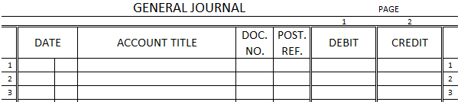

- Receiving Cash for a Dishonored Note Receivable
  - Sometimes payment may be received on a previously dishonored note. Additional interest is charged from maturity date to payment date.
  - The time for computing additional interest begins when the note is dishonored and ends on the day cash is received.
    - Example: September 30. Received cash from Ruth Javinsky for dishonored Note Receivable No. 8; maturity value, $252.50, plus additional interest, $10.18; total, $262.68. Receipt No. 201.

Time Number of Days
June 1 through June 30 29 (30 – 1 = 29)
July 31
August 31
September 1 through September 30 30
Total number of days 121

Maturity x Interest x Fraction = Additional
Value Rate of Year Interest
$252.50 x 12% x 121 = $10.18
360

10.2: UNEARNED AND ACCRUED REVENUE
- U_________________ R_______________ - revenue received in one fiscal period but not earned until the next fiscal period, aka deferred revenue
  - Unearned revenue may be recorded initially as a liability or as revenue.
  - Only that part of unearned revenue actually earned should be recorded as revenue in a fiscal period. An adjusting entry is recorded to separate the earned and unearned portions of revenue.
    - Example: On December 1, Appliance Center received $6,000 from Pace Delivery, $2,000 per month for December, January, and February rent. The receipt was recorded as rent income and is included in the $28,000 balance of Rent Income. At the end of the fiscal period, the January and February rent is unearned and should be reported in Unearned Rent. After the adjusting entry, the new balance of Rent Income, $24,000, correctly reflects 12 months of rent. Record the adjusting entry on December 31.

- Reversing Entry for Unearned Revenue Initially Recorded as a Revenue
  - On December 31, Rent Income is closed as part of closing entries and therefore its balance is zero. reversing entries for unearned revenue are made to return the amount of unearned revenue to the account in which it was initially recorded.
    - Example: January 1. Record the reversing entry for the adjusting entry above (Unearned Rent and Rent Income).
- Adjusting Entry for Accrued Interest Income
  - A_________________ R________________ - revenue earned in one fiscal period but not received until a later fiscal period
    - Example: On December 31, Appliance Center has two notes receivable outstanding.
- Note Receivable No. 12, a 60-day, 10% note dated December 1, $500.
- Note Receivable No. 13, a 30-day, 10% note dated December 16, $700.
Note Principal x Interest x Fraction = Accrued
Rate of Year Interest Income
12 $252.50 x 12% x 121 = $10.18
360
13 $700 x 10% x 15 = 2.92
360
Total accrued interest income, December 31…. $7.09
- Reversing Entry for Unearned Revenue Initially Recorded as a Revenue
  - Example: January 1. Record the reversing entry for the adjusting entry above (Interest Income and Interest Receivable).

