Name: _______________________
Chapter 11 Notes
Organizing a Corporation and Paying Dividends
11.1: Starting a Corporation
- C_______________________ - an organization with the legal rights of a person and that may be owned by many persons
  - exists separately and apart from its owners
  - ownership is divided into units, aka Shares of Stock
  - C_________________ S____________ - total shares of ownership in a corporation
  - S____________________ - owner of one or more shares of a corporation
  - D__________________ - earnings of a corporation distributed to stockholders
- B_______________ of D____________________ - group of persons elected by the stockholders to manage a corporation
  - represent stockholders’ combined interests
  - determines corporation policies and selects corporate officers to supervise the day-to-day management of the corporation
- Legal Requirements for Forming a Corporation
  - To form a corporation, persons must submit an application to the state in which the company is to be incorporated.
    - A_______________ of I____________________ - a written application requesting permission to form a corporation
    - C________________ - approved articles of incorporation, aka certificate of incorporation
- Rights of Stockholders
  - Most stockholders have three basic rights:
- To ____________ at stockholders’ meetings unless an exception is made for holders of a particular kind of stock.
- To ______________ in a corporation’s earnings.
- To share in the ____________________ of the assets of the corporation if it ______________ operation and sells all its assets.
- Capital Stock of a Corporation
  - Corporations may issue two basic kinds of stock:
    - C________________ S__________ - stock that does not give stockholders any special preferences
    - P_______________ S_________ - stock that gives stockholders preference in earnings and other rights
- S____________ C________________ - written evidence of the number of shares that each stockholder owns in a corporation
  - issued when full payment is received for the stock
  - usually states the issue date, certificate number, number of shares, and name of the stockholder
  - S______________ T______________ - changing ownership of stock, when a stockholder decides to sell some or all shares of stock owned
- Value of Stock
  - P________ V___________ - value assigned to a share of stock and printed on the stock certificate
  - Par-Value S____________ - a share of stock that has an authorized value printed on the stock certificate
  - N____-Par-Value Stock – a share of stock that has no authorized value printed on the stock certificate
  - S_____________-V___________ S____________ - no-par-value stock that is assigned a value by a corporation, some states required that no-par-value stock be assigned a stated or specific value, similar to par-value stock, except that the value is not printed on the stock certificates
- Common Stock
  - If a corporation issues only common stock, the common stockholders are entitled to all of the dividends.
  - Only owners of common stock have the right to vote on matters brought before the stockholders.
- Preferred Stock
  - To attract more investors, a corporation may offer preferred stock with preferences as to some of the basic stockholders’ rights.
  - Preferred stockholders usually do not have voting rights and cannot influence when and how much is paid in dividends.
  - Preference is given to preferred stockholders is to received dividends before common stockholders.
- Capital Accounts of a Corporation
  - Because of the number of owners, a corporation does not keep a separate capital account for each stockholder. Instead, it maintains a since summary general ledger capital account for each kind of stock issued.
  - A corporation’s net income is recorded in the capital account, R________________ E________________.
Example:
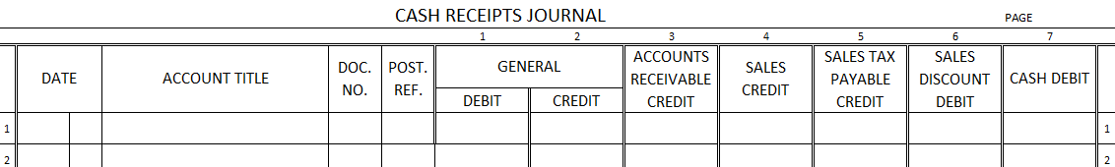
January 5. Received cash from six incorporators for 30,000 shares of $10.00 stated-value common stock, $300,000. Receipt Nos. 1-6.

- O___________________ C__________ - fees and other expenses of organizing a corporation, may include the following:
- An _____________________ fee paid to the state when the articles of incorporation of submitted.
- ____________________ fees for legal services during the process of incorporation.
- Other ___________________ expenses incurred prior to receiving a charter.
  - Until it receives a charter, a corporation does not exist to pay the organization costs. The planning required to start a new corporation often takes months. Therefore, one of the incorporators usually agrees to pay these costs until the charter is granted. After it receives a charter, a corporation reimburses the incorporator for the organization costs.
Example:
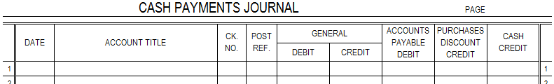
January 5. Paid cash to Amy Thacker as reimbursement for organization costs, $2,400.00. Check No. 1

11.2: Stock Subscriptions and the Balance Sheet
- Corporations frequently contract with investors to sell capital stock with payment to be received at a later date.
- S__________________ for C_____________ S__________ - entering into an agreement with a corporation to buy capital stock and pay at a later date
Example:
January 5. Received a subscription from Daniel Herring for 2,000 shares of $10.00 stated-value common stock, $20,000.00. Memorandum No. 1.
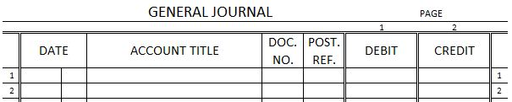
Example:
March 1. Received cash from Daniel Herring in partial payment of stock subscription, $10,000.00. Receipt No. 45.

- When a stock subscription is fully paid for, a stock certificate is issued to the stockholder.
Example:
July 1. Issued Stock Certificate No. 7 to Daniel Herring for 2,000 shares of $10.00 stated-value common stock. Memorandum No. 67.

- Balance Sheet of a Newly Formed Corporation
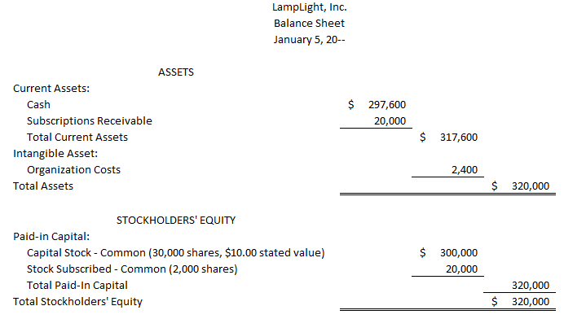
  - Assets
    - Cash on Hand = original $300,000 paid by the incorporators minus the $2,400 paid for organization costs
    - Subscriptions Receivable = amount due from Daniel Herring, $20,000
    - (Long-Term Investments and Plant Assets listed here if needed)
    - Intangible Assets – assets of a nonphysical nature that have value for a business
      - Organization Costs
  - Stockholders’ Equity
    - Paid-In Capital = $300,000 of issued common stock plus $20,000 in common stock subscribed

11.3: Calculating and Journalizing Dividends for a Corporation
- D_________________ a D_______________ - action by a board of directors to distribute corporate earnings to stockholders
- The board determines when and what amount of retained earnings will be distributed. A corporation has no obligation to distribute money to stockholders until the board of directors has declared a dividend.
- Three important dates are involved in distributing a dividend:
- D________ of D__________________ - the date on which a board of directors votes to distribute a dividend
- D________ of R______________ - the date that determines which stockholders are to receive dividends, stockholders may buy and sell stock at any time, however, only persons listed as stockholders on the date of record will receive dividends
- D________ of P______________ - the date on which dividends are actually to be paid to stockholders
- Transactions are recorded in a corporation’s accounts on two of the three dates: (1) date of declaration and (2) date of payment.
Example:
Calculating a Dividend
The board of directors has decided to declare an annual dividend of $24,000. On the date of record, the corporation has issued 1,000 shares of 8%, $100.00 par-value preferred stock and 16,000 shares of $20.00 stated-value common stock.
Value of Preferred and Common Stock:
Number of x Par Value = Value of
Preferred Shares Preferred Stock
1,000 x $100.00 = $100,000.00

Number of x Stated Value = Value of
Common Shares Common Stock
16,000 x $20.00 = $320,000.00

Distribution of Dividend:
Value of x Preferred = Preferred Dividend
Preferred Stock Dividend Rate Amount
$100,000.00 x 8% = $8,000.00

Total Amount - Preferred Dividend = Amount Available
Available for Dividends Amount for Common Dividend
$24,000.00 - $8,000.00 = $16,000.00

Dividend Rate for Common Stock:
Common Dividend ÷ Value of = Common
Amount Common Stock Dividend Rate
$16,000.00 ÷ $320,000.00 = 5%
Example:
December 15. CompuForm’s board of directors declared an annual dividend of $24,000.00. Preferred stock issued is $100,000.00 of 8%, $100.00 par-value preferred stock. Common stock issued is $320,000.00 of $20.00 stated-value common stock. Date of payment is January 15. Memorandum No. 132.
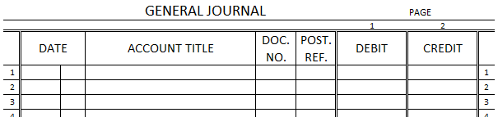

Example:
January 15. Paid cash for annual dividend declared December 15, $24,000.00. Check No. 432.

