Name: _______________________
Chapter 12 Notes
Acquiring Additional Capital for a Corporation
12.1: Capital Stock Transactions
- As a corporation grows, it may require additional capital to finance its expansion. A corporation can acquire additional capital by selling stock to investors or borrowing money.

Example – Issuing Preferred Stock at Par Value:
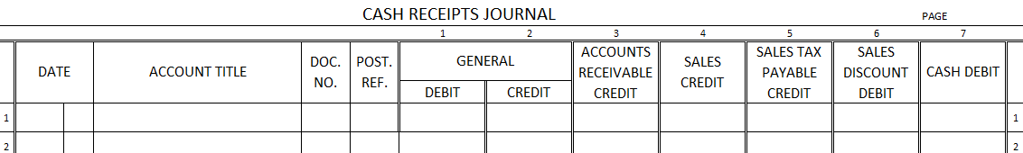
March 1. Received cash from Brenda Henson for 800 shares of $100.00 par value preferred stock at $100.00 per share, $80,000.00. Receipt No. 117.

Example – Issuing Preferred Stock for More than Par Value:
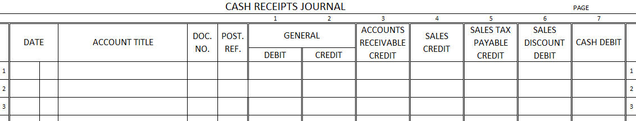
April 6. Received cash from Adam Kellogg for 300 shares of $100.00 par value preferred stock at $120.00 per share, $36,000.00. Receipt No. 127.

- D_______________ on C_____________ S___________ - an amount less than par or stated value at which capital stock is sold

Example – Issuing Preferred Stock for Less than Par Value:
August 9. Received cash from Hazel Deloach for 500 shares of $100.00 par value preferred stock at $90.00 per share, $45,000.00. Receipt No. 173.

Example – Issuing Preferred Stock for Assets Other than Cash:
October 7. Received office equipment from Steven McBee at an agreed value of $12,000.00 for 100 shares of $100.00 par value preferred stock. Memorandum No. 246.
No. of Shares x Value per Share = Value
Total Received 100 x $120.00 = $12,000.00
Par Value 100 x 100.00 = 10,000.00
Amount received in excess of par value $2,000.00
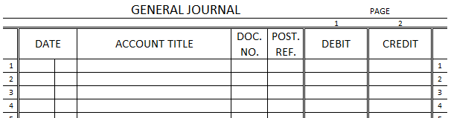

Example – Issuing Common Stock with No Par Value:
July 8. Received cash from Elizabeth Griffin for 1,000 shares of no-par value common stock at $14.00 per share, $14,000. Receipt No. 148.

Example – Issuing Common Stock with a Stated Value:
October 10. Received cash from Alice Blake for 100 shares of $10.00 stated value common stock at $12.00 per share, $1,200.00. Receipt No. 181.

12.2: Treasury Stock Transactions
- T___________________ S______________ - a corporation’s own stock that has been issued and reacquired
  - When a corporation buys treasury stock, it reduces the number of shares outstanding. However, treasury stock is still considered to be issued stock.
  - A corporation usually intents to use the treasury stock for a specific purpose, like giving it to employees as bonus payments.
  - Treasury stock is not an asset of a corporation.
  - Once treasury stock is given or sold to a stockholder, it ceases to be treasury stock and is again capital stock outstanding.
  - Treasury stock is recorded at the price paid regardless of the stock’s par or stated value.

Example – Buying Treasury Stock:
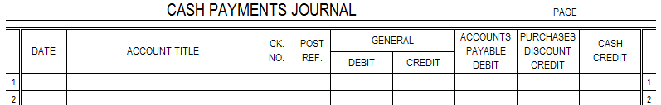
October 24. Paid cash to Francis Burns for 500 shares of $10.00 stated value common stock at $12.00 per share, $6,000.00. Check No. 502.

Example – Selling Treasury Stock for Original Cost:
November 21. Received cash from Lisa Vance for 100 shares of treasury stock at $12.00 per share, $1,200.00. Treasury stock was originally bought by LampLight on October 24 at $12.00 per share. Receipt No. 205.

Example – Selling Treasury Stock for More than Original Cost:
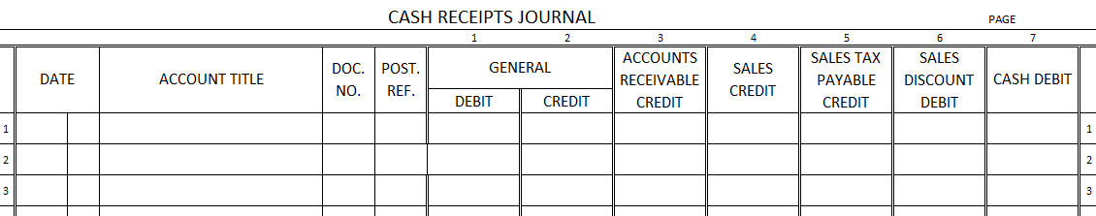
November 25. Received cash from Mary Long for 200 shares of treasury stock at $15.00 per share, $3,000.00. Treasury stock was bought on October 24 at $12.00 per share. Receipt No. 216.

Example – Selling Treasury Stock for Less than Original Cost:
December 22. Received cash from Frank Demetz for 50 shares of treasury stock at $10.00 per share, $500.00. Treasury stock was orignally bought October 24 at $12.00 per share. Receipt No. 229.

12.3: Bonds Payable Transactions
- For a growing business, the capital needed to expand may come from three sources:
- Using ___________________ earnings.
- Selling additional _________________ stock.
- ____________________ the funds.
- Retained Earnings:
  - Capital needed for expansion could be accumulated from retained net income during the next 5 to 10 years. However, the business may need the additional capital within the next year.
- Selling Stock:
  - Advantages:
    - additional capital becomes part of a corporation’s permanent capital
    - permanent capital does not have to be returned to stockholders as long as the business continues to operate
    - dividends do not have to be paid to stockholders unless earnings are sufficient enough to warrant
  - Disadvantage:
    - ownership is spread over more shares and more owners
- Borrowing Funds:
  - Advantage:
    - equity is not spread over additional shares of stock
  - Disadvantage:
    - interest must be paid on the loan, which decreases net income and the amount available for dividends
    - the amount borrowed must be repaid in the future
    - large loans can be difficult to obtain for short periods or from one bank or individual
  - B__________ - printed, long-term promise to pay a specified amount on a specified date and to pay interest at stated intervals
    - generally run for long period of time (5, 10, or 20 years)
    - B____________ I____________ - all bonds representing the total amount of a loan
      - A corporation usually sells an entire bond issue to a securities dealer who sells individual bonds to the public.

Example – Issuing Bonds:
July 1, 20X0. Received cash for the face value of a five-year, 12%, $1,000.00 par value bond issue, $250,000.00. Receipt No. 246.

- A year’s interest is paid to each bondholder on July 1 of each year until the bond’s maturity date.
- ______________ - a person or institution, usually a bank, given legal authorization to administer property for the benefit of property owners

Example – Paying Interest on Bonds:
July 1, 20X1. Paid cash to bond trustee for annual interest on bond issue, $30,000.00. Check No. 526.

- B__________ S________________ F________ - an amount set aside to pay a bond issue when due
  - used to assure bondholders that the bond issue will be paid at maturity

Example – Depositing Cash in a Bond Sinking Fund:
July 1, 20X1. Paid cash to bond trustee for annual deposit to bond sinking fund, $50,000.00. Check No. 563.

Example – Depositing Cash to Sinking Fund and Recording Income Earned:
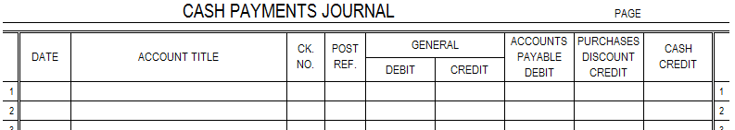
July 1, 20X2. Paid cash to bond trustee for annual deposit to bond sinking fund, $48,000.00, and recorded interest earned on bond sinking fund, $2,000.00. Check No. 610.

- R_________________ a B_________ I____________ - paying the amounts owed to bondholders for a bond issue
- T___________ B__________ - bonds that all mature on the same date
- S_______________ B___________ - portions of a bond issue that mature on different dates

Example – Retiring a Bond Issue:
July 1, 20X4. Received notice from bond trustee that bond issue was retired using bond sinking fund, $250,000.00. Memorandum No. 600.

