Name: ____________________________________
Financial Management
Chapter 12 Notes

Video – Financial Reporting for Business

Before Watching the Video
Using your textbook, define the following terms:
- assets –
- liabilities –
- owner’s equity –

- revenue –

- expenses –

While Watching the Video
Answer the following questions while you watch the video.
- When transactions are recorded they can be categorized into:

- cash r_____________________
- _____________________ purchases
- credit _____________________
- credit _____________________
- sales _____________________ and allowances
- _____________________ returns and allowances
- general _____________________

- List one advantage of using computers to record accounting information.

- What accounting package (software) does Paul Spano, franchise owner from Video Ezy use?

- Why are cash transactions important to a business?

- What are the three main headings in a statement of cash flows?

- What are two things a business can a business do to improve cash flow?

- How is profit calculated?

- List two operating expenses:

- How is net profit calculated?

- What are the two groups of assets?
  - _____________________ assets
  - _____________________ assets

- What is the importance of assets to a business?

- Give two examples of liabilities:

- Define current liabilities.

- What are the three components of owner’s equity?

- What are drawings and what effect do they have on owner’s equity?

- State the accounting equation.

12.1 – Financial Planning

FINANCIAL PLANNING
- Beginning a Business
  - Many new businesses fail due to poor ____________________________.
  - Consult an _________________!
  - Many ___________________ to answer.
- Ongoing Operations
  - Every ________________________ costs money. Without careful _________________, these costs can grow to a level where the business income cannot cover the _________________.
  - Basic financial equation:
_________________ - _________________ = ______________ or ______________

  - Both ___________________ AND ___________________ should be concerned with costs
    - Profitability is directly linked to the number of ______________ and their ___________.
      - Reduce ______________ and control __________________.
      - Increase sales and income with better _________________________ and more customer __________________________.
- Business Expansion
  - Successful businesses ________________ to serve more ___________________, reach unserved markets, and sell new _______________________.
  - Expansion costs __________________!
    - New ______________ will hopefully be greater than the _____________ to expand.
    - Research, new ________________ /_________________, marketing, etc.
  - All expansion must be well ____________________ and often takes a great deal of __________ (and $$)

developing business budgets
- Budgeting:
  - Budget -
    - Main Purposes:

    - Sources of Information:
      - Established businesses
      - New businesses
      - Other sources -
    - Types of Budgets:
      - ____________________________ – plans income and expenses form the beginning of a new business or a major business expansion until its profitable
        - includes
      - ____________________________ - financial plan for the ongoing operations of the business for a specific period
        - covers
      - ____________________________ - estimate of the actual money received and paid out for a specific period
        - shows if

12.2 – Financial Records and Financial Statements

FINANCIAL records
- Financial Records -
  - Types of Records:
- Asset Records -
- ________________________________ - identify the amount assets have decreased in value due to their age and use
- Inventory Records -
- ________________________________ - identify the companies from which credit purchases were made and amount purchase, paid, and owed
- Accounts Receivable Records -
- _______________________________ - list all cash received and spent by the business
- Payroll Records -
- _______________________________ - show all taxes collected, owed, and paid
FINANCIAL statements
- Financial Statements -
  - _____________________________________ – summarizes the revenues, costs, and expenses incurred during a specific period of time
  - _____________________________________ – a report of assets, liabilities, and owner’s equity
  - _____________________________________ – shows how changes in balance sheet accounts and income affect cash and cash equivalents

Sample Financial Statements:
Marty Foxey owns and operates Foxey’s Fishing. The store is located in a large regional town and has a reputation for stocking a wide range of fishing equipment and accessories. The business has grown over the past 12 months so Marty purchased two vans so he could deliver to customers on location.
Balance Sheet
The following figures are provided for the 12 months ending June 30, 20--. Use these figures to prepare a Balance Sheet.
Accounts Payable (creditors) | 21,922 |  | Fixtures & Fittings | 7,200
Accounts Receivable (debtors) | 17,885 |  | Loans (short-term, due within 12 mo.) | 12,000
Capital | 145,775 |  | Loans (long-term) | 22,000
Cash at Bank | 4,157 |  | Investments (stocks) | 22,455
Drawings | 50,000 |  | Vans | 100,000

Foxey’s Fishing
Balance Sheet
June 30, 20--
Current Assets: |  | Current Liabilities:
 |  | Non-Current Liabilities:
Non-Current Assets:
 |  | Total Liabilities
 |  | Owner’s Equity:
Total Assets
 |  | Net Owner’s Equity
 |  | Total Liabilities & Owner’s Equity

Profit and Loss Statement
The following figures are provided for the 12 months ending June 30, 20--. Use these figures to prepare a Profit and Loss Statement.
Accounting Fees | 1,050 |  | Electricity | 240
Advertising | 9,700 |  | Interest on Loan | 650
Cash Sales | 142,000 |  | Rent | 16,800
Cost of Sales | 110,525 |  | Telephone | 3,000
Credit Sales | 79,050 |  | Wages | 46,000

Foxey’s Fishing
Profit and Loss Statement
For Year Ended June 30, 20--
Revenue
Total Sales
Less: Cost of Sales
Gross Profit
Less: Expenses
Total Expenses
Net Profit

Cash Flow Statement
The following Cash Flow Statement has been provided containing 6 significant errors. Circle and correct each error.
JTz Bicycle Superstore
Cash Flow Statement
For Year Ended June 30, 20--
Cash Flow from Operating Activities
Cash Inflow from Operating Activities:
Cash Sales | 142,000
Receipts from Debtors | 85,772
Credit Sales | 44,000
Total Cash Inflow from Operating Activities | 271,772
Cash Outflow from Operating Activities:
Payments to Creditors | (74,225)
Rent | (16,800)
Advertising | (9,700)
Wages | (46,000)
Purchase of Van | (34,000)
Telephone | (3,000)
Accounting Fees | (1,050)
Electricity | (240)
Total Cash Outflow from Operating Activities | (185,015)
Net Cash Flow from Operating Activities | 86,757
Cash Flow from Investing Activities
Loan | 34,000
Net Cash Flow from Investing Activities | 34,000
Cash Flow from Financing Activities
Loan | (12,000)
Interest on Loan | (650)
Drawings | (50,000)
Net Cash Flow from Financing Activities | (62,650)
Owner’s Equity
Net Increase in Cash | 58,107
Bank Balance, beginning | 24,050
Bank Balance, ending | 82,157
Add Net Profit | 505
Total Owner’s Equity | 82,662

12.3 – Payroll Management

payroll systems
- Payroll -
  - Employer must pay employees ________________, ________________, or ________________.
  - Compensation:
    - Employees are generally paid _____________, salary, or with _________________ pay.
    - Most businesses also provide benefits like _________________, (un)paid vacation, _____________________ leave, retirement plans, and __________________________.
  - Payroll Taxes:
    - Income Taxes -
    - Social Security and Medicare Taxes -
    - Unemployment Taxes -
preparing a payroll
- Payroll Record -
  - Payroll records include:
    - employee’s name, ___________________________, address, etc.
    - _____________ information like ________________________ and allowances
    - benefits
    - current and year-to-date earnings (_______________________, gross pay, and _______________)
  - Preparing paychecks:
    - Earnings Report -
    - Direct Deposit -

Calculating payroll
Employee Information |  |  | Earnings |  |  | Deductions |  |  |  |  |  | NET PAY
Name | Marital Status | Withhold. Allow. | Hourly Rate | Hours Worked | GROSS PAY | Federal Income Tax | Social Security Tax | Medicare Tax | Health Insurance | Union Dues | TOTAL DEDUC.
Jane Doe | Single | 3 | $10.25 | 35 |  |  |  |  | --- | $5.00
Tim Irvin | Married | 6 | $11.45 | 40 |  |  |  |  | $50.00 | $5.00
Bob Jones | Single | 4 | $8.75 | 40 |  |  |  |  | $25.00 | ---
Julie Pope | Single | 1 | $9.55 | 20 |  |  |  |  | --- | ---
Zoe Yates | Married | 2 | $10.25 | 38 |  |  |  |  | $50.00 | $5.00

- Gross Pay –
  - Gross Pay =
- Federal Income Tax –
  - Calculated using the Federal Income Tax Withholding Tables and your _____________ status, withholding __________________, and ____________ pay.
- FICA –
  - Social Security Tax –
    - calculated as ____% of your gross pay
    - tax base (only taxed on first $__________ of earnings each year)
  - Medicare Tax –
    - calculated as ____% of your gross pay
    - no tax base
  - FICA Taxes (Medicare and Social Security) are paid by ______________________________________________________.
- Net Pay –
  - Net Pay =
(Withholding Table for Calculating Payroll)

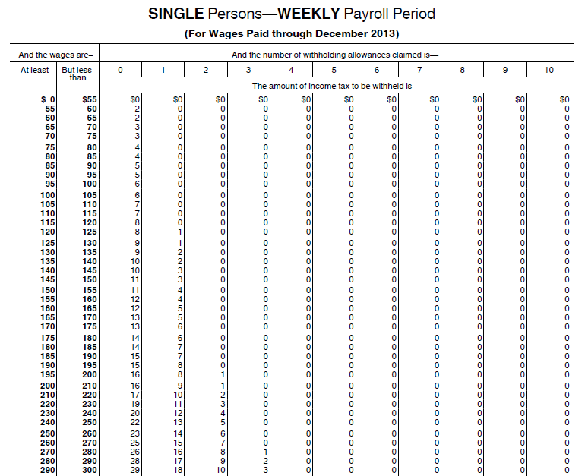
(Withholding Table for Calculating Payroll)
