Chapter 12 Study Guide Name: ______________________________
Part One – Vocabulary
Match each term to its definition by writing the letter corresponding to each term next to the appropriate definition below. Write your answer in the space provided.

accounts payable records
accounts receivable records
balance sheet
budget
cash budget
depreciation records
expenses
federal income tax
gross pay
income statement
Medicare tax
net pay
operating budget
payroll
revenue
Social Security tax
start-up budget

- _________________________ The financial record of employee compensation, deductions, and net pay.
- _________________________ The money received by a business from the sale of products or services.
- _________________________ A tax that funds old age, survivors, and disability insurance.
- _________________________ A report of assets, liabilities, and owner’s equity on a particular date.
- _________________________ A budget planning the income and expenses from the beginning of a new business until it is profitable.
- _________________________ An employee’s take home pay; the amount on the paycheck.
- _________________________ A tax that funds hospital insurance.
- _________________________ The costs incurred to run a business, like payroll, rent, and utilities.
- _________________________ Documents and files identifying the amount assets have decreased in value due to their age and use.
- _________________________ Items identifying customers that made purchases using credit and the status of each account.
- _________________________ A tax that funds national defense, health care, and job security, for example.
- _________________________ A budget planning the ongoing operations of a business.
- _________________________ A report of revenue, expenses, and net profit/loss for a specific period of time.
- _________________________ A detailed plan outlining the financial needs of an individual, family, or business.
- _________________________ An employee’s earnings before deductions.
- _________________________ Items that identify the companies from which credit purchases were made and the amount purchased, paid, and owed.
- _________________________ A budget planning for the actual money received and paid out for a specific period of time.
Part Two – Application
Complete each problem below.
- Complete the balance sheet below by calculating the missing amounts.
Bobby’s Boda Boda’s
Balance Sheet
December 31, 2013
Assets: Liabilities:
Cash $20,000 Accounts Payable $ 9,000
Accounts Receivable 7,000 Loans Payable 15,000
Supplies _______ Total Liabilities ____________
Equipment 35,000 Owner’s Equity: 40,000
Total Assets: $ Total Liabilities & Own. Eq. $

- Complete the income statement below by calculating the missing amounts. Also, circle the appropriate term to show whether this company had a profit or loss this year.
Marilyn’s Music
Income Statement
For the Year Ending December 31, 2013
Revenue:
Cash Sales $20,000
Credit/Charge Sales 11,000
Total Revenue $
Expenses:
Salaries and Wages $21,000
Advertising 2,000
Rent 18,000
Utilities 3,000
Total Expenses $

Profit / Loss: $
(circle profit or loss)

- Complete the Payroll Table below. Use the attached Federal Withholding tables to find the Federal Income Tax, 6.2% to calculate Social Security Tax, and 1.45% to calculate Medicare Tax.

Employee Information |  |  | Earnings |  |  | Deductions |  |  |  | NET PAY
Name | Marital Status | Withhold. Allow. | Hourly Rate | Hours Worked | GROSS PAY | Federal Income Tax | Social Security Tax | Medicare Tax | TOTAL DEDUC.
Alex | Married | 2 | $11.50 | 30
Ali | Single | 1 | $12.00 | 14

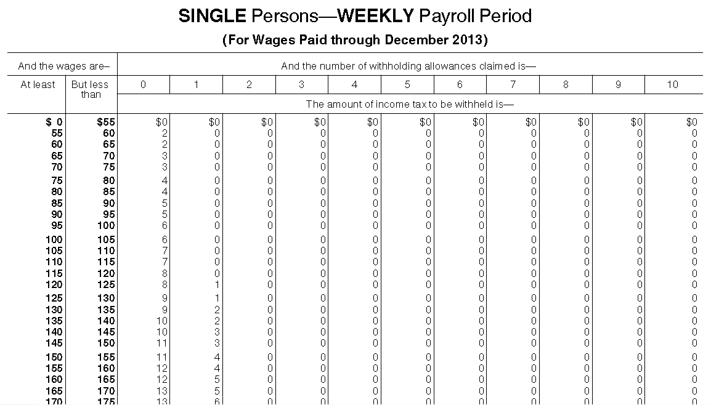
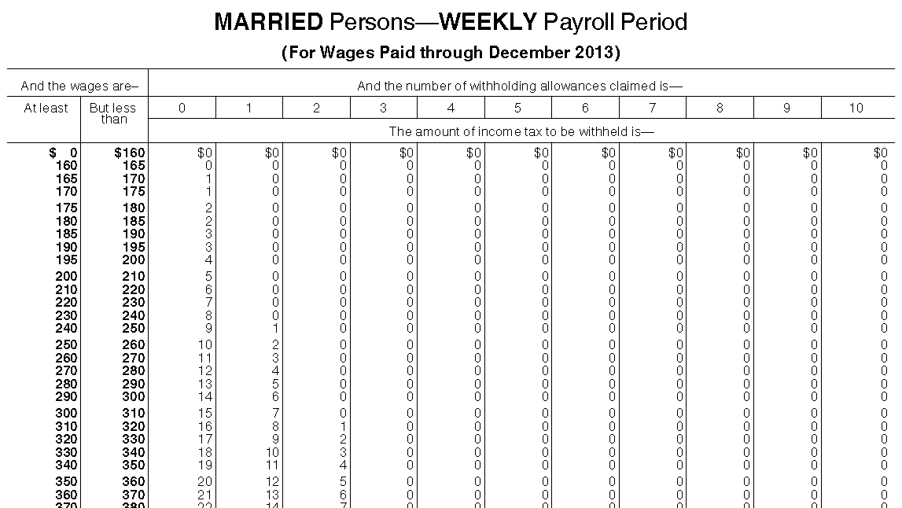

Part Three – Matching
Match each of the descriptions below to the four financial performance ratios. You will use each ratio more than once.
- current ratio
- debt to equity ratio
- return on equity ratio
- net income ratio

- _____ total sales
net income
- _____ current assets
current liabilities
- _____ net profit
owner’s equity
- _____ total liabilities
owner’s equity
- _____ Tells you how much the business is relying on money borrowed from others rather than the money provided by the owners.
- _____ Shows the rate of return on the owners are getting on the money they invested in the company.
- _____ Shows how much profit is being made by each dollar of sales for that period.
- _____ Tells you if the business can pay its debts when they become due.
- _____ Should be at least 1:1 (aka, the current assets should be at least the same or greater than the current liabilities).
- _____ Banks want to see this ratio no higher than 2:1. In other words, the total liabilities should be no more than two times that of the owner’s equity.
- _____ Should be compared to that of past periods and competing companies.
- _____ Should be compared to possible rates of return on savings or other investments.

