Name: __________________________
Chapter 13 Notes
Section 13.1 – Journalizing Payroll
Recording Payroll Information
- So far we have discussed how to record payroll information on the:
  - Payroll ____________________
  - ________________ _________________ Record
- These two records provide all the payroll information needed to prepare payroll and payroll tax reports.

How does payroll look in the journals and ledgers?
- In the Ledgers
  - Separate ______________ ______________ are not kept for each employee.
  - Rather, accounts are kept to summarize:
    - _____________ _______________
    - ____________________
- In the Journals
  - Two journal entries are used to record payroll. The payment of:
- _____________
- Employer payroll _____________

Other Reports
- Various ______________ and ______________ payroll tax reports are required to report the payment of payroll taxes.
  - _________ (Wage and Tax Statement): tells employee total earnings and deductions for the year
  - ____________________ ____________________ ____________ _______________: employer reports the payroll taxes withheld from employee salaries and employer payroll taxes to the gov’t
  - _________ (Transmittal of Wage and Tax Statement): employer reports earnings and payroll taxes of each employee during the previous year
  - Form 8109, ___________________ ________________ ___________________: employer sends to the government with the payment of payroll taxes

Journalizing the Payment of Payroll
- The information for this journal entry comes from the column totals of the _____________ ____________.
- This entry is recorded in the _____________ ___________________ _________________.
- Transaction:
  - Debit ______________ _______________ for the ______________ _________________ total.
  - Credit each individual ________________ _________________ for their ________________ column totals, such as:

      - Employee Income Tax Payable
      - Social Security Tax Payable
      - Medicare Tax Payable
      - Health Insurance Premiums Payable
      - U.S. Savings Bonds Payable
      - United Way Donations Payable

  - Credit ___________ for the total for the _________ ___________ column

Practice!
Metro Company’s payroll register has the following column totals for the semimonthly pay period, July 1-15 of the current year:

Total Earnings, $12,600
Federal Income Tax Withheld, $1,186
Social Security Tax Withheld, $781.20
Medicare Withheld, $182.70

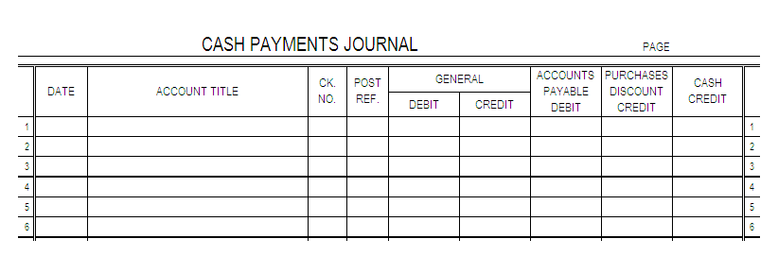
Journalize the payment on page 15 of the cash payments journal; the payroll was paid by Check No. 455.

Section 13.2 – Journalizing Employer Payroll Taxes

Employer Payroll Taxes
- Most employers must pay four separate payroll taxes:

- _____________ _______________Tax
- _____________ Tax
- _____________ Unemployment Tax
- _____________ Unemployment Tax

  - Each of these taxes is based on a percentage of employee earnings.

Employer Social Security and Medicare Taxes
- These are the only employer payroll taxes paid by both the _____________ and _____________ .
- For example, if Hobby Shack withheld $354.11 in social security tax and $82.83 in Medicare tax from employee wages this last pay period, Hobby Shack would owe the same amount of social security and Medicare tax.
  - Where would we find these amounts?

Unemployment Taxes
- Federal laws require _____________ to pay taxes for unemployment compensation.
  - These funds are used to pay workers _____________ and partial _____________ for limited periods of unemployment.
- The total earnings subject to unemployment tax are called unemployment _____________ earnings.
  - Unemployment tax is applied to the first $_______ earned by each employee each year.
- There are two types of unemployment tax paid:
  - Federal Unemployment Tax –___________________________________________________ ______________________________________________________________________________
  - State Unemployment Tax – _____________________________________________________ ______________________________________________________________________________
Federal Unemployment Tax
- ____% of the first $7,000 earned by each employee each year.

State Unemployment Tax
- ____% of the first $7,000 earned by each employee each year.
- Regulated by the _____________ _____________ _____________ , so even though laws vary by state, they vary only slightly. There are certain standards that must be followed.

Journalizing Employer Payroll Taxes
- The entry is recorded in the General Journal
  - Debit:
    - Payroll Taxes Expense (for the ____________ of the taxes _____________)
  - Credit:

    - Social Security Tax Payable
    - Medicare Tax Payable
    - Unemployment Tax Payable-Federal
    - Unemployment Tax Payable-State

Practice!
Payroll information taken from employee earnings records is given below.
- Complete the table by:
      - Calculating the amount of earnings subject to unemployment taxes. Unemployment taxes are owed on the first $7,000 of earnings for each employee.
      - Calculating the amount of employer payroll taxes owed for the May 1-15 pay period and then again for the May 16-31 pay period. Use the appropriate payroll tax rates.
- Journalize the employer’s payroll taxes for the May 1-15 pay period on May 15 of the current year. Use general journal page 10 and Memorandum No. 46.
Employee Name | Accumulated Earnings, April 30 | Total Earnings, May 1-15 Pay Period | Unemployment Taxable Earnings | Accumulated Earnings, May 15 | Total Earnings, May 16-31 Pay Period | Unemployment Taxable Earnings
Tammy Beltran | $5,100.00 | $650.00 |  |  | $700.00
Irma Cintron | $7,350.00 | $900.00 |  |  | $850.00
George Davis | $6,500.00 | $750.00 |  |  | $600.00
Total:
Social Security Tax Payable, 6.2%
Medicare Tax Payable, 1.45%
Unemployment Tax Payable – Federal, 0.8%
Unemployment Tax Payable – State, 5.4%
Total Payroll Taxes
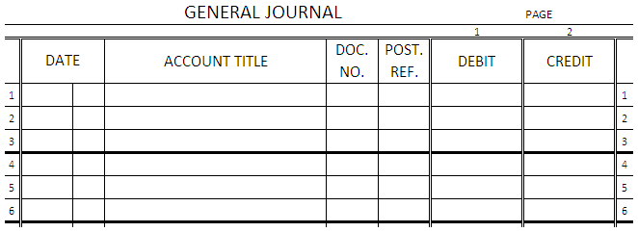

Section 13.3 – Reporting Withholding and Payroll Taxes

Employer Annual Report to Employees of Taxes Withheld
- Form _______, Wage and Tax Statement—annual report of an employee’s total earnings and taxes withheld (____________ tax, _____________________ tax, and _______________ tax) during the year.
  - Amounts are found on each employee’s ______________________________________.
  - Employers are required to provide employees with this form by ____________________ of the next year (or within _______________ if an employee ends employment before December 31).
  - ___________ copies of this form are prepared.
    - Copies B and _____ are given to the employee.
      - Copy B—employee attaches to a personal federal _________________ ________________.
      - Copy ____—employee keeps for a personal record.
    - Copy ____—employer sends to the Social Security Administration.
    - Copy D—employer keeps for the _________________ records.
  - Businesses in states with ____________________________ must prepare additional copies of this form. The employee attaches the additional copy to the personal income tax return.

Preparing Employer’s Quarterly Federal Tax Return
- Each employer must file a _________________ federal ______________________ showing the federal income tax, social security tax, and Medicare tax due to the ________________________.
- This form is called Form ________, Employer’s _______________________________________ and is submitted every three months before the __________ day of the month following the end of a calendar ________________.
- The steps to complete the form are found on page 380.

Employer Annual Reporting of Payroll Taxes
- Form ________, Transmittal of _________ and ____________________________ is sent to the Social Security Administration by _______________________ of each year.
  - This form reports the ________________ year’s earnings and ______________________ withheld for all employees.
  - Attached to this form is Copy A of each employee Form _________.
- At the end of a _______________ year, employers must also report to the federal and state governments a summary of all _________________ paid to employees during the _____ months.

Section 13.4 – Paying Withholding and Payroll Taxes

Paying the Liability for Employee and Employer Payroll Taxes
- Employers must pay to the _______________, _______________, and _______________ governments payroll taxes withheld from employee earnings and employer payroll taxes
- Deposit—_____________________________________________________________________
  - Two amounts determine how often the deposit is made:
    - Amount of payroll taxes collected during the _______________deposit period
    - Amount of payroll taxes owed during the _________________ _______________ (the 12-month period that ends on June 30th of the prior year).

Form 8109, Federal Deposit Coupon
- New employers must make _______________ deposits for the first calendar year of business. After a lookback period is established, the business must evaluate whether a change in its deposit period is required.
- Form 8109, Federal Deposit Coupon—_____________________________________________.
  - See page 384: Fill in the Type of Tax (Form 941) and the Tax Period (which quarter).
- Deposits can be made through EFTPS (_________________ __________________ __________________ _______________ _______________) if desired, but must be made through EFTPS if a business had deposits of more than $200,000 in the last calendar year.

Journalizing Payment of Liability for Employee Income Tax, Social Security Tax, and Medicare Tax
- Payment must be submitted by the _____^{th} of the month following the payroll payment.
- This transaction is recorded in the _______________ _______________ Journal.
  - Debit each tax ______________ account:
    - Employee Income Tax __________________
    - Social Security Tax __________________
      - Remember, this tax is paid by both the employer and the employee.
    - Medicare Tax ____________________
      - Remember, this tax is paid by both the employer and the employee.
  - Credit the _____________ account for the ______________ of the tax liabilities.

Journalizing Payment of Liability for Federal Unemployment Tax
- Payment must be submitted by the _____ of the month following each ______________.
- Journalized in the _______________ _______________ Journal.
  - Debit: _______________________ __________ _____________________- _____________________
  - Credit: ________________

Journalizing Payment of Liability for Federal Unemployment Tax
- Payment must be submitted by the _____ of the month following each ______________.
- Journalized in the _______________ _______________ Journal.
  - Debit: _______________________ __________ _____________________- _____________________
  - Credit: ________________

Practice!
The following payroll data is for Digital Supplies for the monthly pay period ended March 31 of the current year.

Date Paid | Federal Income Tax Withheld | Employee Social Security Tax Withheld | Employee Medicare Tax Withheld
Mar. 31 | $1,386.00 | $1,322.05 | $309.25

Credit balances on March 31 for the unemployment tax accounts for the first quarter are as follows: Unemployment Tax Payable – Federal, $511.75; Unemployment Tax Payable – State, $3,454.34. Digital Supplies pays both unemployment taxes each quarter.

- Prepare a journal entry for the payment of the withheld taxes. Digital Supplies is a monthly schedule depositor. Journalize Check No. 383 on cash payments journal page 14 using the date taxes are due to the federal government.

- Prepare journal entries for payment of the federal and state unemployment taxes liability. Assume both checks were prepared on the due date for the federal tax deposit. Check Nos. 401 and 402.

