Name: _____________________________

Chapter 15 Notes
Financial Statements for a Corporation

15.1: Preparing an Income Statement
- Income Statement Information
  - An income statement is used to report a business’s __________________________________.
  - Merchandising businesses report the following on an income statement:
    - revenue
    - cost of ___________________________
    - ______________________ on sales
    - expenses
    - net __________________ or _________________
  - Information from a completed ________________________ is used to prepare an income statement.
  - Amounts in all ___________________ and __________________ accounts and __________________________________ are reported on an income statement.
  - The income statement has three main sections:

- Key Terms
  - net sales –
  - cost of merchandise sold –
  - gross profit on sales –
- Sample Problem
The work sheet for Interstate Tires, Inc. for the year ended December 31 of the current year is given on the next page.
- Prepare an income statement.
- Calculate and record on the income statement the following component percentages:
  - cost of merchandise sold
  - gross profit on sales
  - total expenses
  - net income before federal income tax.
Round percentage calculations to the nearest 0.1%.
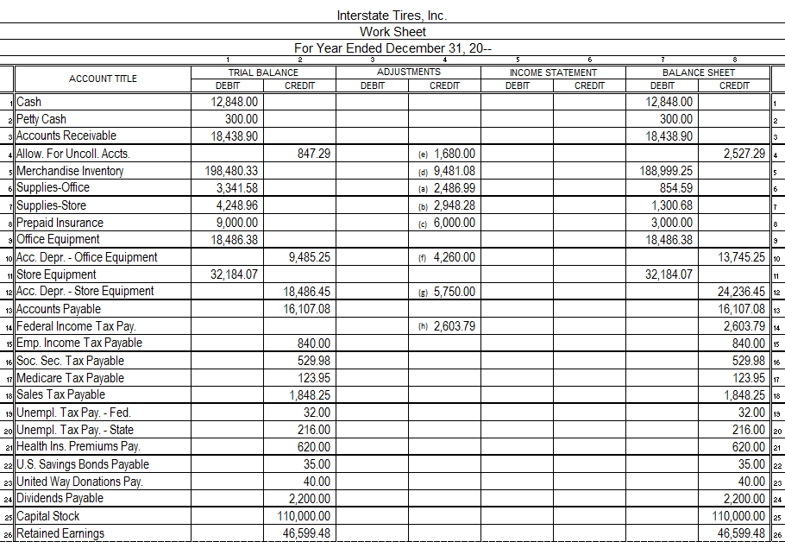

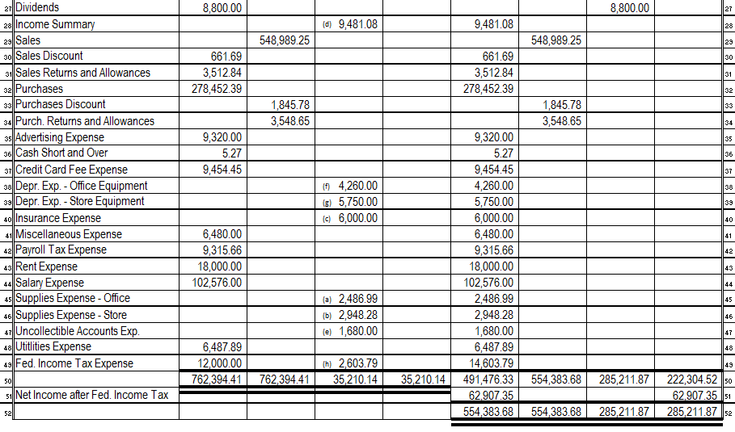
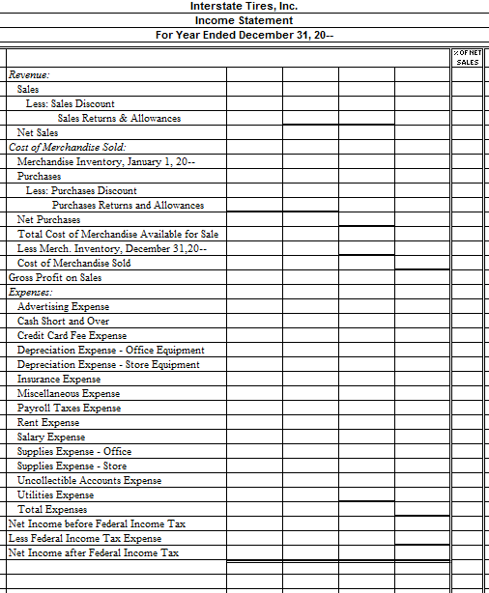

15.2: Analyzing an Income Statement
- Component Percentages
  - A percentage relationship between one financial statement item and the total that includes that item is known as a _________________________________________.
  - Every sales dollar reported on the income statement includes four components:

  - To help make ____________________ about __________________________________, a merchandising business analyzes the relationships between these four income statement components and sales.
- Acceptable Component Percentages
  - For a component percentage to be useful, a business must know _____________________ percentages.
  - Acceptable component percentages are determined by:
    - making comparisons with _______________ fiscal periods and
    - ____________________ standards published by industry ________________________.
  - Below is an example of acceptable component percentages for a sample business.
    - How did the sample business do? Were its component percentages within the acceptable industry standards? Place a check mark under yes or no.
 | Acceptable Industry Standards | Sample Business Component Percentages | Acceptable Result
 |  |  | Yes | No
Sales | 100% | 100%
Cost of Merchandise Sold | Not more than 46.0% | 44.9%
Gross Profit on Sales | Not less than 54.0% | 44.9%
Total Expenses | Not more than 35.0% | 33.9%
Net Income before Federal Income Tax | Not less than 19.0% | 21.2%

- Analysis of Component Percentages
  - Cost of Merchandise Sold
    - The cost of merchandise sold is a _______________________ and must be kept as ___________ as possible.
  - Gross Profit on Sales
    - Gross profit must be _______________ enough to cover total ___________________ and the desired amount of ______________________________.
  - Total Expenses
    - Total expenses must be ________________ than ______________________________ _________________ to provide a desirable ______________________________.
  - Net Income before Federal Income Tax
    - This component percentage shows the ____________________ being made by a business.
- Actions to Correct Unacceptable Component Percentages
  - Unacceptable Component Percentage for Gross Profit on Sales
    - This component percentage is directly related to __________________________ and ______________________________________________.
    - An unacceptable component percentage for gross profit on sales requires one of three actions:
- ______________________ sales revenue
- decrease ______________________________________, or
- ______________________ sales revenue and also ____________________ cost of merchandise sold.
- Unacceptable Component Percentage for Total Expenses
  - Each expense account must be ______________________ to determine if major ______________________ have occurred.
  - Actions must be then be taken to _____________________ any expenses for which major ______________________ have occurred or that are __________________ industry standards.
- Unacceptable Component Percentage for Net Income before Federal Income Tax
  - If the component percentages for cost of merchandise sold, gross profit on sales, and total expenses are brought within ________________________ ranges, this component percentage will also be acceptable.
  - Financial Ratios
    - Individual amounts reported on an income statement have little ___________________ without being ________________________ to another amount.
      - financial ratio –
    - Earnings per Share
Net Income after ÷ Number of Shares = Earnings
Federal Income Tax Outstanding per Share
      - earnings per share –
        - Unlike component percentages, earnings per share cannot be compared to industry standards. Instead, it is compared to:
- _________________________ earnings per share or
- the __________________________ of the stock
    - Price-Earnings Ratio
Market Price ÷ Earnings = Price-Earnings
per Share per Share Ratio
      - price-earnings ratio –
        - It provides _______________________ with information concerning the _______________ of the stock relative to the _____________________.
        - Online sources highlight the earnings per share and price-earnings ratio over several years.
          - Investors can analyze the _________________ in the earnings per share to project __________________________________ of the company.
          - Then, using _____________________ price-earnings ratios, investors can predict future _____________________________ of the company’s stock.
          - Sample Problem
Use the income statement for Interstate Tires, Inc. from the previous section. A form for completing this problem is below each set of instructions.
- Interstate Tires determines that no more than 53 cents, of 53.0%, of each sales dollar should be devoted to cost of merchandise sold. Compare the actual component percentage for cost of merchandise sold to the acceptable percentage. Indicate if the actual component percentage is acceptable or unacceptable. If it is unacceptable, suggest an action that corrects it.
- Acceptable auto parts industry standards show that at least 47 cents, or 47.0%, of each sales dollar should result in gross profit. For Interstate Tires, compare the actual component percentage for gross profit on sales to the actable percentage. Indicate if the actual component percentage is acceptable or unacceptable. It if is unacceptable, suggest an action that corrects it.
Component | Acceptable Percentage | Actual Percentage | Acceptable Result |  | Recommended Action  If Needed
 |  |  | Yes | No
- Cost of Merchandise Sold | No more than 53.0%
- Gross Profit on Sales | No less than 47.0%

- Interstate Tires currently has 110,000 of shares outstanding with a market price of $13.75 per share. Calculate the earnings per share and price-earnings ratio.
Earnings per Share
Net Income after Federal Income Tax | ÷ | Number of Shares Outstanding | = | Earnings per Share
$ | ÷ |  | = | $

Price-Earnings Ratio
Market Price per Share | ÷ | Earnings per Share | = | Price-Earnings Ratio
$ | ÷ | $ | = | $

15.3: Preparing a Statement of Stockholders’ Equity
- Statement of Stockholders’ Equity
  - Statement of Stockholders’ Equity –
    - Has two major sections:

  - Capital Stock Section
    - The amounts in the capital stock section are obtained from the general ledger account, _____________________________.
      - The amount of capital stock issued as of the beginning of the year is the _______________________________ of the capital stock account.
      - Any additional stock ______________________ recorded in the ledger during the fiscal year would be ______________________ to calculate the amount of stock __________________ during the fiscal year.
    - Each share of stock issued by a corporation has a _________________________ value.
      - par value –
  - Retained Earnings Section
    - The amounts used in the retained earnings section are obtained from the _______________________________ and _________________________ columns of the __________________________.
- Sample Problem
Use the work sheet and income statement for Interstate Tires, Inc. from the previous sections. A form for the statement of stockholders’ equity is given below.
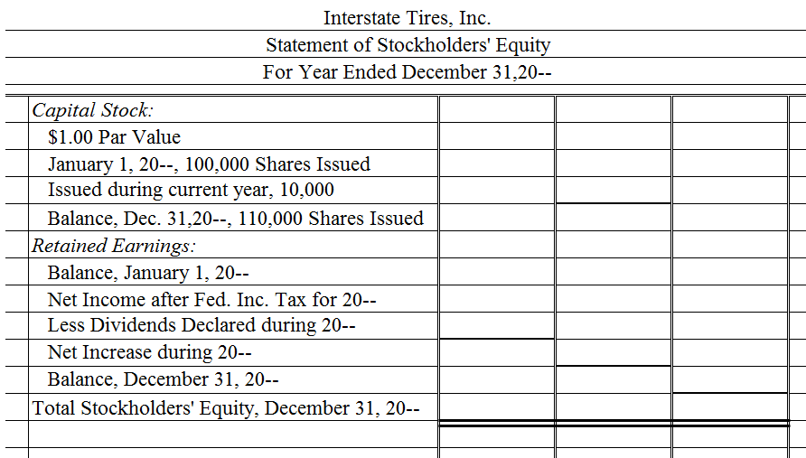
- Prepare a statement of stockholders’ equity for the current year. As of January 1, Interstate Tires, Inc. had issued 100,000 shares of capital stock with a par value of $1.00 per share. During the fiscal year, the corporation issued 10,000 additional shares of capital stock.

15.4: Preparing a Balance Sheet
- Balance Sheet Information
  - A corporation’s balance sheet reports ______________________, ________________________, and ___________________________________________ on a specific date.
  - Some ___________________________ decisions can best be made after owners have _______________________ the balance sheet.
    - For example, balance sheet information would enable management to determine whether the corporation should incur additional ______________________ to acquire additional _____________________________________.
  - The information used to prepare a balance sheet is obtained from two sources: the ______________________________ columns of the work sheet and the ___________________ _________________ statement.
- Key Terms
  - current liabilities –
  - long-term liabilities –
- Sample Problem
Use Interstate Tires’ work sheet and statement of stockholders’ equity from the previous sections. A form for the balance sheet is given on the next page.
- Prepare a balance sheet for the current year.

