Name: _________________________

Chapter 1

Recording Departmental Purchases & Cash Payments

Section 1.1: Using Accounting Principles and Records

Accounting Equation
- asset –
- liability –
- equities –
- owners’ equity –
- stockholders’ equity –
- accounting equation –
- Unit of Measurement (summarize) –
- source documents –
- Objective Evidence –

General Journal
- double-entry accounting –
- journal –
- special journal –
  - Purchases Journal –
  - Cash Payments Journal –
  - Sales Journal –
  - Cash Receipts Journal –
  - General Journal –

Normal Balances of Accounts
- account –

Label each t account below with the following: Debit, Credit, Normal Balance, Increase, and Decrease.
Assets = Liabilities + Owners’ Equity
Any Asset Any Liability Stockholders’ Equity

Any Revenue

Any Expense

Ledgers
- ledger –
- general ledger –
- subsidiary ledger –
- controlling account –
Subsidiary Ledgers Controlling Accounts
_____________________________ _____________________________
_____________________________ _____________________________

General and Subsidiary Ledger File Management
- file maintenance –

Work Together 1.1

Determining the normal balance, increase, and decrease sides for accounts
For each of the accounts below, complete the following.
- In parentheses to the right side of the account title, identify the account as asset, liability, owners’ equity, revenue, or expense.
- Label the debit and credit sides.
- Label each side the T account using the labels Normal Balance, Increase Side, or Decrease Side.
Lee Enterprises
Prepaid Insurance Advertising Expense (an account payable)

Nguyen Entertainment
Capital Stock Merchandise Inventory (an account payable)

Sales Cash

Section 1.2: Journalizing and Posting Purchases and Purchases Returns

Departmental Accounting System
- departmental accounting system –
- merchandising business –

Journalizing Purchases on Account
Sample Problem (Work Together 1.2)
City Music has two departments: Discs and Tapes. A purchases journal is provided. Journalize each transaction. Source document is abbreviated as follows: purchase invoice, P.
March 1 Purchased tapes on account from Raymond Wholesalers, $1,350. P283.
2 Purchased discs on account from Artex Music, $965. P284.
18 Purchased tapes on account from Quality Tapes, $268. P285.
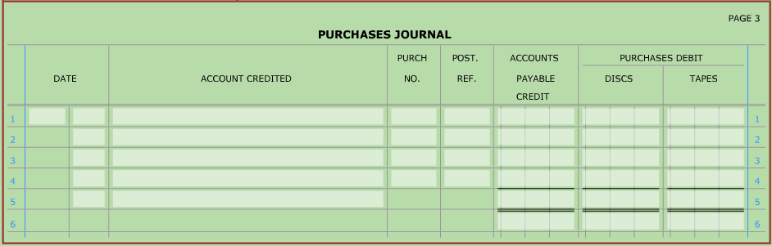
23 Purchased tapes on account from Castle Records and Tapes, $993. P286.

Journalizing Purchases Returns and Allowances
- debit memorandum –
- contra account –
Sample Problem, continued (Work Together 1.2)
City Music has two departments: Discs and Tapes. A general journal is provided. Journalize each transaction. Source document is abbreviated as follows: debit memorandum, DM.
March 5 Returned discs to Dade, Inc., $165, from P280. DM36.
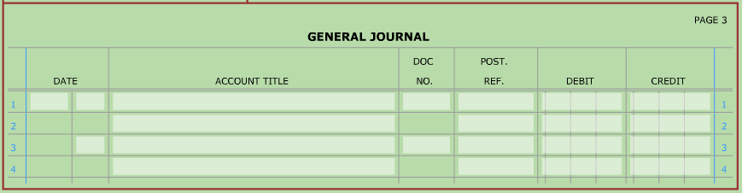
6 Received an allowance on tapes from Raymond Wholesalers, $100, from P283. DM37.

Posting from a Purchases Journal
- posting –
Sample Problem, continued (Work Together 1.2)
City Music has two departments: Discs and Tapes. A partial general ledger and accounts payable ledger are provided. The balances are recorded as of March 1 of the current year. Use the purchases journal and general journal from the previous page.
- Post the items that are to be posted individually from the purchases journal.
- Post from the general journal.
- Prove and rule the purchases journal. Post the totals.

General Ledger
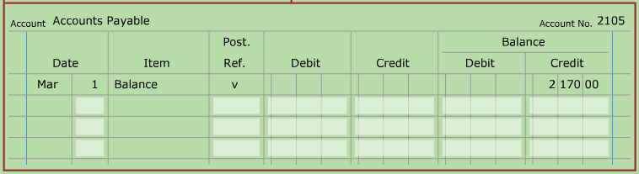
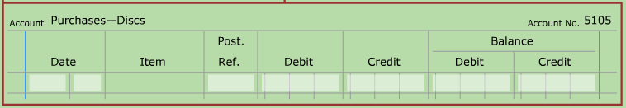
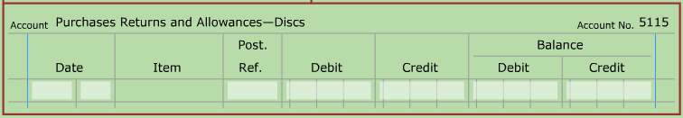
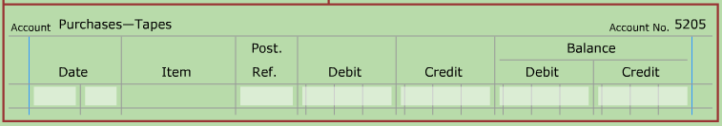
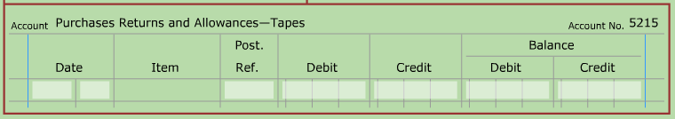

Accounts Payable Ledger
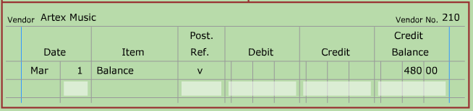
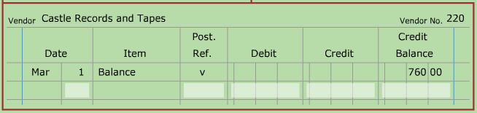
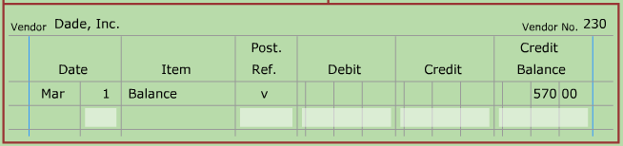
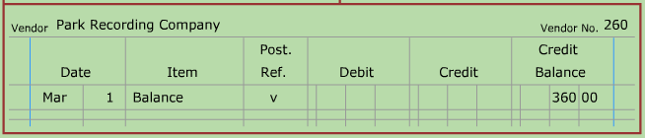
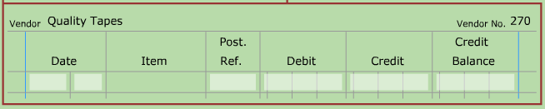
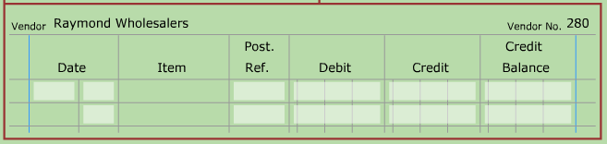

Section 1.3: Journalizing and Posting Cash Payments

Departmental Cash Payments
- cash discount –
- purchases discount –

Recording Entries in a Cash Payment Journal (pg. 21)
Sample Problem (Work Together 1.3 - modified)
Village Music Center has two departments: Guitars and Keyboards. Page 17 of a cash payments journal is provided. Source documents are as follows: check, C; debit memorandum, DM; and purchase invoice, P.
Sept. 5 Paid cash on account for guitars from Peninsula Guitar covering P358 for $1,150; no discount. C241.
7 Paid cash for administrative supplies, $120. C242.

Journalizing a Purchases Discount (pg. 19)
Sample Problem, continued (Work Together 1. 3 - modified)
Continue to use the cash payments journal started above.
Sept. 9 Paid cash on account for keyboards from Magic Keyboard covering P361 for $1,800, less 2% discount. C243.

Taking a Discount after a Purchase Return (pg. 20)
Sample Problem, continued (Work Together 1. 3 - modified)
Continue to use the cash payments journal started above.
Sept. 16 Paid cash on account for keyboards from Magic Keyboard covering P360 for $2,210, less DM53 for $210, and less 2% discount. C244. (use the calculation area below to help prepare this transaction)

Amount owed on invoice:
Purchase Invoice - Purchases Return = Purchase Invoice
Amount (P360) (DM53) Amount after Return
______________ - ______________ = ______________

Purchases discount:
Purchase Invoice x Purchases Discount = Purchases
Amount after Return Rate Discount
______________ x ______________ = ______________

Amount owed on invoice:
Purchase Invoice - Purchases = Total Amount
Amount after Return Discount Due
______________ - ______________ = ______________

Cash Payment to Replenish Petty Cash (pg. 22)
- petty cash –
Sample Problem, continued (Work Together 1. 3 - modified)
Continue to use the cash payments journal started above.
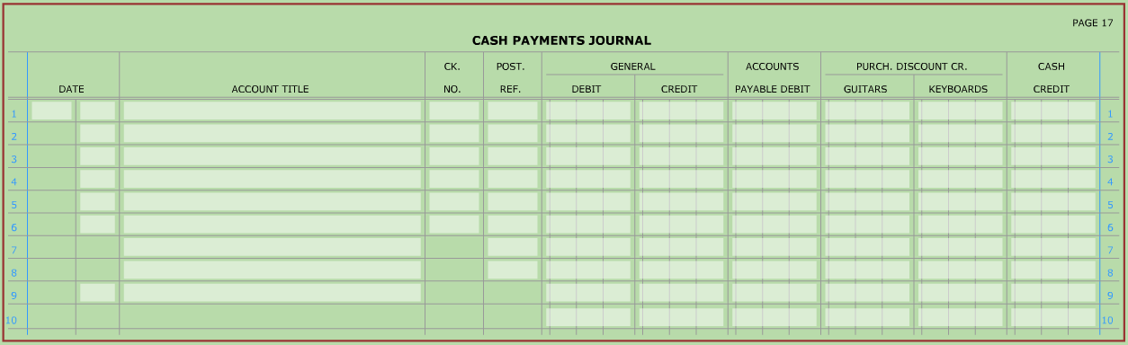
Sept. 30 Paid cash to replenish the petty cash fund, $64: administrative supplies, $15; advertising expense, $22, miscellaneous expense, $27. C245.

Posting from a Cash Payments Journal (pg. 23)
Continue to use the cash payments journal started above. A partial general ledger and an accounts payable ledger are provided.
- Post items that are to be posted individually.
- Prove and rule the cash payments journal. Post the totals.
General Ledger
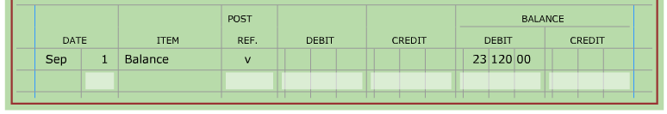
1105

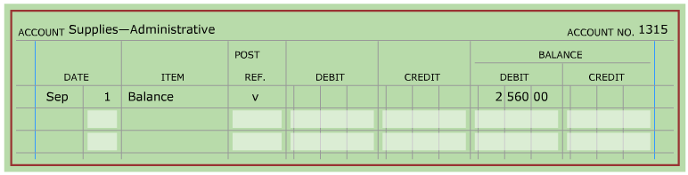

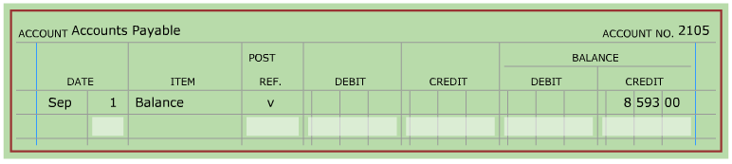
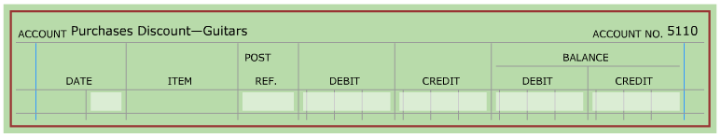
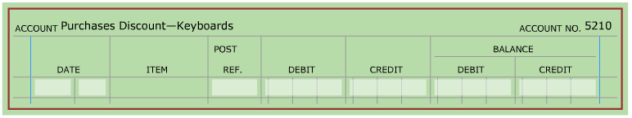
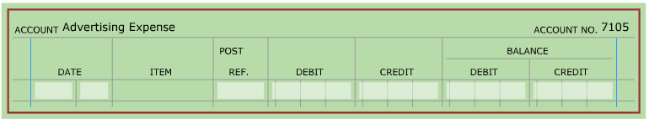
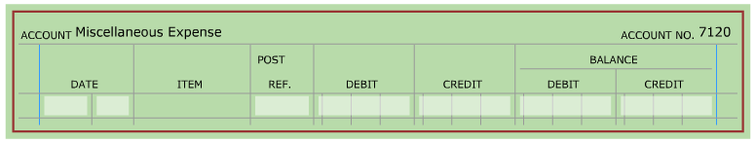

Accounts Payable Ledger
