Chapter 2 Crossword Puzzle Name: ________________________________
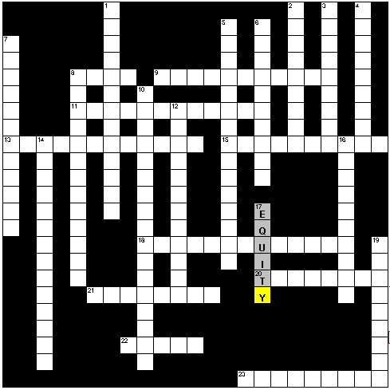

Across
8) a certificate of debt for an organization
9) the sales of durable and nondurable goods bought by consumers
11) the rate financial institutions are charged to borrow funds from the Federal Reserve banks
13) the output per person, calculated by dividing gross domestic product (GDP) by the total production
15) a number that compares prices in one year with some earlier base year
18) occurs when a government spends less than it takes in
20) what you make when you give something up to have something else (review from last chapter)
21) the one who sells on credit or makes a loan; the purchaser of a corporate or government bond
22) ownership in a corporation
23) a decrease in the general level of prices
Down
1) a movement of the economy from one condition to another and back again; it has four cycles including prosperity, recession, depression, and recovery
2) the yield on short-term (13-week) U.S. government debt obligations
3) the phase of the business cycle in which demand begins to decrease, businesses lower production, unemployment begins to rise, and GDP growth slows for two or more quarters of the calendar year
4) the rate businesses make available to their best business customers, such as large corporations
5) spending by businesses for items such as land, buildings, equipment, and new products
6) the peak of the business cycle, it is a period in which most people who want to work are working, businesses produce goods and services in record numbers, wages are good, and the rate of GDP growth increases
7) the amount individuals pay to borrow for the purchase of a new home
8) occurs when a government spends more than it takes in
10) the cost of borrowing for large U.S. corporations
12) the total amount owed by the federal government
14) salaries and wages as well as investment income and government payments to individuals
16) the phase of the business cycle that is marked by a prolonged period of high unemployment, weak consumer sales, and business failures
17) stock ownership
19) an increase in the general level of prices

