Name: ____________________________________

Chapter 2 Notes

Recording Departmental Sales and Cash Receipts

2.1 – Departmental Sales on Account and Sales Returns and Allowances

Departmental Sales on Account
- Realization of Revenue (summarize) -

Journalizing Sales on Account
Sample Problem (Work Together 2.1)
The sales journal for Manhattan Beach Swimwear is provided below. Manhattan Beach has two departments: Swimwear and Accessories. Journalize each of the following sales on account. The sales tax rate is 6%. Source document is abbreviated as follows: sales invoice, S.
Sept 1. Sold a bathing suit to Emily Branford for $40, plus sales tax. S12.
10. Sold three beach mats to Roger Minkow for $75, plus sales tax. S13.
14. Sold bathing suits to Oak Grove High School Swim Team for $310. No sales tax. S14.
18. Sold beach towel to Sara Nunez for $15, plus sales tax. S15.
24. Sold a beach umbrella to Emily Branford for $70, plus sales tax. S16.

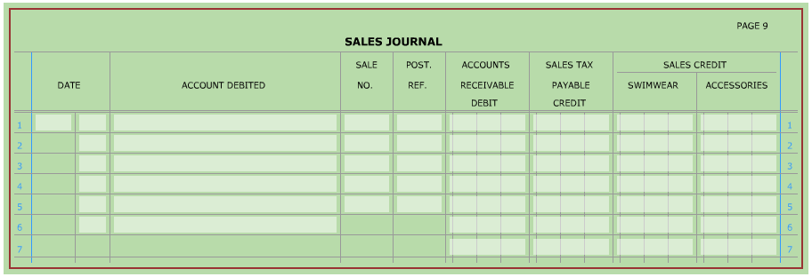

Journalizing Sales Returns and Allowances
- credit memorandum -

Sample Problem, continued (Work Together 2.1)
The general journal for Manhattan Beach Swimwear is provided below. Manhattan Beach has two departments: Swimwear and Accessories. Journalize each of the following sales returns and allowances. The sales tax rate is 6%. Source document is abbreviated as follows: credit memorandum, CM.
Sept 15. Granted credit to Roger Minkow for one beach mat returned, $25, plus sales tax from sales invoice S13. Issued CM23.
30. Granted credit to Sara Nunez as an allowance for a defective beach towel, $15, plus sales tax from sales invoice S15. Issued CM24.
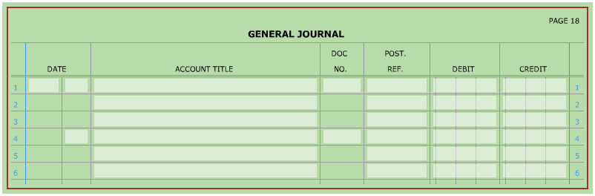

Posting from a Sales Journal and General Journal
Sample Problem, continued (Work Together 2.1)
The partial accounts receivable and general ledgers for Manhattan Beach Swimwear is provided below.
- Post the items that are to be posted individually from the sales journal.
- Post the items that are to be posted individually from the general journal.
- Prove and rule the sales journal. Post the totals to the general ledger.

General Ledger
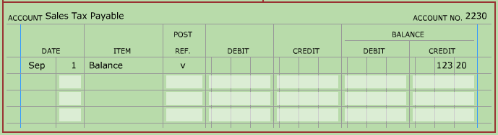
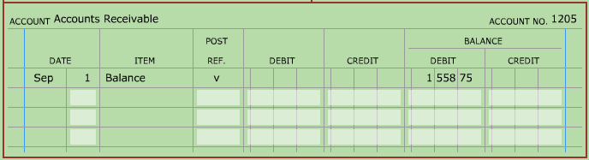

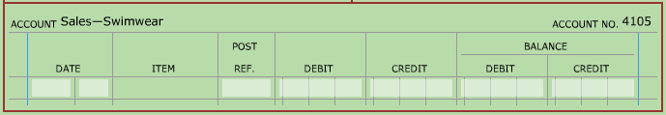
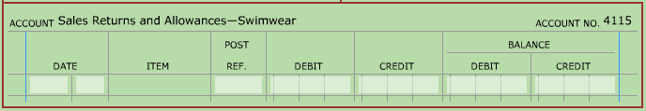
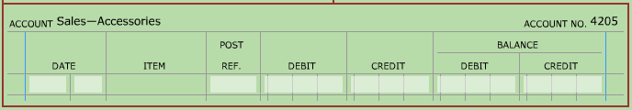
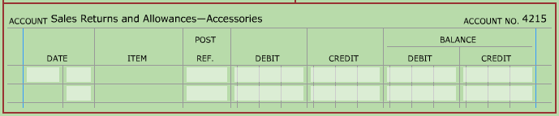

Accounts Receivable Ledger
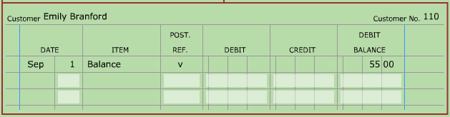
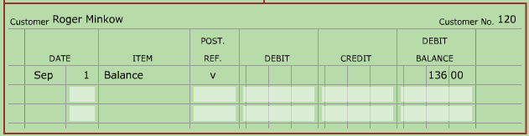
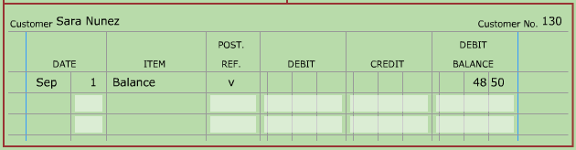
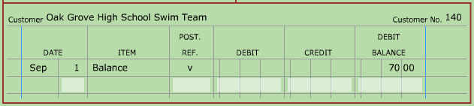

2.2 – Journalizing and Posting Cash Receipts

Departmental Cash Receipts

Journalizing a Cash Receipt with a Sales Discount
Sample Problem (Work Together 2.2)
The cash receipts journal for Norwalk Interiors is provided below. Norwalk Interiors has two departments, Furniture and Carpeting, and offers credit terms of 2/10, n/30. Journalize each of the following cash receipts transactions. The sales tax rate is 6%. Source document is abbreviated as follows: receipt, R.
Feb. 1. Received a check from Filo Raines for furniture purchased February 3 on S231 for $1,272, less discount. R343.
7. Received a check from Carlee Hanks for furniture purchased on February 12 on S232 for $848, less discount. R344.

Journalizing a cash receipt with a sales return and sales discount
- Sales Discount -
Sample Problem, continued (Work Together 2.2)
Continue to use the Cash Receipts Journal started above.
Feb. 12. Received cash on account from Melinda Ashworth, $2,908.64 for five area carpets, purchased on January 25 on S230 for $3,180.00, less CM29 ($200.00 plus sales tax), less discount. R345.
Sales return:
Sales Return x 1.06 = Total Sales
Amount (CM29) (for 6% Sales Tax) Return Amount
______________ x ______________ = ______________

Sales invoice after return:
Sales Invoice - Sales Return = Sales Invoice Amount
Amount (S230) Amount after Return
______________ - ______________ = ______________

Sales Discount:
Sales Invoice x 2% = Sales Discount
Amount after Return (Sales Discount) Amount
______________ x ______________ = ______________

Amount owed on invoice:
Sales Invoice - Sales Discount = Amount Owed
Amount after Return Amount on Invoice
______________ - ______________ = ______________

Journalizing Cash and Credit card sales
Sample Problem, continued (Work Together 2.2)
Continue to use the Cash Receipts Journal started above. The sales tax rate is 6%. Source document is abbreviated as follows: terminal summary, TS.
Feb. 14. Recorded cash and credit card sales for the week: carpeting, $3,074; furniture, $3,286; plus sales tax. TS81.
19. Recorded cash and credit card sales for the week: carpeting, $2,112; furniture, $2,862; plus sales tax. TS82.
21. Recorded cash and credit card sales for the week: carpeting, $2,851; furniture, $4,103; plus sales tax. TS83.
28. Recorded cash and credit card sales for the week: carpeting, $2,967; furniture, $2,803; plus sales tax. TS84.

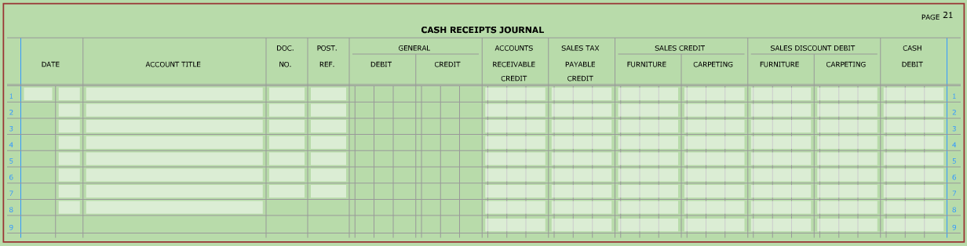

Posting from a cash receipts journal
Sample Problem, continued (Work Together 2.2)
Continue to use the Cash Receipts Journal started above. The partial accounts receivable ledger, and partial general ledger for Norwalk Interiors are provided below. The sales tax rate is 6%. Source document is abbreviated as follows: terminal summary, TS.
- Post the items that are to be posted individually.
- Prove and rule the cash receipts journal. Post the totals to the general ledger.

General Ledger
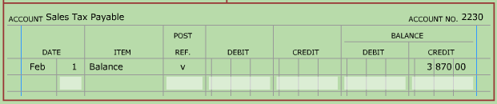
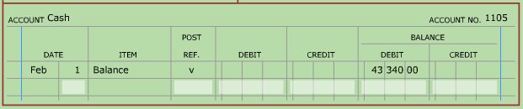
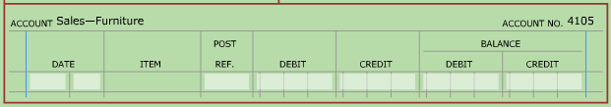
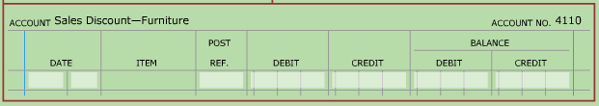
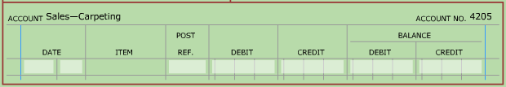
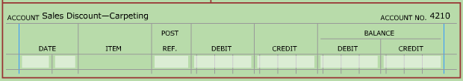

Accounts Receivable Ledger
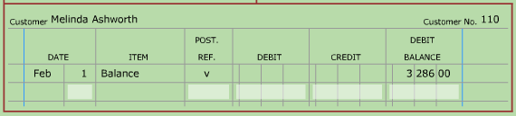
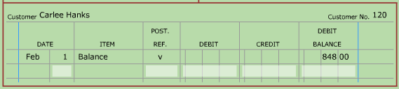
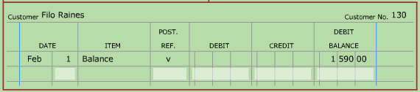

Order of Posting from Journals
The order to post journals is listed as follows:
- ______________________________________________
- ______________________________________________
- ______________________________________________
- ______________________________________________
- ______________________________________________
This posting order generally places they debits and credits in the accounts in the order that the transactions occurred.

