Name: ______________________________

Chapter 3 Notes

3.1: Payroll Records for Employee Earnings & Deductions
- Salary -
- Federal, ________________, and _______________ laws require employers to keep accurate records of the money paid to _________________________ and of other __________________ related to employee services.
- Pay Period -
- Payroll -
- Payroll Taxes -
- Periodically, employers must ___________ government agencies all payroll ______________ withheld from employee ___________________ as well as the _____________________ payroll taxes.
- Form W-2 -

  - Must be distributed to employees by __________________________.

Payroll Deductions
- FICA (F________________ I________________ C__________________ A______) Taxes
  - __________________ _________________ Tax
    - Finances

    - Calculated on employee earnings up to a ____________________ paid in a ____________________ year.
      - Tax Base -

      - The social security tax rate and base used in this textbook are _____% of earnings up to a maximum of $_______________ in each calendar year.
  - ____________________ Tax
    - Finances
    - Medicare does not have a tax _____________.
    - The Medicare tax rate used in this textbook is _____% of total employee earnings.
- Federal Income Tax
  - Determined by

  - Withholding Allowance -

- Some businesses also make deductions from employee earnings for health _________________, ____________ insurance, __________________ plans, and savings _____________________.

Calculating Employee Earnings
- Hourly Employees:
  - In this textbook, employees usually work only a ___________-day week of _______ hours. Therefore, a biweekly pay period is _______ hours.
  - All time worked in excess of 40 hours in any one week is considered __________________. Employees are paid _________ times the regular rate for overtime hours.
  - Employee regular earnings are calculated by multiplying the hourly ___________ by the number of regular ______________.
- Commissions Records:
  - An employee’s basic salary may be supplemented by other types of earnings like: _____________________, cost-of-living ___________________, a share of __________, or a bonus.
  - In this textbook, department supervisors are paid a regular biweekly _______________. They are not paid for __________________ hours. To encourage increased sales, they are paid a ____% commission on the department’s monthly net ______________.

Sample Problem (WT 3.1-Part One)
  - Prepare a commissions record for Allison Cavero, Supervisor of the Hardware Department, for June of the current year. Ms. Cavero, Employee No. 2, is paid a biweekly salary of $1,200 and receives a monthly commission of 1% of net sales. Commissions for the previous month are paid in the first pay period the current month. Accounting records for the Hardware Department for the month ended June 30 of the current year are as follows: sales on account, $17,895; cash and credit card sales, $15,523; sales discount, $179; sales returns and allowances, $2,039.
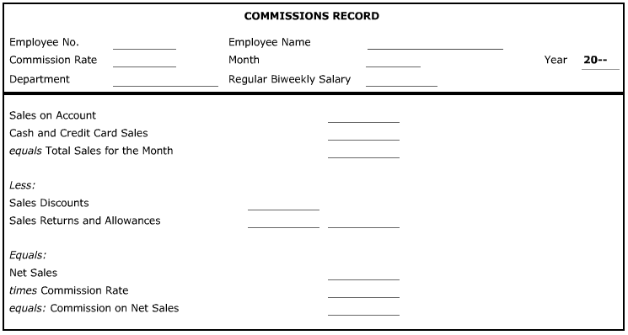

Preparing a Payroll Register
- Payroll Register -

Sample Problem (WT 3.1-Part Two)
Santa Clara Hardware’s partial payroll register for the pay period ended July 3, 20—is provided below. Use the appropriate withholding tax tables shown in the pages that follow to determine the federal income tax. Deductions for all employees are 5% of total earnings for state income tax, 6.2% for social security tax, and 1.45% for Medicare tax. Use H to indicate health insurance and L to indicate life insurance. Save this work to complete WT 3.2.
Prepare the payroll register entries for the following two employees (*Note: On the payroll register, write the last name of the employee before the first name):
- On line 1: Allison Cavero, Employee No. 2, Hardware Department supervisor, married, two allowances, regular salary of $1,200 per pay period plus 1% of net sales. Use the commission calculated in WT 3.1-Part One. Health insurance premium is $56 and life insurance premium is $25.60.
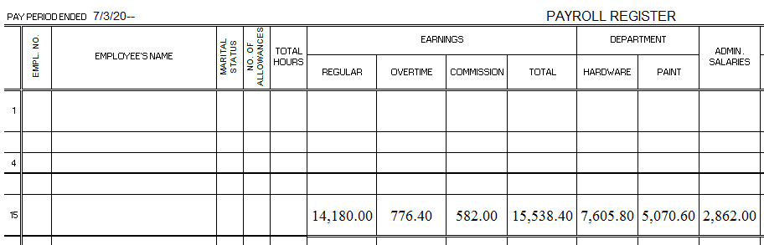
- On line 4: James Lee, Employee No. 4, Hardware Department salesclerk, single, one allowance, regular salary of $10 per hour with overtime paid at 1 ½ times the regular rate. He worked 80 hours regular time and 8 hours overtime. Health insurance premium is $28.

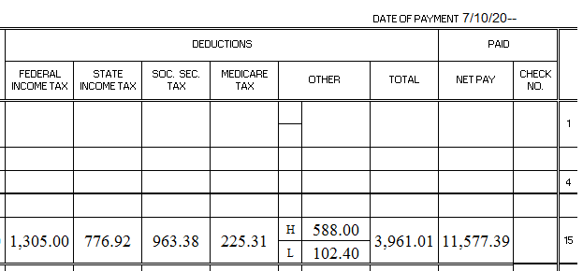

Preparing an Employee Earnings Record
- A business must send a ____________________ report to federal and state governments showing employee ________________ earnings and taxes _________________ from employee earnings.
- Employee Earnings Record -

  - A new earnings record is prepared for each employee each ____________________.
  - ________________________ earnings are often referred to as year-to-date earnings. These are needed for each employee because certain payroll _______________ do not apply after an employee’s earnings reach a certain ________ ________________.

Sample Problem (WT 3.1-Part Three)
A blank earnings record form for Santa Clara Hardware is provided below. Save this work to complete WT 3.2.
- Prepare James Lee’s earnings record for the first pay period of the quarter ended September 30, 20--. Accumulated earnings for the quarter ended June 30, 20—are $11,900.
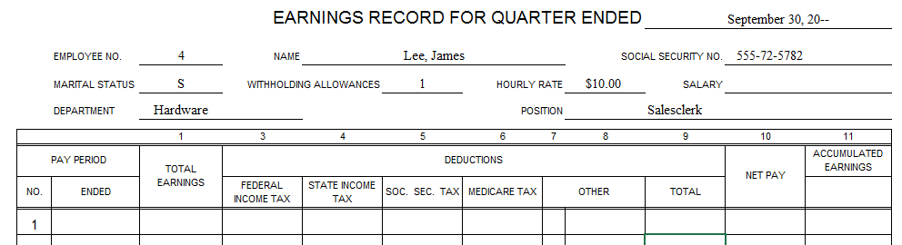

3.2: recording a payroll and payroll taxes

Payroll Bank Account
- In this textbook, employees are paid biweekly by _____________________.
- A special payroll ____________________ account and special payroll _________________ are used. After a biweekly payroll register has been completed, a check is written on a business’s __________________ checking account payable to Payroll for the total _________ __________.

Automatic Check Deposit
- Automatic Check Deposit -

- Electronic Funds Transfer (EFT) -

Journalizing Payment of a Payroll

Sample Problem (WT 3.2-Part One)
Use the solution from WT 3.1. A cash payments journal, page 15, is provided below.
- Journalize the following transaction for July of the current year.
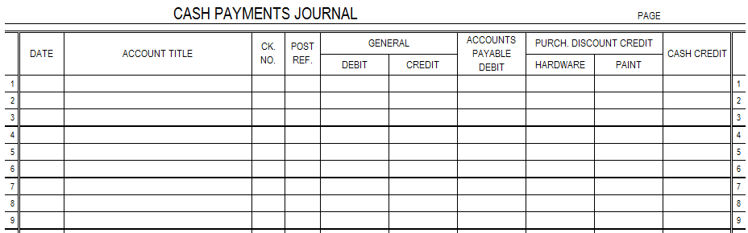
July 10 Paid July 3 Payroll. Check No. 260.

Employer Payroll Taxes
- Most employers have four separate payroll taxes:
- _____________________ Social Security Tax
- ___________________ Tax
- Federal ______________________________ Tax
- __________________ Unemployment Tax

Calculating Employer Payroll Taxes
- Employer payroll taxes expense is based on a percentage of employee ____________________.
- Employer social security tax (_______%) and Medicare tax (________%) rates are the same as the rates used for employees. The __________________ unemployment tax is 0.8% of the first $_____________ earned by each employee. State unemployment tax is ________% of the first $_____________ in earnings.

Sample Problem (WT 3.2-Part Two)
- Use the grid below to calculate departmental payroll taxes. There are two taxable earnings columns, one for FICA Taxable Earnings and one for Unemployment Taxable earnings, since the bases for these two classes of salaries are different for this period. Social security and Medicare taxes are due on total earnings for this period. Unemployment taxes are due on total earnings for this period. Unemployment taxes are due on the following earnings for this period: Hardware, $2,132; Paint, $1,983; and Administrative, $985.
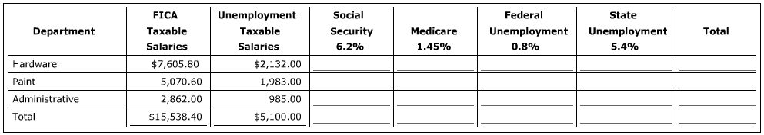

journalizing Employer Payroll Taxes
- At the time the payment of payroll is recorded, employer payroll taxes for that pay period will also be recorded in the ____________________ journal.

Sample Problem (WT 3.2-Part Three)
Use the solution from WT 3.2-Part Two. A general journal, page 7, is provided below.
- Journalize the following transaction for July of the current year.
July 10 Recorded employer’s payroll taxes for the pay period ended July 3. Memo. No. 33.
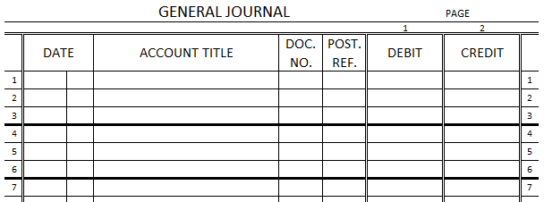
*Note: A small rounding difference exists between the total Medicare tax amount in the Payroll Register (WT 3.1) and the allocation of that tax to the departments in the schedule of departmental payroll taxes (WT 3.1-Part Two). Such differences are normal when total amounts are allocated to departments. Journalize the Cash Payments Journal entry using the appropriate amounts from the payroll register, and journalize the General Journal entry using the schedule of departmental payroll taxes.

journalizing the payment of payroll taxes
- The frequency of the payments of payroll taxes is determined by the ______________ owed.
  - In this textbook, a business will be a monthly depositor for employee’s federal income taxes and employee/employer social security and Medicare taxes. Taxes must be paid by the 15th day of the month following the pay period.
  - For federal and state unemployment taxes, a business will make payments quarterly. Payments must be made by the last day of the month following the end of the quarter.

Sample Problem (WT 3.2-Part Four)
Use the solution from WT 3.2-Part Two. The continuation of the cash payments journal, page 15, is provided below.
- Journalize the following transaction for July of the current year.
July 15 Paid employees’ federal income tax withholding, social security tax, and Medicare tax liabilities for the pay period ended July 3. Check No. 265.
29 Paid federal unemployment tax, $745.84, and state unemployment tax, $5,034.44, for the quarter ended June 30. Check No. 270.

