Name: ______________________________
Chapter 4 Notes
4.1: Responsibility Accounting for a Merchandising Business
- __________________________ Statements summarize the financial information that a business records.
  - used in preparing _________ reports, others such as those required by the ____________
  - prepared at least _________ a year
- Fiscal Period -
Features of a Responsibility Accounting System
- Responsibility Accounting -
  - Two Features:
    - Each manager is assigned responsibility for only those revenues, costs, and expenses for which the ______________________ can make ________________________ and affect the _______________________.
    - The revenues, costs, and expenses for which a manager is responsible must be readily identifiable with the manager’s ____________. For example, if a manager is responsible for advertising expense, that manager should make decisions about _________________. Also a separate record should be kept for the manager’s advertising expense. Thus, responsibility accounting traces revenues, costs, and expenses to the individual managers who are __________________ for making decisions about those revenues, costs and expenses.
  - Merchandising businesses often prepare ______________________ statements to show each department’s contribution to _______________________________.
  - Direct Expense -
  - Indirect Expense -
  - Departmental Margin -
  - Departmental Margin Statement -
  - A business will group its departmental accounts by _______________. For example, accounts under Direct Expenses – Audio are 6100 numbers and under Direct Expenses – Video are __________ numbers.

Sample Problem: Recording a Direct Expense
April 1. Paid cash for advertising of audio merchandise, $400.00 Check No. 610.
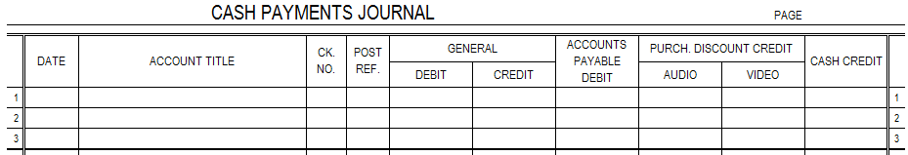
Sample Problem: Recording an Indirect Expense
April 1. Paid cash for rent, $1,500.00 Check No. 611.

Sample Problem: Identifying Direct and Indirect Expenses
Mulberry, Inc. has two departments: Crafts and Fabrics. Mulberry completed the transactions below. Fill out the table below. For each transaction, indicate: (1) Whether the expense is a direct expense (identifiable with a specific department) or an indirect expense and (2) the title of the expense account.
Transaction | Direct Expense or Indirect Expense | Expense Account Title
Paid cash for utilities bill.
Paid cash for advertising in a craft fair program. The ad was prepared by the Craft Department and includes craft products only.
Paid cash for rush delivery (delivery expense) on a special order of fabric for a regular customer.
Paid cash for bimonthly payroll for all administrative, fabric, and crafts employees. Salesclerks are hired by specific department managers.
Paid cash for maintenance on the company’s website.
Paid a consultant to train all salesclerks in effective selling techniques.
Paid a retainer fee to an attorney for legal advice.
Paid cash for monthly payroll taxes (consider the taxes on the accounting employees only).
Paid cash for a promotional mailing to past customers to announce a new line of craft supplies.
Paid cash for food and beverages for the annual employee party.

4.2: Interim Departmental Statement of Gross Profit
Interim Financial Statements
- A departmentalized business prepares financial statements in the same form as a nondepartmentalized business. In addition, they usually prepare reports about the performance of each _________________.
- Gross Profit -
  - shows the relationship between sales and sales _____________ and ____________________ inventory and the _____________ of merchandise inventory
  - can determine amount of ___________________ remaining after the cost of _______________ has been deducted from net _______________
- Departmental Statement of Gross Profit -
  - May show a need to:
    - Change merchandise selling ________________.
    - Change ________________ of merchandise.
    - Add, delete, or change ______________________.
    - ______________________ a department.
- A successful business does not wait a full _______________ to analyze its gross profit and take action to reverse _________________ trends. Therefore, businesses often prepare an _____________ department statement of gross profit at the end of a month or quarter. (interim means
)
Determining Ending Merchandise Inventory
- Two principal methods are used to determine the actual amounts of merchandise on hand.
- Periodic Inventory -
- Perpetual Inventory -
- When a perpetual inventory is not kept and a monthly periodic inventory is not practical, a business may estimate merchandise inventory:
  - Gross Profit Method of Estimating an Inventory -

Sample Problem: Identifying Direct and Indirect Expenses
The following data are obtained from the accounting records of Willow Glen Interior Design on May 31 of the current year. Estimated merchandise inventory forms are on the next page.
 | Kitchen | Bath
Beginning Inventory, January 1 | $110,000.00 | $84,000.00
Estimated Beginning Inventory, May 1 | 111,426.00 | 87,072.00
Net Purchases, January 1 to April 30 | 42,500.00 | 30,100.00
Net Sales, January 1 to April 30 | 78,600.00 | 52,300.00
Net Purchases for May | 8,300.00 | 5,400.00
Net Sales for May | 20,200.00 | 8,400.00
Estimated Gross Profit Percentage | 48.0% | 45.0%
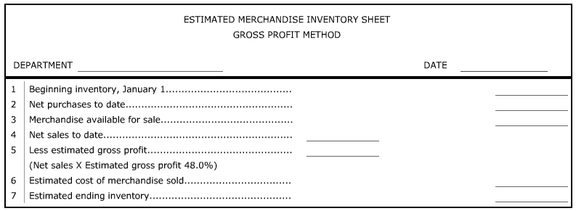
- Prepare an estimated merchandise inventory sheet for each department for the month ended May 31.

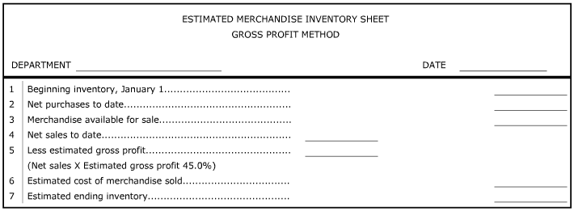
Sample Problem: Identifying Direct and Indirect Expenses
Use the estimated merchandise inventory sheets from above. The statement paper is on the next page.
- Prepare an interim departmental statement of gross profit for the month ended May 31. Calculate and record component percentages (see next page for notes on component percentages) for cost of merchandise sold and gross profit on operations. Round percentage calculations to the nearest 0.1%.

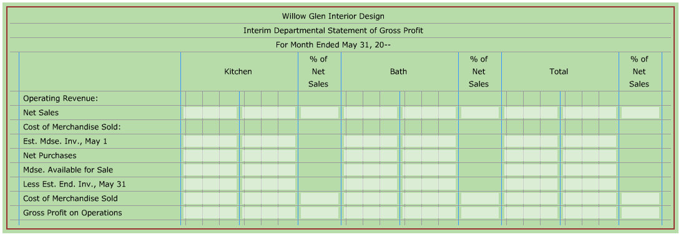
Analyzing an Interim Departmental Statement of Gross Profit
- Component Percentage -
  - Four basic components in every sales dollar:
- Cost of ________________________ Sold
- Gross ________________ on Operations
- Total Operating _______________________
- Net ___________________ Before Federal Income Tax
  - Each month, the component percentage for _______________ of merchandise sold and _______________ profit on operations is analyzed.
  - Component percentages for operating __________________ and net __________________ are analyzed at the end of each fiscal period.
  - To calculate a component percentage, divide the component by Net Sales.
  - Example:
Net Sales $69,429.95
Cost of Merchandise Sold 42,186.47
Gross Profit on Operations 27,243.48
- The cost of merchandise sold percentage: 42,186.47 ÷ 69,429.95 = .6076 or 60.8%
- The gross profit margin percentage: 27,243.48 ÷ 69,429.95 = .3924 or 39.2%

Determining Acceptable Levels of Performance
- Two sources are frequently used to determine acceptable performance:
- business’s historical _______________
- ________________ performance standards

4.3: Preparing a Work Sheet for a Departmentalized Business
Proving the Accuracy of Posting to Subsidiary Ledgers
- Schedule of Accounts Receivable -
  - The total of a schedule of accounts receivable must equal the balance of the general ledger _____________________ account, ____________________________________.
- Schedule of Accounts Payable -
  - The total of a schedule of accounts payable must equal the balance of the general ledger _____________________ account, ____________________________________.

Expanded Work Sheet
- Work Sheet -
  - The work sheet for a departmentalized business has ____________ additional columns, making it a 12-column work sheet, rather than the standard 8-column work sheet.

- Trial Balance on a Departmental Work Sheet
  - Trial Balance -
  - Notice, there are three income summary accounts. Two are used for adjusting ______________ accounts related to separate departments. The other is used for other ______________ entries.
  - Also notice that Federal Income Tax Expense is written _______ lines below Departmental Margin. This simplifies _____________________ the income statement columns and calculating additional _________________________ expense.
- Adjustments on a Work Sheet with Departmental Margins
  - Some general ledger accounts are not up to date. The entries needed to bring accounts up to date are planned in the ________________________ columns of the work sheet.
  - Adjustments are made for:
    - uncollectible accounts __________________
    - changes in departmental ____________________ inventory
    - ____________________ used
    - insurance _____________________
    - depreciation
    - estimated federal _____________________________ expense
  - For information on how each adjustment is calculated, see pages 104-107.
  - Adjustment related vocab:
    - Plant Assets -
    - Depreciation Expense -

Departmental and Company Loss on a Work Sheet
- If a department’s Departmental Margin Statements Debit column total is _______________ than the Credit column total, the difference represents a ________________________ operating loss. This occurs when the total of a departments cost of ________________________ sold plus _________________ expenses exceeds its net sales.
  - The net loss is written in the appropriate Departmental Margin Statements Credit column and the Income Statement Debit column.
- If the Income Statement _________________ column total is larger than the ________________ column total, the difference represents a ________________ net loss. The difference represents a __________________ in stockholders’ equity resulting from a net loss.
  - The net loss is written in the Income Statement Credit and Balance Sheet Debit columns.

Sample Problem: Preparing a Work Sheet with Departmental Margins
Callostay Co. has two departments: Books and Music. The trial balance and adjustment information for Callostay are provided. The work sheet is on the pages that follow.
- Record the adjustments on the work sheet and total the adjustments columns. The adjustment information below is used to complete the work sheet.
Uncollectible Accounts Expense, $130,200.00
estimated at 2.5% of sales on account
Merchandise Inventory – Books 85,200.80
Merchandise Inventory – Music 129,903.20
Supplies Used – Books 824.00
Supplies Used – Music 697.00
Supplies Used – Administrative 2,922.00
Insurance Expired 2,700.00
Depreciation Expense – Office Equipment 2,400.00
Depreciation Expense – Store Equipment, Books 3,450.00
Depreciation Expense – Store Equipment, Music 3,780.00
Federal Income Tax for the Year 10,316.18
- Extend amounts to the proper debit and credit columns for the Departmental Margin Statements columns. Accounts on the trial balance lines 56-65 are classified as indirect expenses. Total and rule the work sheet.

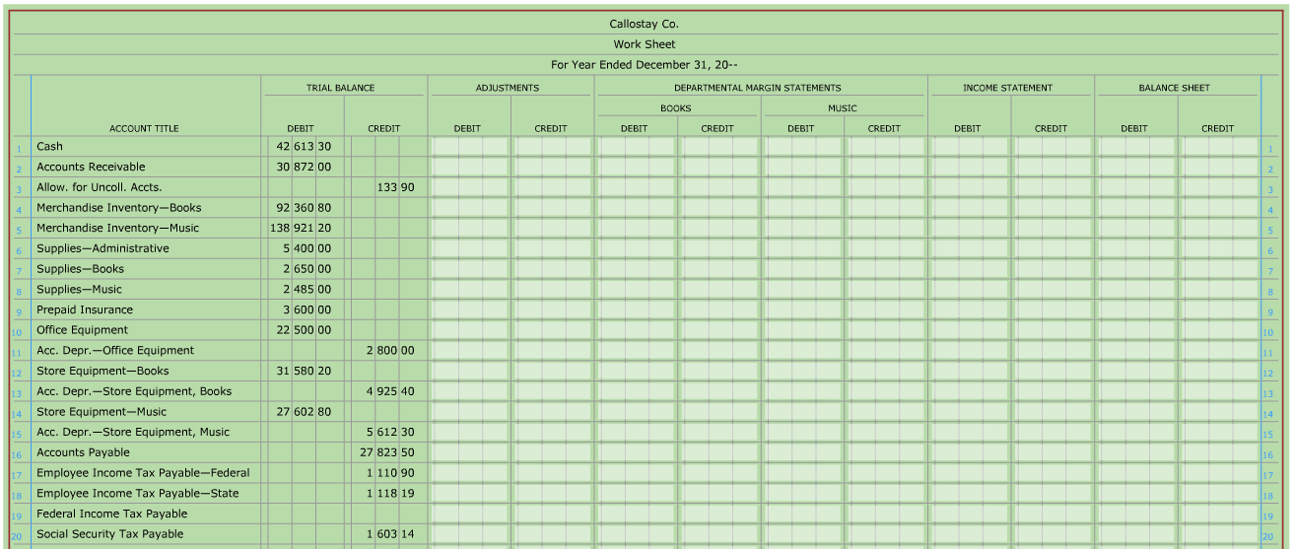

4.4: Responsibility Statements for a Merchandising Business
Departmental Margin Statement
- Responsibility Statements -
  - The departmental margin statements are the responsibility statements. These are similar to the income statement, but only _________________ expenses for that department are included.
Sample Problem: Preparing Financial Statements
Use the work sheet from the previous section.
- Prepare departmental margin statements for the Books Department and the Music Department. Calculate and record the component percentages for each item on the statements. Round the percentage calculations to the nearest 0.1%.
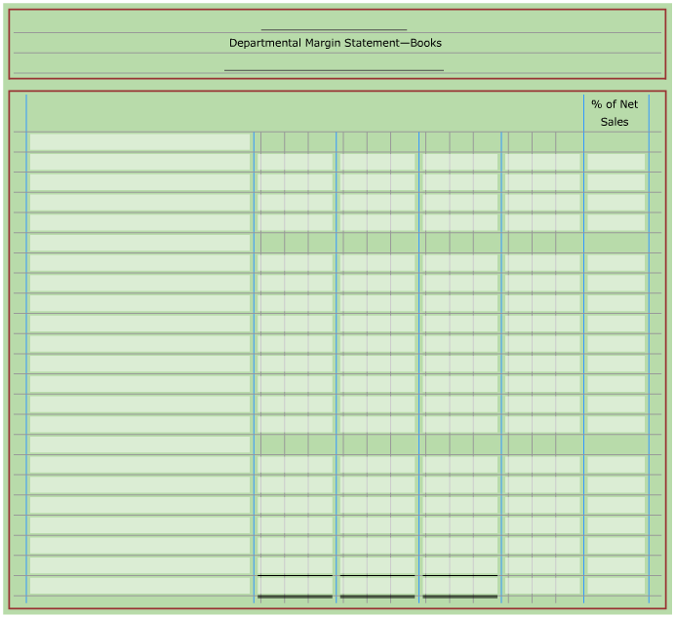

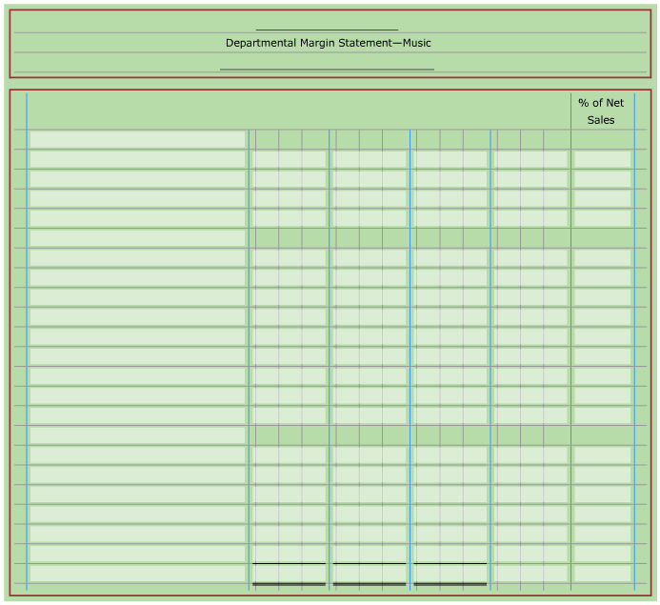

Income Statement with Departmental Margin
- Income Statement -
  - There are five columns: two for ________________________ accounts and three for company amounts and ___________________________________________.

Sample Problem: Preparing Financial Statements, continued
Use the work sheet from the previous section.
- Prepare an income statement. Calculate and record the component percentages for each item on this statement. Round percentage calculations to the nearest 0.1%.

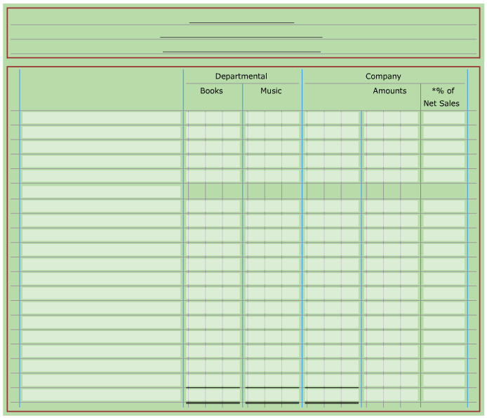

Statement of Stockholders’ Equity
- Statement of Stockholders’ Equity -
  - Two major sections:
- Capital Stock -
- Retained Earnings -
  - Dividends -

Sample Problem: Preparing Financial Statements, continued
Use the work sheet from the previous section.
- Prepare a statement of stockholders’ equity. There are 2,000 shares of stock issued for $100.00 per share and none issued during the current year.

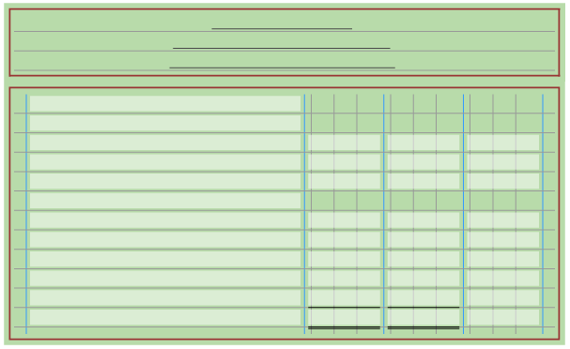

Balance Sheet
- Balance Sheet -

Sample Problem: Preparing Financial Statements, continued
Use the work sheet from the previous section. The balance sheet form is on the next page.
- Prepare a balance sheet.
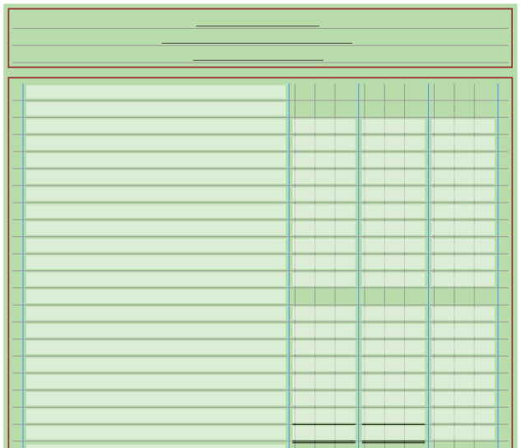
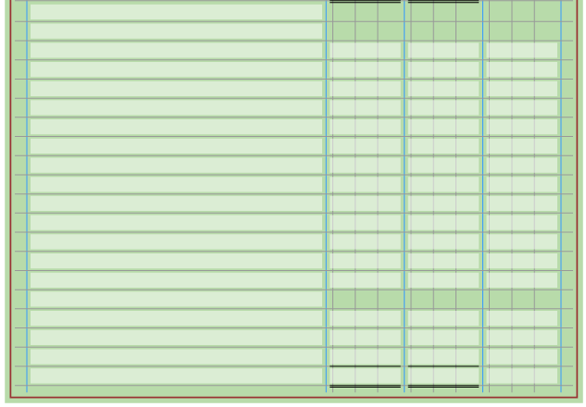
4.5: End-of-Period Work for a Departmentalized Business
Journalizing Adjusting Entries for a Departmentalized Business
- Adjusting Entries -
Sample Problem: Journalizing Adjusting and Closing Entries
Use the work sheet from section 4.3. Page 13 of a general journal is provided below.
- Using the information presented in the Adjustments columns of Callostay’s work sheet, journalize the adjusting entries on page 13 of a general journal.
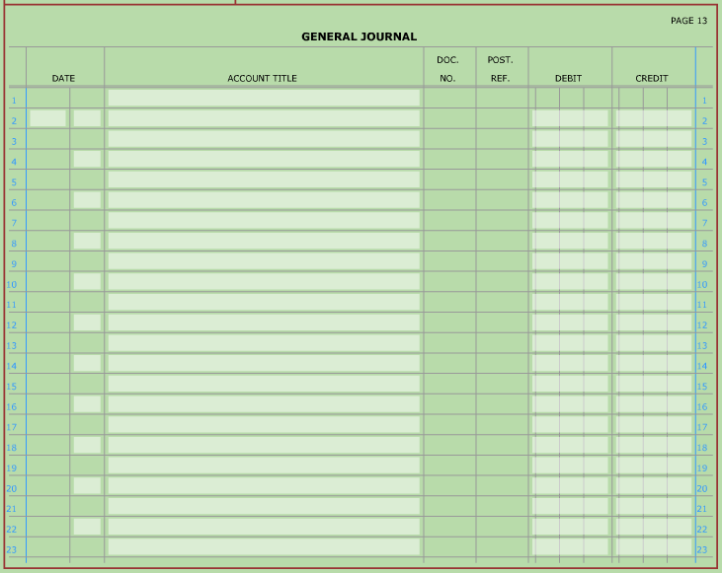

Journalizing Closing Entries for a Departmentalized Business
- Closing Entries -
  - There are four closing entries (for details on each of these entries, see pages 119-121):
- Closing entry for income statement accounts with ________________ balances (revenue and _______________ cost accounts).
- Closing entry for income statement accounts with ________________ balances (____________, contra ___________________, and ____________________ accounts).
- Closing entry to record net ________________ or net __________________ in the retained earnings account and to close the ___________________________ account.
- Closing entry for the _______________________ account.
Sample Problem: Journalizing Adjusting and Closing Entries, continued
Use the work sheet from section 4.3. Pages 14-15 of a general journal are provided below.
- Using Callostay’s work sheet, journalize the closing entries on pages 14 and 15 of a general journal.
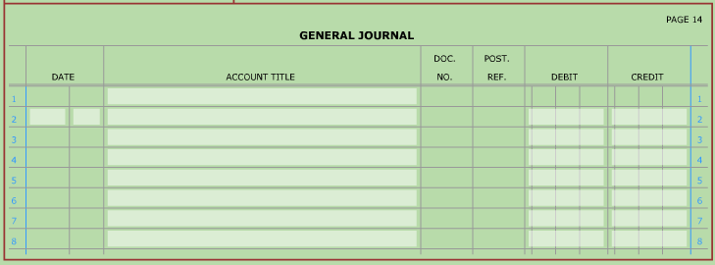

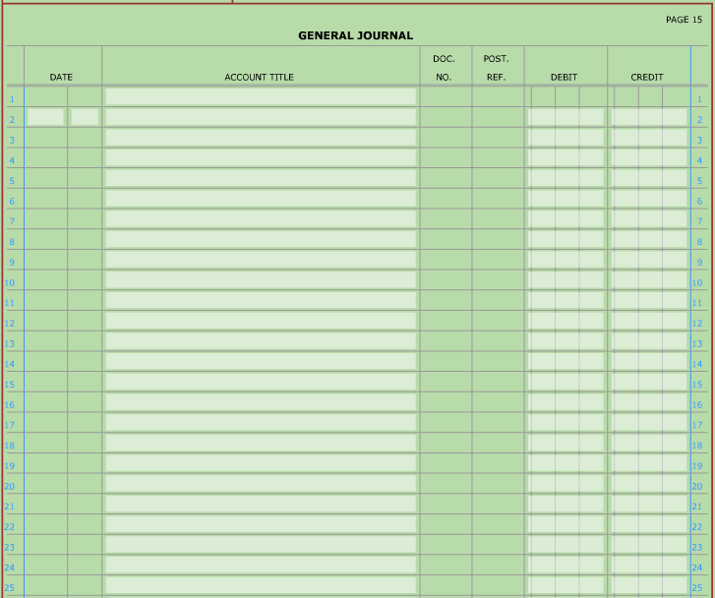

Post-Closing Trial Balance for a Departmentalized Business
- Post-Closing Trial Balance -
  - For an example of a Post-Closing Trial Balance, see page 122.

Summary of Accounting Cycle
- Accounting Cycle -
  - For a review of the specific steps in the accounting cycle, see page 123.

