Name: ___________________________

Chapter 4 Notes
Posting to a General Ledger

Section 4.1: Preparing a Chart of Accounts

Chart of Accounts –

Chart of Accounts

Balance Sheet Accounts
(_____) ASSETS
_____ Cash
_____ Petty Cash
_____ Accts. Rec.— Campus Internet Café
_____ Accts. Rec.— Oakdale School
_____ Supplies
_____ Prepaid Insurance

(_____) LIABILITIES
_____ Accts. Pay.—Supply Depot
_____ Accts. Pay.—Thomas Supply Company

(_____) OWNER’S EQUITY
_____ Kim Park, Capital
_____ Kim Park, Drawing
_____ Income Summary

Income Statement Accounts
(_____) REVENUE
_____ Sales

(_____) EXPENSES
_____ Advertising Expense
_____ Insurance Expense
_____ Miscellaneous Expense
_____ Rent Expense
_____ Supplies Expense
_____ Utilities Expense

Account Number –

F__________ M____________________ – procedure for arranging accounts in a general ledger, assigning account numbers, and keeping records current
- use _____’s for ledger divisions
- use _____’s for accounts
- use _____’s for new accounts
- larger businesses might use ____-digit account numbers
Ledger –

G_______________ L______________ – ledger that contains all accounts needed to prepare financial statements

Account Form –

B________________ - R____________ Account Form – has a debit and credit balance columns to keep an updated account balance

Opening an Account –

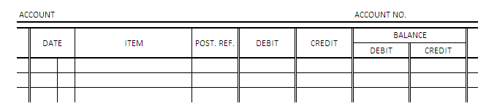

Section 4.2: Posting Separate Amounts from a Journal to a General Ledger
and
Section 4.3: Posting Column Totals from a Journal to a General Ledger

Posting –

- Two Rules of Posting
- Separate amounts in a journal’s _________________ amount columns are posted individually to the account written in the _________________________ column.
- Separate amounts in a journal’s ________________ amount columns are not posted individually.

- The Purpose of the Post Ref. Columns:
  - An entry in an account can be traced to its ___________________ in a journal.
  - An entry in a journal can be traced to where it was _____________________ in an account.
  - If posting is _____________________, the accounting personnel can easily see which entries in the journal still need to be ________________.

Practice!
A completed journal and general ledger accounts are given on the pages that follow. We will go through the following examples as a class.
Leonard Witkowski owns a service business that uses the following accounts.
Assets Owner’s Equity
110 Cash 310 Leonard Witkowski, Capital
120 Accounts Receivable – Danielle Braastad 320 Leonard Witkowski, Drawing
130 Supplies Revenue
140 Prepaid Insurance 410 Sales
Liabilities Expenses
210 Accounts Payable – Joshua’s Supplies 510 Rent Expense
- Section 4.2 Practice: Post the separate amounts (on each lines of the journal) that need to be posted individually.
- Section 4.3 Practice: Post the journal’s special amount column totals.

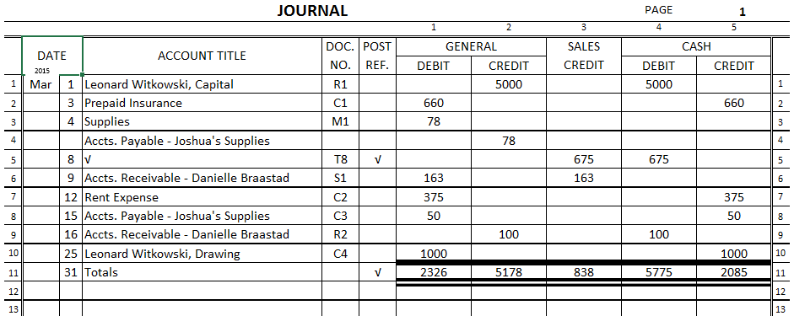

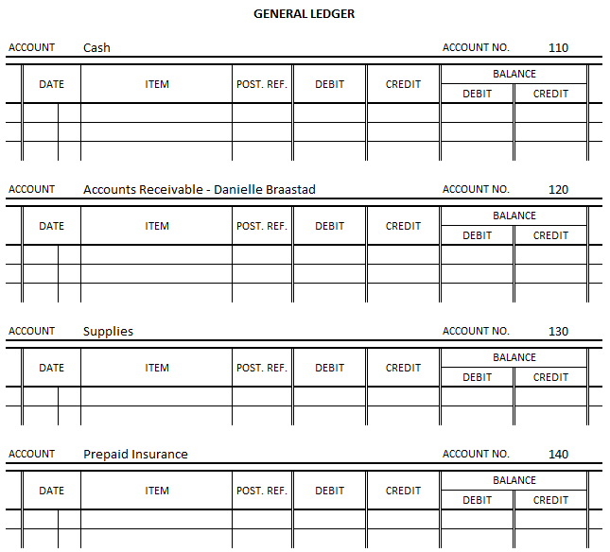

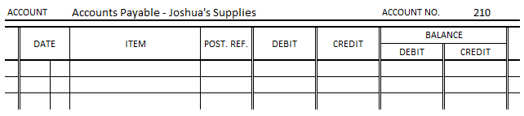

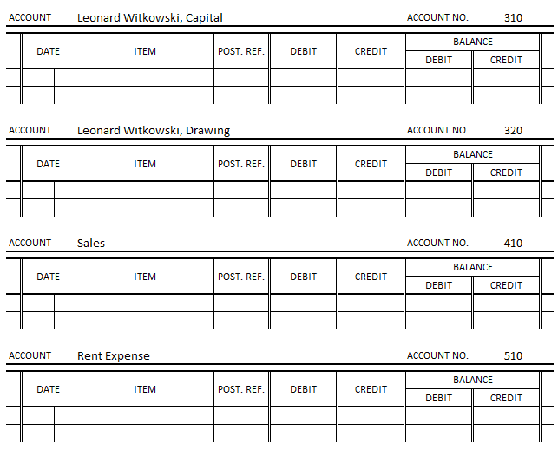

Section 4.4: Making Correcting Entries
Correcting Entries –

- If an accounting error is discovered, a _____________________ is prepared as the source document describing the correction to be made.

Practice!
A journal is given below. We will go through this example together.
- Journalize each correcting entry discovered during November of the current year. Use page 21 of the journal.
Nov. 1 Discovered that a transaction for supplies bought last month was journalized and posted in error as a debit to Prepaid Insurance instead of Supplies, $60. M15.
1 Discovered that a transaction for rent expense for last month was journalized and posted in error as a debit to Repair Expense instead of Rent Expense, $550. M16.
