Name: _________________________
Chapter 6 Notes
Inventory Planning and Valuation
6.1: The Nature of Merchandise Inventory
Flow of Inventory Costs
The cost of the merchandise available for sale consists of:
- The cost of the ____________________ merchandise inventory.
- The cost of the ________ _________________ added to the inventory during the fiscal period.

At the end of each fiscal period, the cost of merchandise available for sale is divided into:
- The cost of the ________________ merchandise inventory. This represents a _______________ asset that will be charged as costs in _________________ fiscal periods.
- The cost of the merchandise _____________ during the __________________ fiscal period. This cost materially affects the amount of ____________________ reported for the fiscal period.

_________________ Merchandise Inventory
_________________ Merchandise Inventory
Cost of Merchandise _____________
Cost of Merchandise Available for _________
Net
___________________

Effects of Errors in Costing an Inventory
- An accurate merchandise _________________ must be determined to adequately report the financial _____________________ and _____________________ of a merchandising business.
- The effects of an understated or overstated ending inventory is described on the chart on page 171 of your textbook.

Costing and Counting the Inventory
- ____________________ - items in the merchandise inventory of a merchandising business, includes:
- price paid to _______________ for the merchandise (less discounts, returns, and allowances)
- cost involved in ________________ the goods to the place of business and ready for sale (transportation, shipping, etc.)
- Two Methods for Determining Number of Goods in Inventory
- Taking a ___________________ count of the individual items in inventory.
- Keeping a _______________________ record for each merchandise item showing the number ________________ and the number ______________.

- Goods in Transit
  - For goods in transit at the time of a physical count of inventory, the business must determine who holds the ____________ to the goods.
  - When in transit and the title passes from the ___________________ to the _____________, the goods become part of the buyer’s ____________________ regardless of where they are physically located.
    - FOB Shipping Point = F___________________ O_____ B_______________ shipping point. This means that the _________________ pays the transportation charges and the title to the goods passes to the buyer as soon as the vendor ________________ the goods to a ______________________ business. The goods in transit, but not yet _________________ by the buyer are part of the _________________ inventory.
    - FOB Destination = Free on Board destination. This means the _____________ pays the transportation charges and the title to the goods passes to the buyer when the buyer __________________ the goods. The goods in transit, but not yet ___________________ by the buyer are part of the ________________ inventory.
- Goods on Consignment
  - Consignment -
  - Consignee -
  - Consignor -
  - The consignee agrees to ________________, _________________, and attempt to ___________ the consigned goods. If the goods are sold, the consignee deducts a ______________________ from the sale amount. The title to the goods does not pass to the ______________________. The goods on consignment are part of the _____________________ inventory.

Stock Record for a Perpetual Inventory System
- Perpetual Inventory -
  - This provides ___________________ records about the quantity of merchandise on ______________.
  - Stock Record -
  - Stock Ledger -
  - Purchase Order -
  - During the year, sales are recorded on the _________________________ when the sale is made. Purchases are record on the stock record when goods are _____________________.

Inventory Record Used for the Periodic Inventory
- Periodic Inventory -
  - Counting, weighing, or measuring merchandise on hand for a periodic inventory is commonly referred to as “___________________________”. For businesses with a large _______________ of merchandise on hand, this is _________________. Therefore, businesses usually only take a periodic inventory once each ______________________.
  - When only a periodic inventory is used, the ___________ quantity of a merchandise item can be __________________________. Therefore some businesses use a perpetual inventory and then complete a periodic inventory once each year to check the accuracy of the perpetual inventory.
  - Inventory Record -

Practice Problem
A stock record form and an inventory record form for Tower Television are provided below.
- Fill in the top portion of the stock record form with the following information: Description, 19” color television set; Stock No., K087; Reorder, 80; Minimum, 20; and Location, Bin 12.
- Record the following information.
Purchase Sales
Date Invoice No. Invoice No. Quantity Balance
Sept. 1 62
Sept. 12 475 40
Sept. 16 508 8
Sept. 17 183 80
Sept. 20 653 15
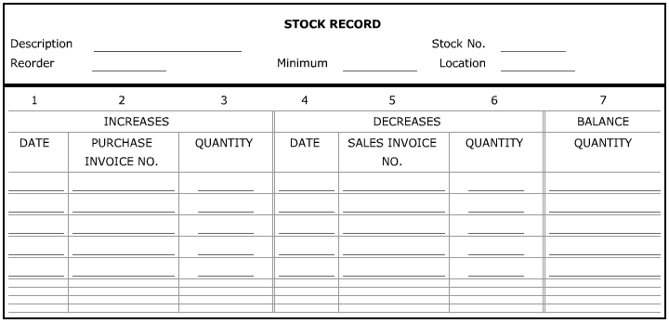

6.2: Inventory Costing
First-In, First-Out Inventory Costing Method
- First-In, First-Out Inventory Costing Method (aka FIFO) -
  - Assumes that the merchandise purchased _______________ (first in) is the merchandise sold _______________ (first out). Thus, FIFO uses the most ____________ purchase prices to determine the cost of merchandise inventory __________________.

Last-In, First-Out Inventory Costing Method
- Last-In, First-Out Inventory Costing Method (aka LIFO) -
  - Assumes that the merchandise purchased _______________ (last in) is the merchandise sold _______________ (first out). Thus, FIFO uses the _______________ purchase prices to determine the cost of merchandise inventory __________________.

Weighted-Average Inventory Costing Method
- Weighted-Average Inventory Costing Method -
  - Assumes that the cost is an __________________ of the price paid for similar items purchased during the fiscal period. The total cost is divided by the total units _____________________ to calculate the weighted-average cost per ____________.

Costing Inventory During Periods of Increasing Prices
- The cost of ending inventory affects the cost of merchandise _______________ amount on the income statement. Therefore, if prices are rising, the three methods of costing inventory have different results on the reported net income:
If prices are rising: FIFO LIFO Weighted-Average
Ending inventory valuation Highest ____________ Always falls
Cost of merchandise sold Lowest ____________ between
Reported net income Highest ____________ FIFO and LIFO

Costing Inventory During Periods of Decreasing Prices
- In a period of decreasing prices, the three methods of costing inventory have the following effects on the report net income:
If prices are decreasing: FIFO LIFO Weighted-Average
Ending inventory valuation Lowest ____________ Always falls
Cost of merchandise sold Highest ____________ between
Reported net income Lowest ____________ FIFO and LIFO

Results of the Three Inventory Costing Methods Compared
- The weighted-average method usually results in a total cost _________________ the FIFO and LIFO total costs. This results in more __________________ reporting of merchandise inventory costs.
- Each business selects the method of costing merchandise inventory that bits fits its _________________ and _______________. A business selects __________ method and uses it for a number of _______________ so that information on a series of ___________________ statements can be compared easily.
Lower of Cost or Market Inventory Costing Method
- Lower of Cost or Market Inventory Costing Method -
  - Market refers to the .
  - When the merchandise is purchased, the ___________________ is used to record inventory costs. If the unit price is _______________ than the market price at the end of a fiscal period, the inventory cost is ________________ to the current market price. However, if the unit price is ___________________ than the market price, the inventory cost is ____________________ at the unit price.
  - Two amounts are needed to apply the lower of cost or market method:
- The cost of inventory using the __________, ___________, or _____________________ method.
- The current _______________ price of the inventory.
  - These two amounts are then _________________ and the lower of the two is used to cost the inventory.

Practice Problem
Forms for calculating inventory costs for Cassie’s Kitchen are provided below.
- Cassie’s Kitchen had the following beginning inventory and purchases for a salad maker, stock number T1150. At the end of the year, 140 units remained in ending inventory. Determine the cost of the ending inventory using the FIFO, LIFO, and weighted-average inventory costing methods.
Units Unit Price
January, Beginning Inventory 120 $20.00
July, Purchase 100 $22.00
October, Purchase 100 $27.60

FIFO:
______________ units from October purchase @ ___________ _________________
______________ units from July purchase @ ___________ _________________
Cost of ending inventory _________________

LIFO:
______________ units from January purchase @ ___________ _________________
______________ units from July purchase @ ___________ _________________
Cost of ending inventory _________________

Weighted-Average:
Total units available for sale _________________
Cost of units available for sale _________________
Average cost _________________
_________ units @ ________ average cost _________________

6.3: Estimating the Inventory
Gross Profit Method of Estimating Inventory
- A business that keeps periodic inventory records and prepares monthly interim financial statements needs a __________ to use for monthly ______________ merchandise inventory. Taking a monthly periodic inventory is usually too _____________________, so monthly ending inventories may be __________________.
- Gross Profit Method of Estimating Inventory -
  - Assumes that a continuing relationship exists between ____________________ and ___________________. Based on experience in previous ________________________, a gross profit to net sales percentage is calculated.

Retail Method of Estimating Inventory
- Retail Method of Estimating Inventory -
  - To use the retail method, a business must keep separate records of both ____________ and _____________ prices for net purchases, net sales, and beginning merchandise inventory.

Merchandise Inventory Turnover
- The more _________________ a business sells merchandise, the more chance it has to make a satisfactory ________________________. Two measures of the speed with which merchandise inventory is sold are:
- Merchandise inventory __________________ ratio.
- Average number of days’ ______________ in merchandise inventory.

Merchandise Inventory Turnover Ratio
- Merchandise Inventory Turnover Ratio -
  - Expresses a relationship between an ___________________ inventory and the ____________ of merchandise sold.
  - A low merchandise inventory turnover ratio indicates a ______________ return on investment.
  - The ratio is compared with other ratios published by national trade associations.
  - Merchandise inventory turnover ratio calculation:
Step 1: January 1 December 31 Average
Merchandise + Merchandise ÷ 2 = Merchandise
Inventory Inventory Inventory

Step 2: Cost of ÷ Average Merchandise = Merchandise Inventory
Merchandise Sold Inventory Turnover Ratio

Average Number of Days’ Sales in Merchandise Inventory
- Average Number of Days’ Sales in Merchandise Inventory -
  - An average number of 70 days, for example, means that, on average, each item in merchandise inventory is sold 70 days after it is ____________________.
  - The average number of days is compared with other averages published by national trade associations.
  - Average Number of Days’ Sales in Merchandise Inventory calculation:
Merchandise Average Number of
Days in Year ÷ Inventory = Days’ Sales in
Turnover Ratio Merchandise Inventory

Practice Problem
The following information is available for Handy Hardware for the month of April. Estimated merchandise inventory sheets are provided below.
Cost Retail
Beginning Inventory, April 1 $124,850 $193,400
Net Purchases 73,230 110,340
Net Sales 138,500
Gross Profit Percentage: 37%
Percentage of merchandise available for sale at cost to merchandise available at retail: 65.2%

- Estimate the ending inventory using the gross profit method.

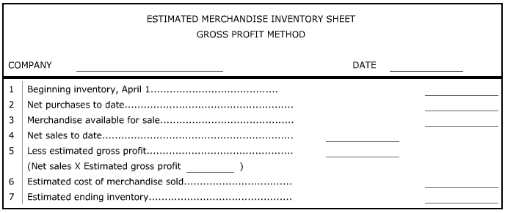

- Estimate the ending inventory using the retail method.

