Name: ___________________________________
Chapter 7 Notes
Accounting for Uncollectible Accounts

7.1: Direct Write-Off Method of Recording Uncollectible Accounts
- Uncollectible Accounts -
- Writing Off an Account -

Recording Uncollectible Accounts Expense
- An uncollectible account is closed by transferring the balance to a general ledger account titled __________________________________________.
- Direct Write-Off Method of Recording Losses from Uncollectible Accounts -

Practice Problem
Cracker, Inc. uses the direct write-off method of recording uncollectible accounts expense. A general journal is provided below. Source document is abbreviated as follows: memorandum, M.
- Journalize the following transactions completed during the current year.
Jan. 10 Wrote off Melinda Sanford’s past due account as uncollectible, $261.54. M13.
Mar. 12 Wrote off Mark Polk’s past due account as uncollectible, $45.00. M24.
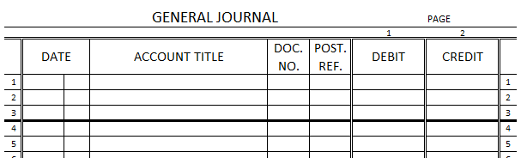

Collecting a Written-Off Account – Direct Method
- Sometimes a customer’s written-off account is later _________________. When the account is written off, the balance is recorded as an ________________. When the account is later collected, the amount is recorded as _____________________________.
- Therefore, _______ journal entries are recorded for the collection of a ____________________ account receivable:
- A __________________ journal entry to _______________ the customer account.
- A __________________________ journal entry to record the cash ________________ on account.
- The account ____________________________________________ is used for recording collection of previously written-off accounts.
Practice Problem
Cracker, Inc. uses the direct write-off method of recording uncollectible accounts expense. A general journal and cash receipts journal are provided below. Source documents are abbreviated as follows: memorandum, M; receipt, R.
- Journalize the following transactions completed during the current year.
Apr. 13 Received cash in full payment of Andrew Leslie’s account, previously written off as uncollectible, $67.42. M31 and R158.
Nov. 15 Received cash in full payment of Melinda Sanford’s account, previously written off as uncollectible, $261.54. M84 and R313.
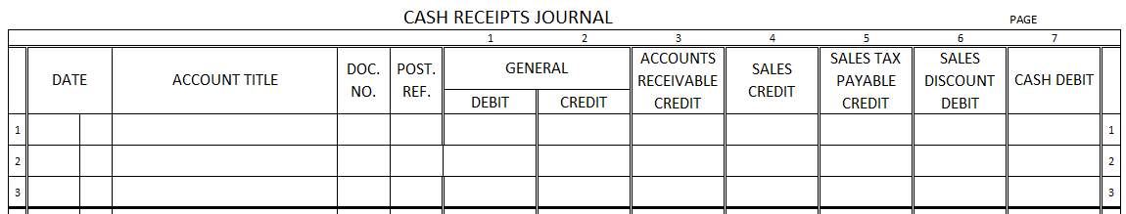

7.2: Allowance Method of Recording Uncollectible Accounts Expense
Estimating Uncollectible Accounts Expense
- When the direct write-off method is used, the ____________________ may be recorded in a fiscal period ____________________ from the fiscal period of the ___________________. Uncollectible accounts expense should be recorded in the same __________________________ in which the sales revenue is received (concept: Matching _______________________ with ______________________)
- At the time sales ______________________ are made, a business has no way to know for sure which customer will not pay an amount due. Therefore, the business makes an ______________________ based on its past history of uncollectible accounts.
- Allowance Method of Recording Losses from Uncollectible Accounts -
  - Two methods are used to estimate uncollectible accounts expense:
- Percentage of ________________ method
- Percentage of ___________________________________ method

Adjustment Using the Percentage of Sales Method
Steps to Estimate Uncollectible Accounts Expense Using the Percentage of Sales Method:
- Compute the estimated uncollectible accounts expense by multiplying net sales by the percentage estimate:
Net Estimated __________________
_____________ x _______________ = Accounts Expense

- Record an adjustment on the worksheet:
- Debit: ____________________________________
- Credit: ____________________________________

Practice Problem
A general journal page has been provided below.
- Lynum, Inc. had net sales of $245,321.09 during the current year. It estimates that the amount of uncollectible accounts expense is equal to 0.5% of net sales. Journalize the adjusting entry for uncollectible accounts expense on December 31 of the current year.

Adjustment Using Aging of Accounts Receivable
- The percentage of accounts receivable method assumes that a percentage of the accounts receivable balance is uncollectible. Therefore, emphasis is place on estimating a percentage of accounts receivable that will ______________________________________.
- Aging Accounts Receivable -
  - For example, Rosedale sells on the terms of _____________________ and expects customers to pay in full within ________ days. If Rosedale has not received cash within 30 days, it mails _________________ to the customers. If it has not received cash after _______ days, the company make special attempts to collect the amount due. If the business has not collect after ______ days, it may stop ________________ on account to that customer until collection has been made.

Adjustment Using Percentage of Accounts Receivable
- Based on past records, a business determines that a ___________________ of each accounts receivable age group (30 days, 60 days, and 90 days) will become uncollectible in the future. Using these percentages, the business calculates the ______________ amount of estimated uncollectible accounts receivable.

Practice Problem
A general journal page has been provided below.
- The aging of accounts receivable for Kersten, Inc., as of December 31 of the current year and estimated percentages of uncollectible accounts by age group are given below. Calculate the estimated balance of Allowance for Uncollectible Accounts. Then journalize the adjusting entry for uncollectible accounts expense. The balance of Allowance for Uncollectible Accounts on December 31 before adjusting entries are recorded is $63.24.
Age Group | Amount | Percentage | Uncollectible
Not yet due | $8,619.18 | 0.1%
1-30 days | 2,254.83 | 0.2%
31-60 days | 862.57 | 0.3%
61-90 days | 2,574.57 | 0.8%
Over 90 days | 350.90 | 50.0%
Totals | $14,662.05 | ------
Current Balance of Allowance for Uncollectible Accounts
Estimated Addition to Allowance for Uncollectible Accounts

Writing Off an Uncollectible Account – Allowance Method
- The procedures for writing off an account are the ______________ regardless of the allowance ______________ used to calculate the estimated uncollectible accounts expense.
- This transaction is recorded in the ________________________ journal and looks like this:
  - Debit: ___________________________________
  - Credit: _________________________________ and _________________________________

Collecting a Written-Off Account – Allowance Method
- The two parts of the transaction to record the collection of a previously written-off account are as follows:
  - In the _______________________ journal:
    - Debit: ______________________________ and _______________________________
    - Credit: ______________________________
  - In the __________________________________ journal
    - Debit: ____________________________
    - Credit: ____________________________

7.3: Accounts Receivable Turnover Ratio
Calculating the Accounts Receivable Turnover Ratio
- If a business does not collect amounts __________ from customers promptly, too large a share of the ______________ of the business will be in accounts receivable and not immediately _______________.
- One way to analyze the collection _____________________ of a business is to calculate the accounts receivable _______________________ ratio.
- Accounts Receivable Turnover Ratio -
  - It is calculated by dividing ________________ on account by the average __________________ of accounts receivable.
  - Book Value of Accounts Receivable -
  - Example: An accounts receivable turnover ratio of 7.1 times means that a business turns over (or ____________________) its average accounts receivable about ______________ times a year.
  - The number of days in a _____________ divided by the accounts receivable turnover ratio yields the average number of ___________ required to pay.

Analyzing Accounts Receivable Turnover Ratios
- A business hopes to see a steady increase in the turnover ratio, which shows a _______________ in the number of days it takes a customer to pay on account.
- A business might take several steps to create a more favorable accounts receivable turnover ratio:
- Send ________________________ of account to customers more _________________, including a request for prompt payment.
- ________ sell on account to a customer who has an account for which payment is ________________ more than 30 days.
- Encourage more _______________ sales and fewer sales on account.
- Conduct a more rigorous ________________ check on new customers before extending credit to them.

Practice Problem
Millikin Industries offers its customers n/30 credit terms. The turnover ratio for the prior year was 8.7. The following account balances were obtained from Millikin Industries’ records for the current year.

Account January 1 December 31
Accounts Receivable $163,874.05 $186,383.48
Allowance for Uncollectible Accounts $6,544.83 $7,745.86
Net Sales on Account $872.895.94

- Calculate the accounts receivable turnover ratio for the current year.
Accounts Receivable Turnover Ratio:
Accounts - Allow. for = Book Value of
Receivable Uncoll. Accounts Accounts Receivable
Beginning _______________ - _______________ = _______________
Ending _______________ - _______________ = _______________

Beginning Book Ending Book Average Book
Value of + Value of ÷ 2 = Value of
Accounts Receivable Accounts Receivable Accounts Receivable
_______________ + _______________ ÷ 2 = _______________

Net Sales on Account ÷ Average Book Value = Accounts Receivable
of Accts. Receivable Turnover Ratio
_______________ ÷ _______________ = _______________

- Calculate the average number of days for payment.
Average Number of Days for Payment:
Days in ÷ Accounts Receivable = Average Number of
a Year Turnover Ratio Days for Payment
_______________ ÷ _______________ = _______________

- Is Millikin Industries effective in collecting its accounts receivable?

Millikin Industries has reduced/increased (circle one) the time required to collect the average account receivable. With n/30 credit terms, Millikin appears to be doing a reasonably good/bad (circle one) job in collecting its accounts receivable on a timely basis.

