Name: _________________________
Chapter 7 Notes
Financial Statements
Why prepare financial statements?

Accounting Concepts
Accounting Period Cycle Adequate Disclosure Going Concern
- _________________________________ - financial statements are prepared at the end of each fiscal period
- _________________________________ - when financial statements contain all information necessary to understand a business’s financial condition
- _________________________________ - when financial statements are prepared with the expectation that a business will remain in operation indefinitely

Income Statement –

There are four parts of an Income Statement:

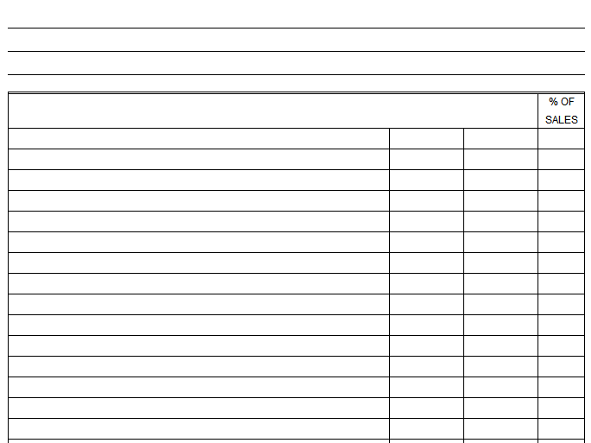

Component Percentage –

Is that a good component percentage?

Balance Sheet –

Financial Strength
vs.

The Accounting Equation
+ =

There are four parts of a Balance Sheet:

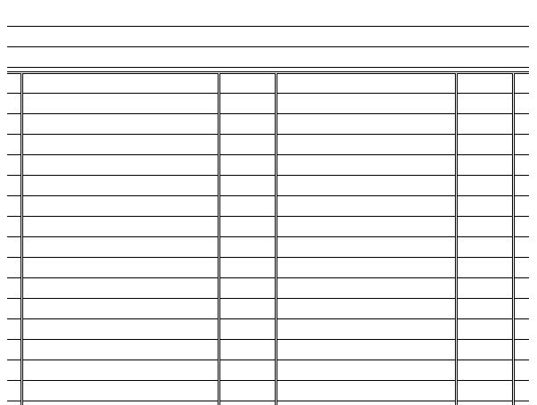

Calculating Current Capital
- When there is a Net Income:
Capital Drawing
Account + Net Income - Account = Current Capital
Balance Balance

+ - =

- When there is a Net Loss:
Capital Drawing
Account - Net Loss - Account = Current Capital
Balance Balance

- - =

