Name: __________________________
Chapter 8 Notes
Accounting for Plant Assets
8.1: Buying Plant Assets
- Current Assets – cash and other assets expected to be exchanged for cash or consumed within one year
- Plant Assets -
  - Examples:
- Plant Asset Record -

Practice Problem
Depreciate all plant assets using the straight-line method. Plant asset records, a general journal, and a cash payments journal are provided below. Source documents are abbreviated as: check, C; memorandum, M.
- Journalize the transactions completed during January. General ledger accounts are: Office Equipment, 1225 and Warehouse Equipment, 1245. (Application Problem 8.1)
Jan. 3 Paid cash for scanner (plant asset no. 162), $600; no estimated salvage value; estimated useful life, three years; serial no. V2GR34. C310.
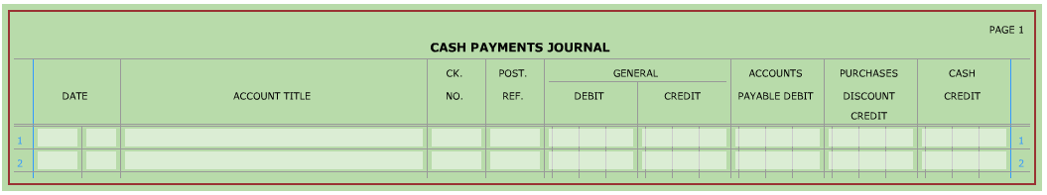

Jan. 5 Bought freight scale (plant asset no. 163) on account from Trent, Inc. $2,800; estimated salvage value, $400; estimated useful life, five years; serial no. GY52232B. M61.
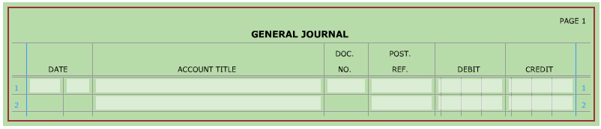

- Complete section 1 of a plant asset record for new asset purchases. (Application Problem 8.1)
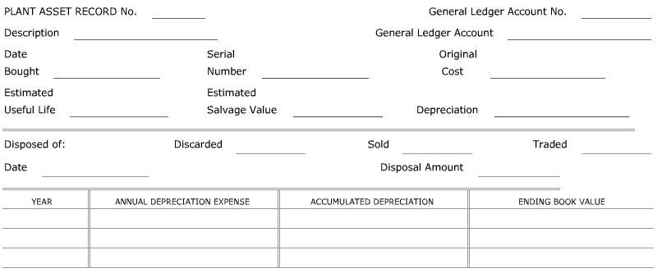

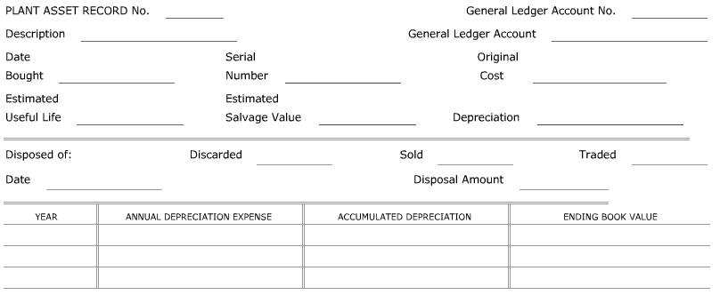

Calculating and Paying Property Tax
- In most states, businesses have to pay taxes on _____________ assets. For tax purposes, state and federal governments define two kinds of property:
- Real Property -
- Personal Property -
- Assessed Value of Property
  - Assessed Value -
  - Assessed value is usually based on the judgement of persons referred to as ________________. An asset’s assessed value may not be the same as the ____________ value on the business’s or individual’s records. It is used for ________ purposes only. However, many persons and businesses use the assessed value to estimate the _______________ value of an asset.
- Calculating Property Tax on Plant Assets
  - Most governmental units with taxing power have a tax based on the value of _____________ property; used on _________________ and land. Some governmental units also tax personal property such as cars, ____________, trailers, and __________________.
  - The tax rate is multiplied by an asset’s ________________ value, not the book value recorded on a business’s records.
- Paying Property Tax on Plant Assets
  - Payment of property taxes is necessary if a firm is to continue in business. Therefore, property tax is classified as an __________________ expense.
Practice Problem
A cash payments journal is provided below. Source document is abbreviated as: check, C.
- Journalize the transaction completed in February. (Application Problem 8.2)
Feb. 5 Paid property taxes on real property with an assessed value of $215,000. The tax rate in the city where the property is located is 3.5% of assessed value. C389.

8.2: Calculating and Journalizing Depreciation Expense
- Plant assets may __________________, may no longer be needed in the _________________ of a business, or may become __________________ by new models. To match revenue with expenses incurred to earn it, the cost of a plant asset should be ________________ to an expense account over the ______________ life of the plant asset.
- Depreciation Expense -
- Because of its permanent nature, _____________ is not subject to depreciation. Increases or decreases in land value are usually recorded only when land is _____________ or otherwise __________________.
- Three factors are used to calculate a plant asset’s annual depreciation expense:
- Original Cost -
- Estimated Salvage Value -
- Estimated Useful Life -
- Straight-Line Depreciation -
  - Example: On January 2, 20X1, Appliance Center bought a computer for $2,000 with an estimated salvage value of $175 and an estimated useful life of five years.
Original Cost $2,000
- Estimated Salvage Value - 175
= Estimated Total Depreciation Expense $1,825
÷ Years of Estimated Useful Life ÷ 5
= Annual Depreciation Expense $365

Beginning Book Value (Year 1) $2,000
- Annual Depreciation - 365
= Ending Book Value (Year 1) $1,635

Practice Problem
Use the plant asset records from the Practice Problem in Section 8.1. Depreciation tables are provided below.
- Complete the depreciation table for each asset using the straight-line depreciation method. If the asset was not purchased beginning of 20X1, compute depreciation expense for the part of 20X1 that the company owned the asset. (Application Problem 8.3)
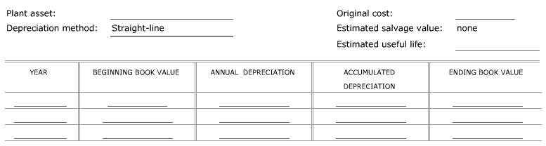

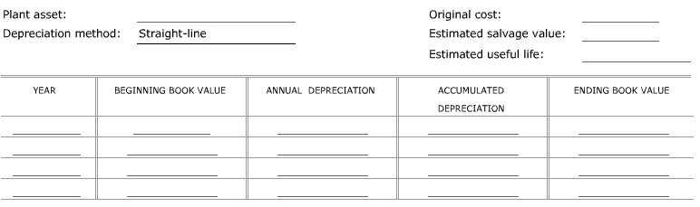

- Recording Depreciation on Plant Asset Records
  - Annual depreciation expense is recorded in two places for each plant asset:
- On the plant asset ________________
- As part of the _________________ entries that are posted to general ledger accounts
  - Book Value of a Plant Asset -
  - At the end of the estimated ________________ life, the plant asset should be depreciated down to its estimated ____________________ value.
  - A plant asset’s actual useful life may _______________ the estimated useful life. If a plant asset is used longer than the estimated useful life, depreciation is __________ recorded one the ____________ value equals the estimated salvage value.
Practice Problem
Plant asset records are provided below.
- Complete each plant asset record for 20X1 through 20X4. (Application Problem 8.3)
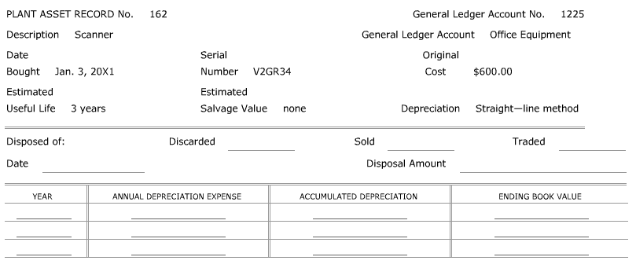
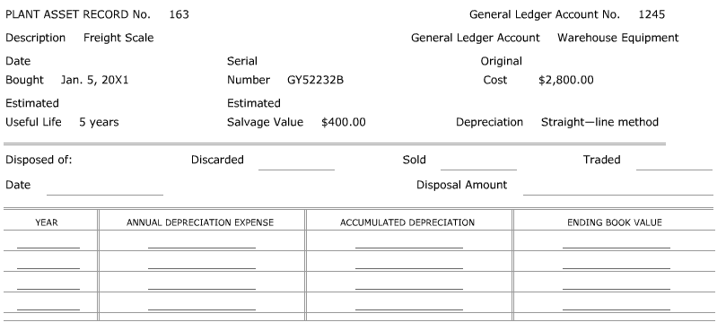
- Journalizing Annual Depreciation Expense
  - After depreciation expense is recorded on the plant asset records, depreciation amounts for the year are __________________.
  - An ____________________ entry is made to record ____________ depreciation expense for the fiscal year for each ___________________ of plant assets.
- Calculating Depreciation Expense for Part of a Year
  - A plant asset may be placed in service at a date other than the first day of a fiscal period. In such cases, depreciation expense is calculated to the nearest ____________ of a month.
Annual Depreciation Expense $120
÷ Months in a Year ÷ 12
= Monthly Depreciation Expense $10
x Number of Months Asset is Used x 5
= Partial Year’s Depreciation Expense $50

Practice Problem
A general journal is provided below.
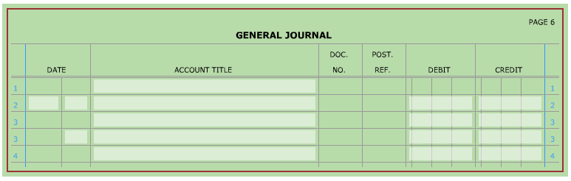
- Journalize the adjusting entries to record depreciation expense for 20X1. (Application Problem 8.4)

8.3: Disposing of Plant Assets
- A business usually disposes of a plant asset in one of three ways:
- The plant asset is discarded because no ____________ life remains.
- The plant asset is ___________ because it is no longer needed even though it might still be usable.
- The plant asset is _______________ for another plant asset of the same kind.
- Discarding a Plant Asset with No Book Value
  - If a plant asset has a salvage value of zero and its total accumulated depreciation is equal to the _______________ cost value, the plant asset has no ____________ value. The journal entry to discard this plant asset _______________ the original cost of the plant asset and its related _________________ depreciation as shown below.
    - Example: Discarded storage cabinet: original cost, $275; total accumulated depreciation through December 31, 20X5, $275. M72.
      - Debit: Accumulated Depreciation – Office Equipment, $275
      - Credit: Office Equipment, $275
- Discarding a Plant Asset with a Book Value
  - A plant asset may be ________________ of at any time during its useful life. When a plant asset is disposed of, its depreciation ________________ from the _________________ of the current fiscal year to the date of ________________ is recorded as shown below, in two entries.
    - Example: Discarded office table: original cost, $200; total accumulated depreciation through December 31, 20X5, $140; additional depreciation to be recorded through June 30, 20X6, $20. M92.
      - Entry 1: Remove the original cost of the plant asset and its related accumulated depreciation.
        - Debit: Depreciation Expense – Office Equipment, $20
        - Credit: Accumulated Depreciation – office Equipment, $20
      - Entry 2: Recognize the loss on disposal of the asset.
        - Debit: Accumulated Depreciation – Office Equipment, $160
        - Debit: Loss on Plant Assets, $40
        - Credit: Office Equipment, $200
- Selling a Plant Asset
  - When a plant asset is sold, a journal entry is recorded to:
- Remove the _______________________ of the plant asset and its related accumulated _____________________.
- Recognize the ____________ received.
- Recognize the ____________ or ____________ on disposal of the asset.
  - Example: Received cash from sale of fax machine, $185: original cost, $600; total accumulated depreciation through December 31, 20X5, $400. R60.
    - Debit: Accumulated Depreciation – Office Equipment, $400
    - Debit: Loss on Plant Assets, $15
    - Debit: Cash, $185
    - Credit: Office Equipment, $600
- Trading a Plant Asset
  - When an old plant asset is traded for a new plant asset, the journal entry:
- Removes the original cost of the old plant asset and its related accumulated ____________________.
- Recognizes the ____________ paid.
- Records the new plant asset at its ________________ cost.
  - Example: Paid cash, $650, plus old counter for new store counter: original cost of old counter, $1,000; total accumulated depreciation through June 27, 20X6, $765. M130 and C154.
    - Debit: Store Equipment, $1,085
    - Debit: Accumulated Depreciation – Store Equipment, $765
    - Credit: Store Equipment, $1,000
    - Credit: Cash, $850
- Selling Land and Buildings
  - Land is considered to be a permanent plant asset. Therefore, its useful life is not _____________ and annual depreciation is not _________________ for it. The book value of land is the original cost.
  - Land is seldom discarded. Usually land is sold at the same time that the buildings on it are sold. A ________________ plant record is maintained for the land and the building. Each record is updated when a sale is made. The journal entry:
- Removes the original cost of the land and building and the building’s related accumulated depreciation.
- Recognizes the cash received.
- Recognizes the gain on disposal of the plant assets.
  - Example: Fidelity Company sold land with a building for $97,000 cash; original cost of land, $25,000; original cost of building, $250,000; total accumulated depreciation on building through December 31, 20X5, $85,000. R105.
    - Debit: Accumulated Depreciation – Building, $85,000
    - Debit: Cash, $97,000
    - Credit: Land, $25,000
    - Credit: Building, $150,000
    - Credit: Gain on Plant Assets, $7,000

Practice Problem
Use the plant asset records from the Practice Problem in Section 8.2. The following transactions occurred in 20X5. A general journal, cash receipts journal, and plant asset records are provided below. Source documents are abbreviated as follows: check, C; memorandum, M; receipt, R.
- Journalize additional depreciation, if needed. Journalize the disposal of each plant asset. (Application Problem 8.5; Application Problem 8.6 for Dec. 30)
- Make appropriate notations in the plant asset records.
Jan. 3 Discarded scanner, no. 162. M65.
Mar. 30 Received cash for sale of freight scale, no. 163, $600. M125 and R145.
June 26 Received cash for sale of a desk, no. 127, $500. M151 and R273.
Dec. 28 Paid cash, $30,000, plus old truck, no. 116, for new truck, no. 172. M222 and C671.
Dec. 30 Sold land, no. 105, and a building, no. 106, for $110,000. M224 and M663.
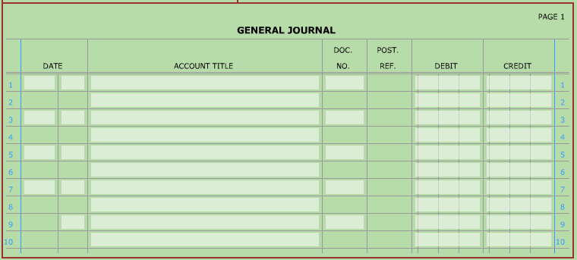

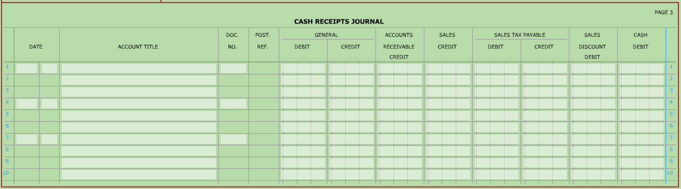
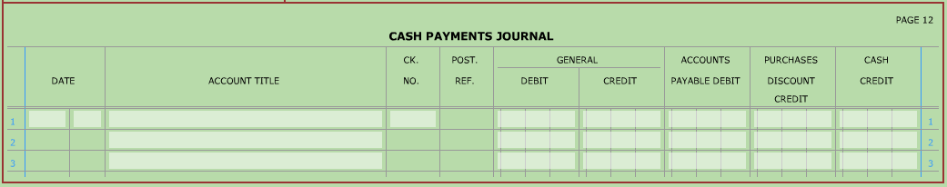

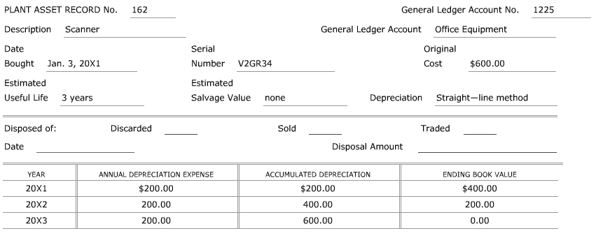

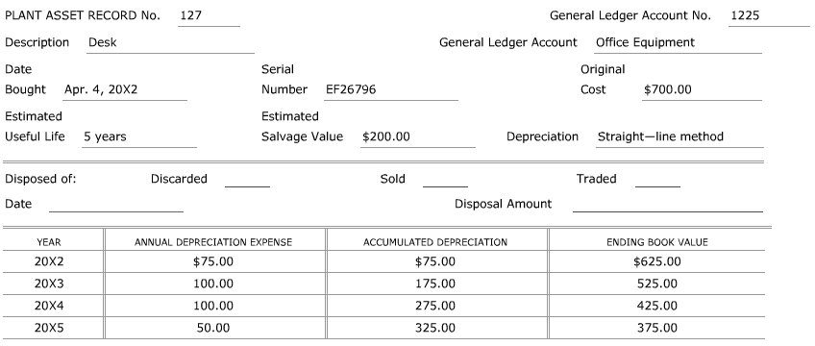
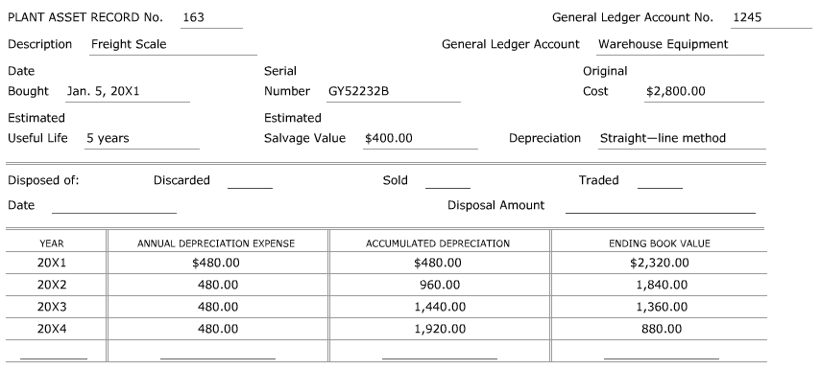
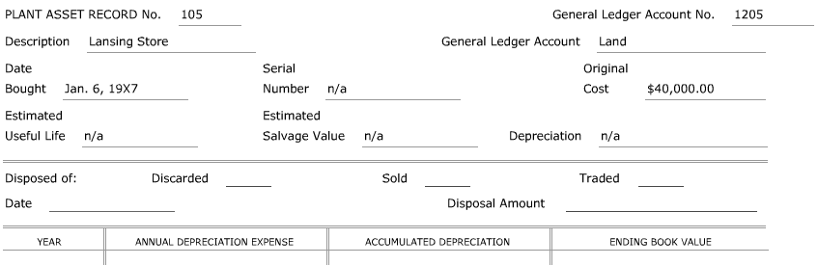
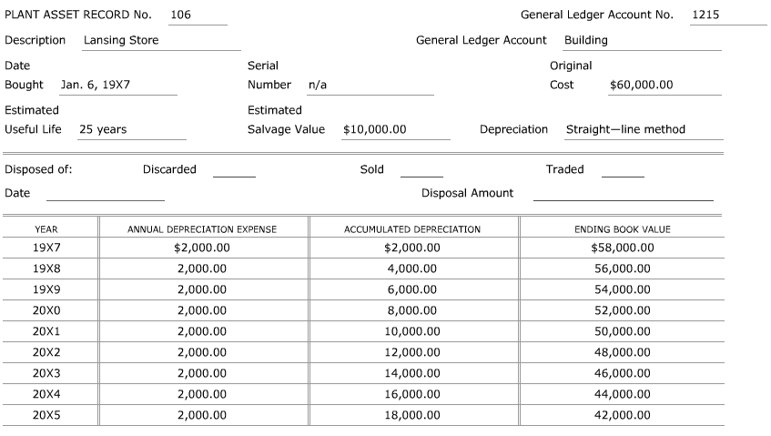
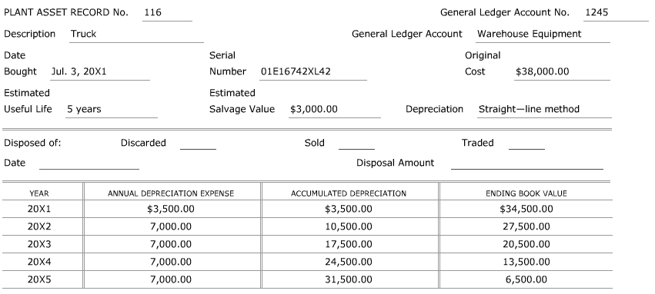
8.4: Other Methods of Depreciation
- Declining-Balance Method of Depreciation
  - Many plant assets depreciate ___________ in the early years of useful life than in the later years. Charging more depreciation expense in the ___________ years of a plant asset may be more ________________ than charging the _____________ amount each year.
  - Declining-Balance Method of Depreciation -
  - Although the depreciation _________ is the same each year, the annual depreciation expense ________________ from year to year.
  - A declining-balance rate that is ____________ the straight-line method rate is commonly used. This is referred to as the _________________ declining-balance method.
    - Example: A plant asset with an estimated useful life of five years would have a depreciation rate of 40%.
Total Depreciation Expense 100%
÷ Estimated Useful Life ÷ 5
= Straight-Line Rate 20%
x Double the Rate x 2
= Declining-Balance Rate 40%
  - The annual depreciation expense is calculated using the ________________ book value for each year. In the asset’s first year of service, the beginning book value equals the ____________ cost.
  - A plant asset is never depreciated below its estimated _________________ value. Therefore, in the last year, only ______________ depreciation expense is recorded to reduce the _________ value of the plant asset to its salvage value.

Practice Problem
The following information relates to a delivery truck purchased on January 2, 20X1. A depreciation table is provided below.
- Complete the depreciation table showing depreciation expense calculated using double declining-balance. (Application Problem 8.7)
Original Cost $90,000
Estimated Salvage Value $6,000
Estimated Useful Life 3 years
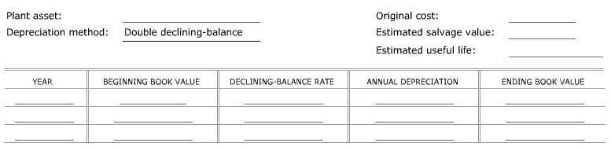

- Sum-of-the-Years’-Digits Method of Depreciation
  - Another method of calculating depreciation is based on a ________________ derived from the years’ digits for the ________________ life of a plant asset.
  - Sum-of-the-Years’-Digits Method of Depreciation -
  - Example: A plant asset has a useful life of five years. The fractions are determined as follows:
- The years’ digits are added (1 + 2 + 3 + 4 + 5 = 15).
- Then, a fraction is created for each year with the years’ digits in _____________ order:
Year 1 5/15
Year 2 4/15
Year 3 3/15
Year 4 2/15
Year 5 1/15
  - The depreciation expense for each year is calculated by multiplying the __________ depreciation expense times the fraction for that year. In the last year, the _____________ book value will equal the plant asset’s ______________ value.

Practice Problem
The following information relates to a delivery truck purchased on January 2, 20X1. A depreciation table is provided below.
- Complete the depreciation table showing depreciation expense calculated using sum-of-the-year’s-digits. (Application Problem 8.7)
Original Cost $90,000
Estimated Salvage Value $6,000
Estimated Useful Life 3 years
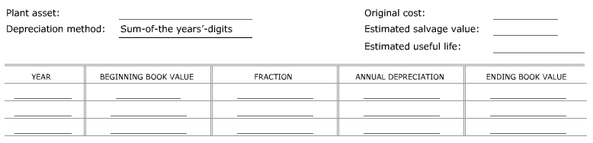

- Production-Unit Method of Depreciation
  - Sometimes the useful life a plant asset depends on how much the asset is _______________.
  - Production-Unit Method of Depreciation -
  - Example: A truck originally cost $18,200, had an estimated salvage value of $2,000, and an estimated useful life of 90,000 miles. The depreciation __________ for the truck is calculated by dividing the estimated ____________ depreciation expense by the estimated useful life.
Original Cost $18,200
- Estimated Salvage Value - 2,000
= Estimated Total Depreciation Expense $16,200
÷ Estimated Useful Life ÷ 90,000 miles
= Depreciation Rate $0.18 /mile
    - The annual depreciation expense is calculated by multiplying the total number of ____________ driven by the depreciation _____________.

Practice Problem
The following information relates to a delivery truck purchased on January 2, 20X1. A depreciation table is provided below.
- Complete the depreciation table showing depreciation expense calculated using production-unit. (Application Problem 8.8)
Miles Driven
Original Cost $90,000 20X1 34,600
Estimated Salvage Value $6,000 20X2 47,300
Estimated Useful Life 200,000 miles 20X3 52,800
20X4 36,900
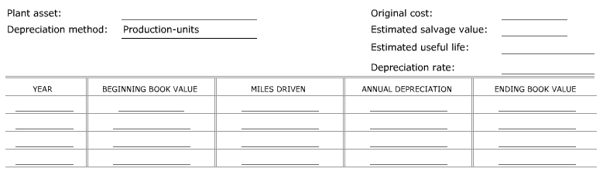

- Calculating Depreciation Expense for Income Tax Purposes (MACRS Method of Depreciation)
  - Modified Accelerated Cost Recovery System (aka MACRS) -
  - MACRS is a depreciation method with prescribed periods for ____________ classes of useful life for plant assets. A property is assigned to a specified class based on its _____________________ and general ___________ expectancy.
  - The two most common classes, other than real estate, are the _______-year and the ___________-year property classes.
    - The five-year class includes: ____________, general-purpose trucks, _______________, manufacturing equipment, and ______________ machinery.
    - The seven-year class includes: office _______________ and __________________.
  - The depreciation approximates the use of the double declining-balance method.
  - To calculate depreciation using MACRS, the IRS has prescribed methods that use annual ____________________________ to determine the depreciation. These rates are applied to the _______________ cost of the plant asset without considering _________________ value. All plant assets are assumed to be place in service in the _______________ of the year and taken out of service in the _________________ of the year.
  - Example: A printer, with an original cost of $2,000 is classified as five-year property. With the MACRS method, its depreciation is spread over six years as shown.
Year Depreciation Rate Annual Depreciation
1 20.00% $400.00
2 32.00% 640.00
3 19.20% 384.00
4 11.52% 230.40
5 11.52% 230.40
6 5.76% 115.20
Totals 100.00% $2,000.00

Practice Problem
The following information relates to a delivery truck purchased on January 2, 20X1. A depreciation table is provided below.
- Complete the depreciation table showing depreciation expense calculated using MACRS. (Application Problem 8.9)
Original Cost $90,000
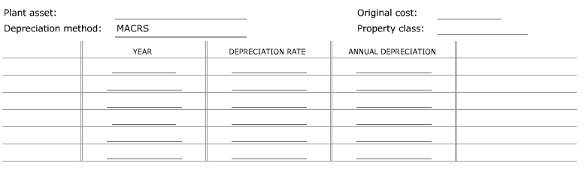
MACRS Property Class 5 years

- Depletion
  - Some plant assets decrease in value because _____________ of these plant assets is physically removed in the operation of a business.
  - Depletion -
  - Example: A business owns land on which a coal mine is located. The land with the coal has an original cost of $100,000. The company’s experts estimated that the land contains 50,000 tons of recoverable coal. The estimated value of the remaining land after the coal is removed is $12,250. The depletion rate of the land per ton of coal is calculated as follows:
Original Cost $100,000
- Estimated Salvage Value - 12,250
= Estimated Total Value of Coal $87,750
÷ Estimated Tons of Recoverable Coal ÷ 50,000
= Depreciation Rate per Ton of Coal $1,755
    - The annual depreciation expense is calculated by multiplying the depreciation rate by the tons of coal removed that year.

Practice Problem
The following data relate to a mineral mine owned by Kellogg, Inc. A depletion table is provided below.
- Complete a table showing depletion expense calculated using the production-unit method. (Application Problem 8.10)
Tons Mined
Original Cost $260,000 20X1 3,500
Estimated Salvage Value $60,000 20X2 12,500
Estimated Tons of 20X3 15,600
Recoverable Mineral 60,000 tons
