Names: _______________________________

_______________________________

_______________________________

Economic Indicators

**Project Overview:**

*Each pair/trio will find and graph data on one economic indicator. All data will be gathered from the same time period (2001 – 2010). Students will use the given websites to locate data and Microsoft Excel to compile and graph their data.*

**Economic Indicators and Data Sources:**

*(Topic will be selected by the roll of a die)*

1. **GDP**: Department of Commerce’s Bureau of Economic Analysis
2. **Unemployment Rate**: Department of Labor’s Bureau of Labor Statistics
3. **Personal Income**: Department of Commerce’s Bureau of Economic Analysis
4. **Home Price**: Federal Housing Finance Agency
5. Your choice from above!
6. Mrs. Burnett’s choice!

**Project Instructions**

1. Select your partner(s).
2. Roll the die with Mrs. Burnett to determine your Economic Indicator.
3. Follow the **Retrieving Data** instructions for your Indicator (see half sheet of paper).
4. Use Microsoft Excel to enter and graph your data:
   1. Open Microsoft Excel.
   2. Enter your data in the worksheet similar to below:

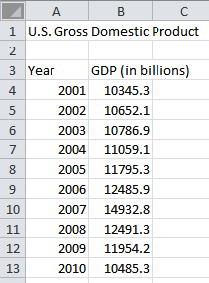

* 1. Select your data, just the amounts, not years (cells B4 through B13).
  2. Click **Insert** 🡪 **Line Chart** 🡪 **Line** (the first one)
  3. Select the **Layout Tab** under **Chart Tools**.
     1. Click **Chart Title** 🡪 **Above Chart**. Then enter a title for your graph.
     2. Click **Axis Titles** 🡪 **Primary Horizontal Axis Title** 🡪 **Title Below Axis**. Enter a label, such as *Year*.
     3. Click **Axis Titles** 🡪 **Primary Vertical Axis Title** 🡪 **Rotated Title**. Enter a label, such as *Dollars (billions)*.
     4. Click **Legend** 🡪 **None**.
  4. Double-click one of the numbers on the vertical axis.
     1. Click the **Axis** Options tab (if necessary)
        1. For **Minimum**, choose **Fixed** and enter a number that is a slightly less than your smallest amount (for this example, 10000 was used).
        2. For **Maximum**, choose **Fixed** and enter a number that is a slightly greater than your smallest amount (for this example, 15000 was used).
     2. Click the **Number** tab.
        1. For monetary figures ($), choose **Currency** and change the **Decimal places** to 0.
        2. For percentages (%), choose **Percentage** and change the **Decimal places** to 0.
  5. Click **Chart Tools** 🡪 **Select Data** 🡪 Horizontal (Category) Axis Labels **Edit**. Then select (highlight) the years from your table. Click **OK**, then **OK** again.
  6. Your chart should now look similar to the one below:

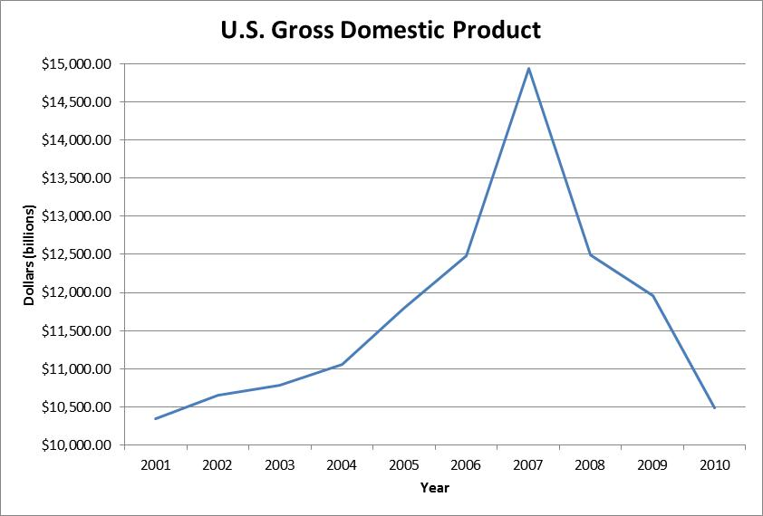

* 1. At this point, you can modify the design of your chart and data (color, font, etc.). Also try to make your chart as large as possible, while still printing on one page.
  2. When you are satisfied with your work, print your spreadsheet and chart to the printer specified by your teacher.

Names: ________________________

________________________

________________________

#1 - GDP

***Retrieving Data:***

1. Go to <http://www.bea.gov/itable/index.cfm>.
2. Click **GDP & Personal Income**.



1. Click **Begin using the data…**
2. Click **Section 1 – Domestic Product and Income**.
3. Click **Table 1.1.5. Gross Domestic Product (A) (Q)**.
4. Click **Options** (to the right, above the chart).
5. Choose the options below, then click **Update**.
   1. Series: **Annual**
   2. First Year: **2001-A & Q**
   3. Last Year: **2010-A & Q**
6. Write the data from **Line 1 Gross domestic product** in the table on the right.

Names: ________________________

________________________

________________________

#2 - Unemployment Rate

***Retrieving Data:***

1. Go to <http://www.bls.gov/cps/>.
2. Click **CPS TABLES** (on the left side, under Browse CPS)
3. Click **Employment Status**.
4. Click **HTML** next to **1. Employment Status of the civilian….population.**
5. Enter into the table below the data found in the **Unemployed, Percent of labor force** column:

|  |  |  |  |
| --- | --- | --- | --- |
| **Year** | **Unemployment Rate** | **Year** | **Unemployment Rate** |
| 2001 |  | 2006 |  |
| 2002 |  | 2007 |  |
| 2003 |  | 2008 |  |
| 2004 |  | 2009 |  |
| 2005 |  | 2010 |  |

Names: ________________________

________________________

________________________

#3 – Personal Income

***Retrieving Data:***

1. Go to <http://www.bea.gov/itable/index.cfm>.
2. Click **GDP & Personal Income**.



1. Click **Begin using the data…**
2. Click **Section 2 – Personal Income and Outlays**.
3. Click **Table 2.1. Personal Income and Its Disposition (A) (Q)**
4. Click **Options** (to the right, above the chart).
5. Choose the options below, then click **Update**.
   1. Series: **Annual**
   2. First Year: **2001-A & Q**
   3. Last Year: **2010-A & Q**
6. Write the data from **Line 1 Gross domestic product** in the table on the right.

Names: ________________________

________________________

________________________

#4 – Home Price

***Retrieving Data:***

1. Go to <http://www.fhfa.gov/Default.aspx?Page=87>.
2. Scroll down a little bit and click **Quarterly Average and Median Prices for States and US: 2001Q1-2010Q2**.
3. When asked what to do with the document, click **Open**.
4. Write the data from the **Average Price** column in the table below (pay attention to the year and quarter – the line number is given to help).

|  |  |  |  |  |  |
| --- | --- | --- | --- | --- | --- |
| **Line #** | **Year** | **Average Home Price** | **Line #** | **Year** | **Average Home Price** |
| 10 | 2001 Q1 |  | 30 | 2006 Q1 |  |
| 14 | 2002 Q1 |  | 34 | 2007 Q1 |  |
| 18 | 2003 Q1 |  | 38 | 2008 Q1 |  |
| 22 | 2004 Q1 |  | 42 | 2009 Q1 |  |
| 26 | 2005 Q1 |  | 46 | 2010 Q1 |  |