Name: _______________________________
Financial Literacy
Notes
SAVINGS, INTEREST, AND TYPES OF ACCOUNTS
Savings & Interest
Why Save Money?
Saving money is the cornerstone of a strong financial game plan. Some of the main reasons to save include:

Financial Goals:
- Short-Term Financial Goals
  - Ex)
- Long-Term Financial Goals
  - Ex)

How Much to Save:
You may already be saving on a small scale. As you are able to increase your savings, here are some savings guidelines:
- Experts suggest saving at least ______ of your income.
- If you can’t save ___________, save _____________. Saving is _________________________.
- Save for _________________________. You should have _________ to __________ months’ of living expenses saved.

Ways to Save:
The first rule of saving: ___________________________________. Don’t treat savings as the lowest priority, or you may never get around to it.
An easy way to get started saving is simply to look for __________________ ways to shave money off your __________________ spending.

How Savings Works:
- Principal –
- Withdrawal –
- Deposit –
How Savings Works:
- Interest –

- Interest Rate –

  - Fixed Rate –

  - Variable Rate –

Types of Interest:
- Simple Interest –

  - Calculating Simple Interest:

    - Example: You open a savings account with $1,000, at a 5% simple APR. What will you earn in interest the first year?

- Compound Interest –

    - Example: Use the same information from above, but assume the interest is compounded annually.

Rule of 72:
Want to know how fast your money will ________________? The Rule of 72 is a fast way to estimate how long it will take to double your savings with ______________________ interest.

- Example: With our example from above, how long will it take to double your money?

Types of Accounts
Liquidity
Liquidity refers to

- For example, high interest accounts often require that you do not ___________________ any funds for a given amount of _______________ and may charge you ____________ for doing so. This makes the money in those types of accounts less _______________ than money in an account with ___________________ withdrawals.

Savings Account:

- Pros

- Cons

Checking Account:

- Pros

- Cons

Money Market Account:

- Pros

- Cons

Certificate of Deposit:

- Pros

- Cons

Budgeting
Budgeting:
- Budget –
- Income –
  - Net Income –
- Expenses –
  - Fixed Expenses –
  - Variable Expenses –
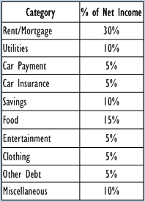
  - Discretionary Spending –
- The chart on the right shows the main types of expenses in the average adult’s household. Also provided are guidelines for what percentage of your net income should be spent on each category.

________________- ________________= ________________
Positive Difference (___________________________________)

Negative Difference (___________________________________)

Net Worth
We’ve learned that a balanced budget can help monitor monthly spending and maximize savings. In the long term, it can also improve one’s overall net worth.
- Net Worth –
  - Assets –
  - Liabilities –

CARDS AND CREDIT
Debit Cards, Credit Cards, and Prepaid Cards
Debit, credit, and prepaid cards provide convenience by allowing users to buy items in stores without cash and make purchases online. They also provide “zero liability” protection, which means that if your card is lost or stolen, you are not responsible for any unauthorized merchant charges.

Debit Cards (Pay Now)

Credit Cards (Pay Later)

Prepaid Cards (Pay in Advance)

Type of Card | Benefits | Drawbacks
Debit Cards
Credit Cards
Prepaid Cards

Understanding Your Credit Card Statement
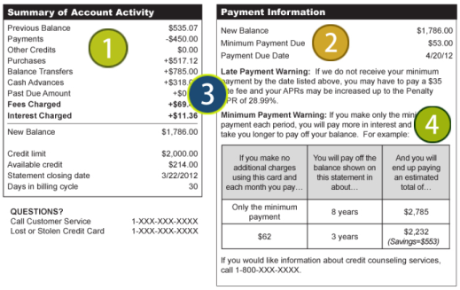

- Summary of Account Activity
- Credit Limit –
- Available Credit –
- Payment Information
- Minimum Payment –
- Late Payment Warning
- Late Payment Fee –
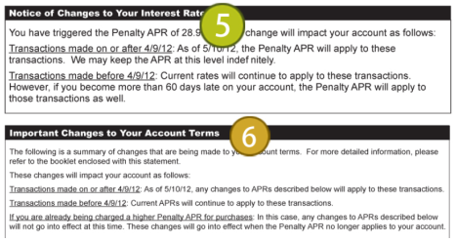
- Minimum Payment Warning
- Notice of Changes to Your Interest Rate
- Annual Percentage Rate (APR) –

- Important Changes to Your Account Terms
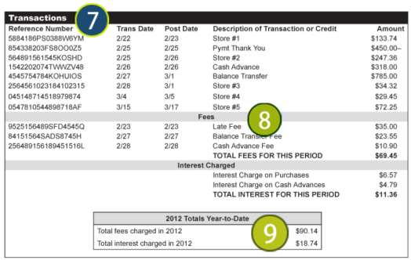

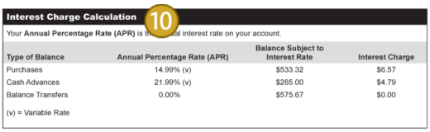

- Transactions
- Fees and Interest Charges
- Cash Advance Transaction Finance Charge –
- Finance Charge –
- Annual Fee –
- Year-to-Date Totals
- Interest Charge Calculation

Protecting Your Identity and Preventing Fraud
Fraud prevention is crucial to managing your credit, debit, and prepaid card accounts. Here is some common advice given to credit and debit cardholders to keep their accounts safe:
- If your credit or debit card is lost or stolen, report it __________________.
  - Maintain a list of all your credit and debit account __________________ in a ___________________ location, along with the _________________________ for each card company.
- When ordering items online, look for websites that start with ______________ and utilize SSL (_________________ _____________) and certificates to keep your transactions safe from __________________.
- Guard your _____________________.
  - Don’t give out your account number or Social Security number with anyone who _____________ you—share it only with those companies ________ contact.
  - Most merchants show only the last ________ digits of your card number on the bill; if the full number appears, ________________________ when signing the bill.
  - _____________ any documents and receipts where your card number may appear.
  - Never send your card number or other personal information through ________________.

What can be done if you discover an unauthorized charge on your account?
- Zero Liability
- You have _____ days to report errors and the credit card company must respond within _____ days.
- If a merchant made an unauthorized charge, the ______________________ will act on your behalf to dispute it.

Protecting Your PIN
- Your PIN (________________________________) is a secret numeric password you use to authenticate yourself as the legal owner of the card.
- Choose a random number that you can remember, but that’s not related to _____________ information.
- Never ___________ your PIN on the back of the card or keep it in your ___________________.

Managing Your Card Accounts
- Stick to Your ______________
- Follow the “20-10” Rule
  - Limit your credit card __________ to less than 20% of your total _______________________.
  - Less than 10% of your ______________________________ should go toward paying credit card debt. If it’s more, ___________________ your spending habits.
- Be a Good ______________ Customer
- Review Your Monthly _____________________
- Take Advantage of _________________ Access to Your Account Information
  - Review account __________________.
  - Sign up for ___________________ payments or set up a payment _____________ its due.
  - Set up account _______________ by email or text.
Creditworthiness
Why is having good credit so important?
- Advantages to you for being creditworthy:

- Challenges to you if your creditworthiness is low:

The Three “Cs” of Credit
When lenders consider your loan or credit card application, their main concern is:

- Character -

    - Have you used credit before?
    - Do you pay your bills on time?
    - Have you ever declared bankruptcy?
    - Can you provide character references?
    - How long have you lived at your present address?
    - How long have you been at your present job?

- Capital -

    - What property do you own that can secure the loan?
    - Do you have a savings account?
    - Do you have investments to use as collateral?

- Capacity -

    - Do you have a steady job?
    - What is your salary?
    - What are your current living expenses?
    - How many other loan payments do you have?
    - What are your current debts?
    - How many dependents do you have?

How to Increase Your Creditworthiness

BANKING
Bank, Credit, or Thrift: Which One is Right for Me?
Where do you stash your allowance, birthday cash or paycheck? There are lots of ways to keep your money safe, but knowing which option is best for you means researching your choices. Listen to the “How Having a Bank Account Protects Your Money” podcast at http://fdicmspodcast.com/podcasts/ to answer the questions below. Pause the podcast as you work or listen to it twice if needed.
- Write down four facts that you learn about each type of institution below. Then decide which one you would choose to put your money in and why.
Facts About Banks | Facts About Credit Unions | Facts About Thrifts

- Give three benefits to putting your money in a bank rather than under your mattress.

HOUSING
Your Home
To rent or buy…that is the question.
 | Advantages | Disadvantages
Renting
Buying

Types of Residences
- Apartment/Condominium

- Townhome/Duplex

- Single-Family Home

Expenses
Renting or Buying
Both
Renting
Buying

Expenses Word Bank:

Association Fees
Furniture
Mortgage
Parking Space/Permit
PMI (Private Mortgage Insurance)
Property Insurance
Property Taxes
Rent
Repairs/Maintenance
Security Deposit
Utilities

AUTO
Buying a Car
Costs of Car Ownership

Buying a Used Car
- Decide how much you can _____________________ to spend.
- Decide which car _________________ and ___________________ interest you.
- Research the ______________________ of the model of car you want.
- Shop for _______________________.
- Factor in the costs of the ______________ and the cost of ___________________________.
- Find out the reputation of the ____________________.
- Find out what type of _________________ and/or ___________________ contract comes with the car, if any.

Sources of Used Cars
- _____________________________ - provide quality used vehicles; service department available; higher prices than other sources
- _____________________________ - specialize in previously owned vehicles; limited warranty (if any); vehicles may be in poor condition
- _____________________________ - may be a good buy if vehicle was well maintained; few consumer protection regulations apply to private party sales
- other sources such as auctions or sales by government agencies, auto rental companies, and on the internet; most of these vehicles have been driven many miles

Buying a New Car
- Decide which car ________________ and specific _______________________ you want.
- Find out the _________________ price (the price the ____________________ pays).
- Compare ________________ sales prices and __________________________ from various dealers.
- If you already have a car, find out its value independent of the dealer’s _______________ offer. Try to sell your old car _________________ (dealers usually give better deals without trade-ins).

Warranties
- _____________________________ - assurances that are presumed like the product will do what it is designed to do and what the seller says it will do
- _____________________________ - offered and specifically written, generally covers only the working parts (like engine) and not wear-and-tear to leather or tires, for example
- _____________________________ - covers items in addition to the manufacturer’s warranty, read carefully and make sure it is worth the cost
Car Loans
- Your monthly car payment depends on:

- Your monthly payment goes towards __________________________ and ______________________
usually _____________interest
=price of car - __________________ and ________________ value

- The car payment is the ____________ each month, but the part paid to principal and interest ________________.

Calculating Your Car Payment
Let’s complete the table below to see the differences in the monthly car payment and total interest paid for various loan terms. Use the calculator at http://www.bankrate.com/calculators/auto/auto-loan-calculator.aspx.

Car Payment Calculations
$12,000 loan principal ($15,000 car with a 20% or $3,000 down payment)
APR  (interest rate) | Length of Loan  (# of payments) | Monthly Payment  (use online calculator) | Total Cost of Loan  (monthly payment x # of payments) | Total Interest  (total cost - $12,000)
3% | 36 months
3% | 48 months
6% | 36 months
6% | 48 months
10% | 36 months
10% | 48 months

INSURANCE
Insurance
Types of Insurance
- Auto –

- Homeowners –

- Health –

- Life –

- Personal Property –

- Travel –

Insurance Vocabulary Review
- Insurance Policy – contract between the consumer and insurance company that outlines coverage plans
- Premium – amount paid to the insurance provider every month in order to maintain an insurance plan
- Co-Pay – primarily for health insurance; the amount owed each time you visit the doctor
- Deductible – measured on a yearly basis; refers to the amount you must pay before your insurance provider begins to cover costs

Auto Insurance Coverage
Types of Coverage
Liability
- Covers injuries and property damage that _________ cause to ________________.
- Covers you (and others named on your policy) when driving __________________ ___________ car with their permission.
- Two types:
- Bodily Injury Coverage –

- Property Damage Coverage –

Uninsured and Underinsured Motorist
- Uninsured coverage reimburses you if an _____________________ or a __________________ driver hits you.
- Underinsured coverage pays when an _________________ driver doesn’t have __________________ insurance to fully pay for your loss.
Medical
- Pays for treating injuries to _________ and your ____________________.

Collision
- Pays for the physical damage to your ____________ from a collision with another ___________, an _________________ or a ______________________ or from _____________________ over.

Comprehensive
- Coverage reimburses you for damage to your car that’s __________ caused by a ______________________. This includes ______________, hail, windstorm, ____________, fire, and hitting _______________________.
- Will also reimburse you if your _______________________ is pitted, cracked, or damaged.

Towing and Rental Car
- Pays for towing your car when it is ______________________.
- Pays a specific amount per ___________ to rent a car while yours is being _________________.

Amount of Coverage
100/300 means

Insurance Requirements
Certain types of insurance coverage are specifically required by law or your lender.
Required by State Law (in Illinois) | Required by your Lender if you have an Auto Loan

Auto Insurance Rates
Your Auto Insurance Rate
You've probably figured out that the world of car insurance is – well, let's just say it's complex. When you apply for insurance, a company is going to look at many factors.

How Can I Save Money?

INVESTMENTS
Investing
Key Terms
Saving - | Investing -
Interest Rate - | Rate of Return -
Guaranteed Interest Rates - | Variable Interest Rates -
Simple Interest - | Compound Interest -

What’s My Rate of Return?

How to Calculate Simple Interest:
Principal x Interest Rate x Time
Example:
You have $100 and plan to put it in the bank for 6 years with a 6% interest rate (0.06). Here’s what the calculation would look like:
$100 x 0.06 x 6 = $36
The amount will grow by $36 over 6 years using simple interest.
Year 6: $100 + $36 = $136

How to Calculate Compound Interest:
Principal x (1 + Interest Rate)^{Time}
Example:
Imagine the same scenario, but this time with compound interest:
Year 1: $100 x 0.06 = $6, then $100 + $6 = $106
Year 2: $106 x 0.06 = $6.36, $106 + $6.36 = $112.36
and so on…until Year 6: $141.85
But to determine the compound interest quickly, try:
100 x (1 + 0.06)⁶ = $141.85

Let’s Try!
To complete the table below, assume an investment or savings of $10,000 over a period of 10 years.
Investment | Interest Rate | Interest or Return Type | Show Your Work | Total Value | Interest or Return Earned
Savings Account | 0.1% | Compound
CD | 0.9% | Compound
Bond | 2% | Simple
Mutual Fund | 5% | Compound
Stock | 7% | Compound

Savings and Investment Choices
Option | Definition | Risk/Liquidity | Pros | Cons
Savings Account | A bank account designed to deposit money and earn interest. | - Low risk  - High liquidity | - Very little funds needed to open  - Money can easily be withdrawn | - Earns a low interest rate
Certificate of Deposit | Savings option with a specific fixed term (3 mo. to 5 yr.) and interest rate. | - Low risk  - Low liquidity | - Earns a higher interest rate | - Money cannot be withdrawn until the end of the CD term
Bonds | You loan money to the gov’t or a corporation with a set interest rate and maturity date. | - Lower risk (as long as the issuer repays the loan)  - Low liquidity | - More stability than stocks  - Higher interest rate than a savings account | - Historically lower returns than stocks  - Cashing in before maturity date could result in a loss of principal
Mutual Funds | A fund managed by a company that includes a portfolio or stocks or bonds. | - Risk varies depending on type of mutual fund.  - Medium liquidity | - Diversified  - You can select different risk levels | - Return isn’t guaranteed  - Can be subject to expensive management fees
Stocks | When buying stock, you buy partial ownership of a company. | - Different levels of risk – some can be very risky, but all stocks are subject to ups and downs of the market  - Medium liquidity | - Potential for higher returns over the long-term | - The market goes up and down regularly, making it a volatile investment  - Requires long-term investment to get the best return  - No guarantee for additional money above your investment and you may lose your principal, too

Investment Challenge
- John receives $1,000 as a graduation gift from his grandparents. Rather than spend it, he decides to invest it in a two-year bond that earns 3% simple interest. John doesn’t need access to the money right away because he wants to save it for when he’s ready to buy a home in about 10 years. Is the bond a wise investment for John? Why or why not? What other investment options does John have?

- If you had the choice between investing $1,000 in a mutual fund that earns 7.5% compound interest or a bond that earns simple interest at 7.5%, which would you prefer and why?

