International Business Project
  - You will be acting as an employee of a business, researching a country in which your business is hoping to expand. You will research that country and plan a trip to hold a meeting in its capital city.
  - Your project will have two components: (1) research information and (2) a Google Slides presentation. You may work individually or in pairs.

Google Docs and Slides
For this project, you will be using Google Docs and Google Presentation. You will access these apps through your District 300 Google account. Follow these steps to log into your Google account:
- Go to the DCHS homepage (dchs.d300.org).
- Click Students.
- Click Google Apps Login.
- In the Single Sign On box that opens, enter your login information:
  - Username: your student id#
  - Password: whichever new password you set up (same as the computer login)
- Accept terms.
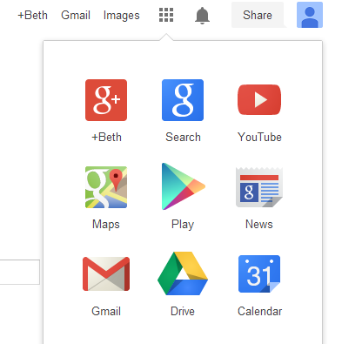
- Click the grid to see your apps

- Click Drive to access Google Docs and Google Presentations
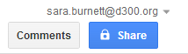
- Share your Document or Presentation with Mrs. Burnett and your partner (if you have one)
- In your Google Drive, click Create. Then select Document or Presentation.

Part 1: Research Information

Instructions
You will research the information below. All information must be typed in complete sentences and organized by topic. This information must be typed into a Google Document that is shared with Mrs. Burnett (sara.burnett@d300.org) and your partner, if applicable.
- Facts About the Country: geography, population, government structure, economic system, transportation modes available, etc.
- Economic Facts: exports, imports, chief agricultural products, currency, exchange rate, etc.
- Travel Information:
  - Airline Ticket(s) Price: Business class price and Economy class price
  - Hotel Room(s) Rate: Price of hotel room(s) in local currency converted to U.S. dollars
- Culture and Customs: business etiquette, major holidays, etc.
- Eating Habits: general cost of meals/restaurants, whether American food is served in that country, what times do people tend to eat, etc.

Suggested Websites
The following list contains various sites for researching your country’s information and making travel arrangements on the web.

Country Information:
  - The World Factbook: https://www.cia.gov/library/publications/the-world-factbook/
  - Country Reports: http://www.countryreports.org/
  - U.S. Department of State: http://www.state.gov/misc/list/index.htm
  - World Bank: http://www.worldbank.org/en/country

Travel Information:
  - U.S. Department of State: http://travel.state.gov/content/passports/english/country.html
  - Expedia: http://www.expedia.com/
  - Bing Travel: http://www.bing.com/travel/
  - Travelocity: http://www.travelocity.com
  - Trip Advisor: http://www.tripadvisor.com/

Part 2: Presentation

Instructions
After completing your research, prepare your presentation. You will be presenting the information about your country to your business manager (the class). Your presentation will be an abbreviated version of your research – the key pieces of information needed to prepare for a successful business meeting in the country you selected.
You must also prepare a Google Presentation (slide show). The slides in your presentation should summarize the information you will be presenting to the class. It is used to help guide your presentation – keeping you organized and giving your audience a visual to follow. There is no minimum or maximum number of slides to include, use your judgment to decide what will best suit your needs.
When preparing your presentation, here are some ways to give a lousy presentation, in other words, these are some things to avoid:

How to Give a Lousy Presentation
From
By Carmine Gallo
Giving truly great presentations requires skill, work, and practice. Giving catastrophic presentations is far easier. So if you want to take the easy way out and look like a rank amateur, here are surefire tips to guarantee that you leave a really, really bad impression.
- Misspell words.
- Create distracting color combinations.
- Use inconsistent fonts.
- Use a really small font size.
- Insert improperly sized photos that are stretched to fit the slide.
- Look completely and totally disinterested.
- Look disheveled.
- Read every word of each slide.
- Don't bother with a backup plan.
- Don't practice.
- Call attention to your mistakes.
- Open with an offensive joke.
- Use wild animations in your slide show.

International Business Project

Grading Rubric
Levels |  | 20 | 15 | 10 | 5 | Score
Criteria | Creativity | Exceptional originality of presented material | Some apparent originality displayed through creative use of materials | Material presented with little originality or creative thought | Project includes little variety in presentation techniques
 | Content | Project is well-organized and meets all requirements | Project is well- organized and meets most requirements | Project meets half of the requirements; well-organized | Unorganized and meets less than half the requirements
 | Grammar | Nearly error-free which reflects clear understanding and thorough proofreading | Few grammatical and/or stylistic errors | Some errors in grammar and/or format that does not interfere with clarity | Multiple grammatical and stylistic errors
 | Presentation of display | Evidence that pride and care was taken and the message of the travel information is clearly defined | Clear, uncluttered, and attractive | Project appears rushed of somewhat careless, but the content is legible | Careless, hurried, and illegible presentation
 | Use of class time and assignment complete on time | Assignment completed on time and good use of class time | Assignment completed on time, but some wasted class time | Assignment completed on time, but poor use of class time | Assignment late and class time and poor use of class time

Total Points Earned

