Name: _______________________________

Labeling the Parts of a Computer

Label the diagram below by writing the name of the component in the blank next to the corresponding number. Use the clues given for each question and hints shown in the drawing to help you with your matching.

Word Bank:
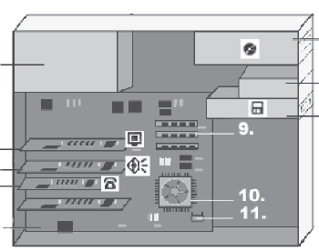
BIOS
#5
#3
#4
#9
#1
#2
#11
#8
#6
#10
#7
CD-ROM drive
cooling fan
CPU
hard drive
main board
modem card
power supply
RAM
sound card
video card

- ___________________________ I am one of the input devices on the computer. I can only read data, unless I am specifically designed to also write data.
- ___________________________ Information in the computer is stored permanently on my magnetic cylinders.
- ___________________________ I manage the sounds coming from the computer.
- ___________________________ I connect computers and allow them to talk to each other.
- ___________________________ I handle the graphics that are displayed on the monitor.
- ___________________________ I wake up the computer and remind it what to do when it starts up.
- ___________________________ I am the brain of the computer.
- ___________________________ I can read and write; but if you turn off the computer, I forget everything. The more of me, the faster the computer runs.
- ___________________________ I get electricity into the computer.
- ___________________________ I am the main switchboard of the computer and hold all of the circuit boards.
- ___________________________ I keep the computer cooled and prevent it from overheating.

