Name: _________________________

**Patent, Copyright, or Trademark?**

Instructions: *Label each statement or graphic below as either a patent, copyright, or trademark.*

1. Merck Pharmaceuticals developed a new medication to lower blood pressure.
2. Marshall wrote and recorded his own music.
3. Parry created his own website.
4. Rosa wrote and published her own book.

1.  (logo)
2. 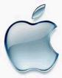 (logo)
3. 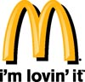 (slogan)
4. 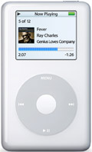 (product shape)

FYI - Here's an interesting one. If you create a document on your computer at work, *your company owns the work and the copyright*. That is, unless you have a contract which says otherwise. This is why it is not wise to use company resources for personal projects - you could wind up creating a lot of money for your company without any compensation at all.