Name: _________________________________
Source Documents Activity
Cy Sawyer owns a service business called Cy’s Repair Service, which uses the following accounts:
Cash Accts. Rec. – J. Hutton Supplies
Prepaid Insurance Accts. Pay. – Atlas Supplies Cy Sawyer, Capital
Cy Sawyer, Drawing Sales Miscellaneous Expense
Rent Expense Utilities Expense

Source documents related to the transactions for Cys Repair Service for May are provided below and on the pages that follow.

Instructions:
- The journal for Cys Repair Service has been provided at the back of this packet. Use page 1 of the journal to journalize the transactions for May. Source documents are abbreviated as follows: check, C; memorandum, M; receipt, R; sales invoice, S; calculator tape, T.
- Prove the journal.
- Prove cash. The beginning cash balance on May 1 is zero. The balance on the next unused check stub is $5,223.00.
- Rule the journal.

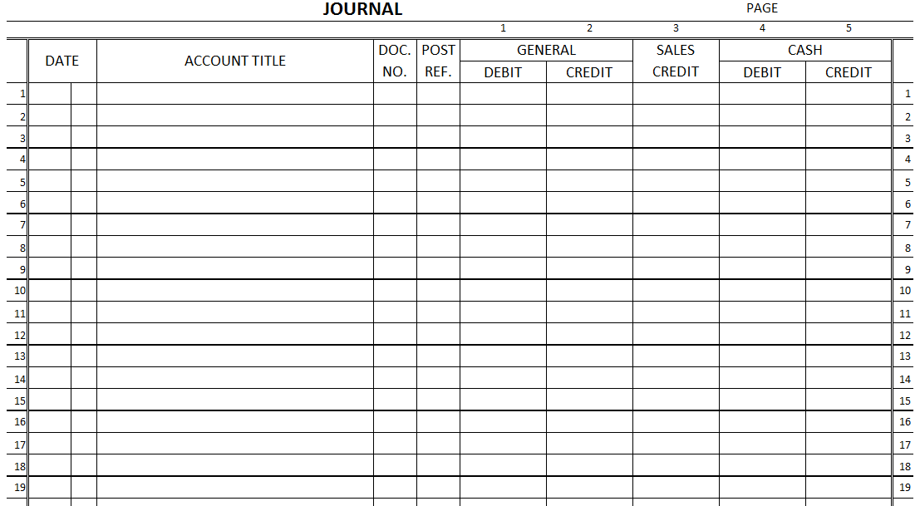
Prove page 1 of the journal: Prove cash:
Debit Credit Cash on hand at the beginning of the month _______________
Column Column Totals Column Totals Plus total cash received during the month _______________
General _____________ _____________ Equals Total _______________
Sales _____________ Less total cash paid during the month _______________
Cash _____________ _____________ Equals cash balance at the end of the month _______________
Totals _____________ _____________ Checkbook balance on the next unused check stub _______________

